**Michael Knowledge Pack**

The purpose of this document is to be used as a reference to learn about arduinos, electrical circuits, electronic components and coding.

The document consists of sections with the following:

* Explanations of terms, concepts
* Activities to undertake
* Extra information (Not relevant to the teaching level but as a reference for questions)

**Contents**

* Activity List
* Component list
* Basics
  + Electrical Circuits
  + Arduino
  + Coding
* Digital Logic
* Constructing and Programming Circuits
* ...To be filled out with progress
* Appendix
  + Table of Acronyms
  + Bill Of Materials
  + Extra Resources

**Activity List**

**Activity 1: Build a simple electrical circuit to light up a LED**

**Activity 2: Build the Same circuit with the resistor**

**Activity 3: Build a series circuit for 2 RED LEDS**

**Activity 4: Build a Parallel circuit with 2 RED LEDs**

**Activity 5: Make LED turn on/off in code**

**Activity 6: Make SOS signal**

**Activity 7: Build AND circuit**

**Activity 8: Build OR circuit**

**Activity 9: Build NOT circuit**

**Activity 10: Build NAND circuit**

**Activity 11: Build NOR circuit**

**Activity 12: Build the a circuit which lights up when push button is pressed**

**Activity 13: Experiment with debouncing code**

**Activity 14: Build a LED LDR circuit**

**Activity 15: Build and program a LDR circuit**

**Activity 16: Control the brightness of an LED with the LDR**

**Activity 17: Dim LED with potentiometer**

**Activity 18: PWM with RGB Colours**

**Activity 19: CONNECT LCD to Arduino**

**Activity 20: hello, world! on LCD**

**Activity 21: Scrolling text**

**Activity 22: Writing characters in number format**

**Activity 23: Serial Read to control brightness of LED from computer**

**Activity 24: Displaying analog value on LCD**

**Activity 25: Display messages on Serial Monitors from buttons**

**Activity 26: Display messages on Serial Monitors from keyboard**

**Activity 27: Basic Controlling a Servo Motor Position**

**Activity 28: Range control a servo motor position**

**Activity 29: Potentiometer control of Servo Motor**

**Activity 30: Basic powering the DC Motor**

**Activity 31: Controlling the DC Motor with simple code**

**Component List**

This list is your quick reference to what we are using. Where necessary a detailed explanation has been included where they are first used in the document.

We will be working with the following components:

|  |  |  |
| --- | --- | --- |
| **Component** | **Image** | **What it does** |
| *Arduino UNO* |  | A microcontroller with expansion circuit board to program |
| *USB A Cable* |  | Powers the arduino board, transfers code from your computer to arduino board |
| *Breadboard* | Image result for breadboard | Used as a base to easily construct circuits |
| *Dupont Cables (Male-Male)*  *(Female-Male)* | Image result for dupont cable | Used to connect circuit components |
| *Push Button (Switch)* | Image result for push button | User Input device  Controls current flow with ON and OFF |
| *LED RED* | Image result for RED LED | Lights up RED |
| *LED RGB* | Image result for RGB LED | Lights up any combination of RED, GREEN, BLUE |
| *photo resistor* | Image result for photo resistor | User Input device  Senses what the light level is |
| *NPN 2N2222 transistor* | Image result for transistor NPN | Used as a switch inside a circuit to control current flow |
| *Potentiometer 1K* | Bourns PTV Series, Linear Potentiometer with a 6 mm Dia. Shaft, 1kΩ, ±20%, 0.05W, Through Hole | User Input device  A physical dial which a changed position changes the resistance |
| *Resistor 220* | Image result for Resistor | A basic circuit component, obstructs current flow |

**Basics: Electrical Circuits**

**Electricity**

 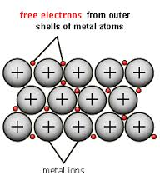

A form of a transfer of energy in the form of flowing electrons in a conductive structure.



Electricity originates in the atomic scale and affects all the way up to the macro scale. Electricity flows along the line of least resistance.

**Electrical Circuit**

An electric circuit is a path in which electrons from a voltage or current source flow. The point where those electrons enter an electrical circuit is called the "source" of electrons. Electrical circuits are used with components to solve a problem.

Electrical Circuits have common symbols. Some examples include:

|  |  |
| --- | --- |
| **Electrical Circuit Symbols**  ***Be aware that symbols can vary according to different national conventions or styles.*** | |
| **Battery**  A Battery stores energy to use in a circuit. When the circuit is complete, this is the source of where the electrons flow from and to. It is measured in Volts. |  |
| **Resistor**  A resistor resists the flow of electrons in a circuit. It is measured in Ohms. |  |
| **LED**  A LED is a Light Emitting Diode. In the right voltage range, it will emit light, increasing light emission with current. It is a diode which means it only works in one direction. |  |
| **Switch**  Sometimes called a push button. It can have two states, open circuit or closed circuit. When it is pushed down it is closed circuit and when it is not pushed down it is open circuit (*The picture is showing the switch when it is open, when it is closed the black bar will touch the two black dots*). |  |
| **Transistor**  A transistor is a semiconductor device that can be used to control large current flow. It has three connections; Base, Emitter , Collector. |  |

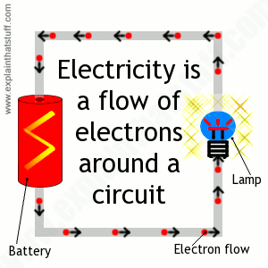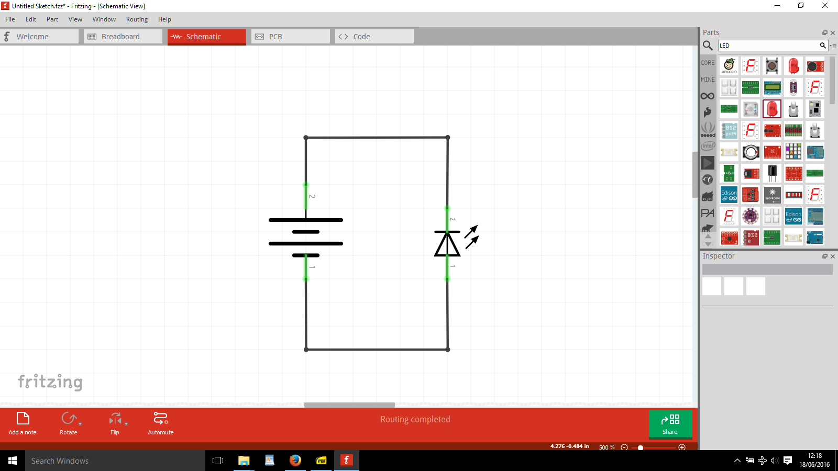

**Electrical equations**

$V = IR$ $I = V/R$ $R =V/I$

|  |  |  |  |
| --- | --- | --- | --- |
| **Symbol** | **Property** | **Units** | **How to Say** |
| *V* | *Voltage* | *[V]* | *Volts* |
| *I* | *Current* | *[A]* | *Amperes* |
| *R* | *Resistance* | *[Ω]* | *Ohms* |

To explain V, I and R, a simple analogy compared to a bathtub filled with water:

* Pressure of water = Voltage
* Flowing water = Current
* Blocked drains = Resistance

**Activity 1: Build a simple electrical circuit to light up a LED**

Equipment:

* Arduino UNO
* Cables
* 1 x RED LED

|  |  |
| --- | --- |
| **Tip 1** | *The convention is for GND to be associated with negative, and Voltage to be associated with positive. Look at a normal battery to see this.* |
| **Tip 2** | *The wiring convention is to use* ***RED*** *or positive connections, and* ***BLACK*** *for negative.* |
| **Tip 3** | *LED’s are polarised: the long leg is the positive end. Connect the Long Leg to the Voltage side of the circuit.* |

Assemble the circuit as shown in the circuit diagram. Connect the **RED** cable to the long leg of the LED, then connect the **BLACK** cable to the short leg of the LED. Watch the LED carefully and contact the **RED** cable to the 3.3V terminal and the **BLACK** cable to the GND terminal.

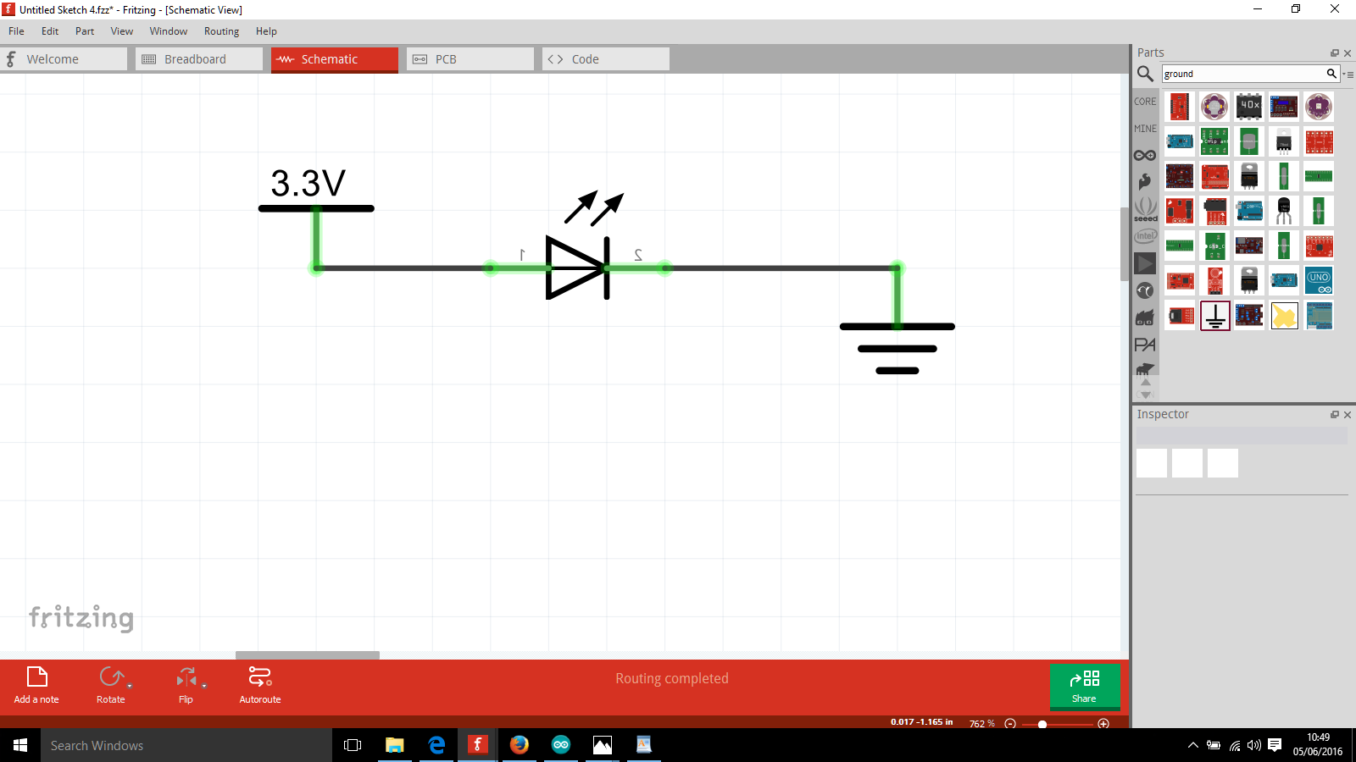

What happened? You should have noticed that the LED flashed and then is permanently off. It's broken now (intended to demonstrate), because the LED was supplied with too much current.

To connect a new LED without breaking it, we need to limit the amount of current. To prevent this happening next time, we could use a resistor. This can be calculated using Ohms law equation as stated below.

$R =V/I$

To work out R we need to know V and I. V is defined as where we have connected it on the board (3.3V) and I is defined in checking the component datasheet as 25mA.

132

$R =3.3[V]/(25/1000)[A] =132 [Ω]$

So we need to add a resistor of at least 132Ω into the circuit. We have chosen 200Ω just because it was easily available.

|  |  |
| --- | --- |
| **Tip 4** | *You can ignore the units part of the equation such as [V], [A], [$Ω$*] *until you finish it* |

|  |  |  |  |
| --- | --- | --- | --- |
| **Context** | **Notation** | **Equivalent** | **How to say** |
| mA | x10-3 | /1,000 | milli-Amp |
| uA | x10-6 | /1,000,000 | micro-Amp |
| nA | x10-9 | /1,000,000,000 | nano-Amp |

How do we know which resistor is which? You can use this diagram, or use an online tool.

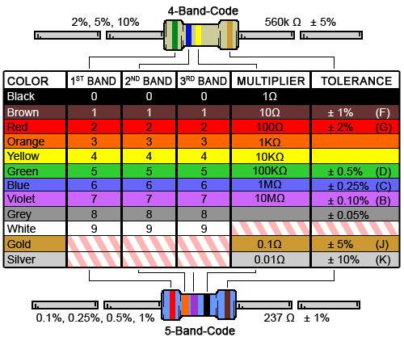

<http://www.digikey.co.uk/en/resources/conversion-calculators/conversion-calculator-resistor-color-code-4-band>

**Activity 2: Build the Same circuit with the resistor**

Equipment:

* Arduino UNO
* Cables
* 1 x 200Ω Resistor
* 1 x RED LED

Assemble the circuit as shown in the diagram just using jumper cables. You should see the LED lit this time.

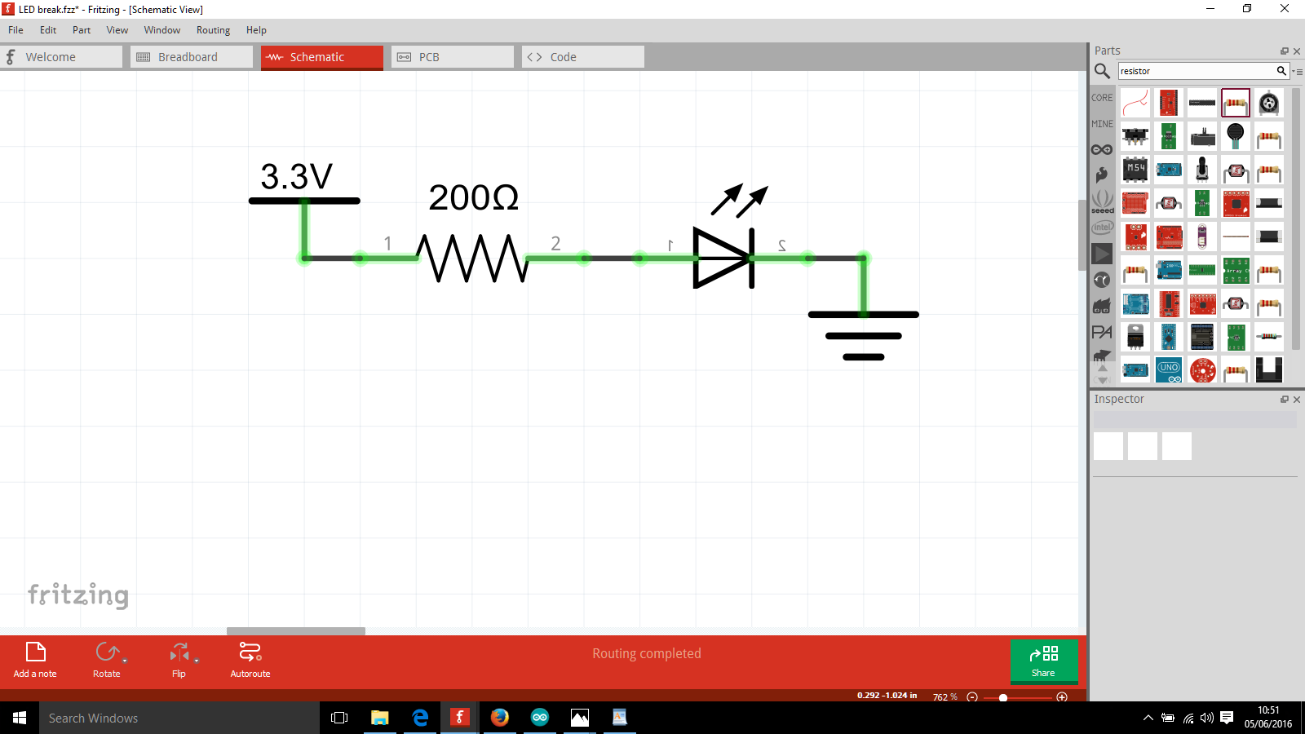

**Breadboarding**

Breadboards are used to prototype circuits quickly and reliably. They are connected vertically on the middle part, and horizontally on the top part.

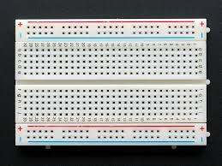 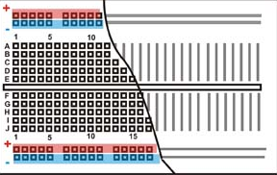

To build the circuit from Activity 2 on a breadboard, it would look something like this. Note that it does matter that you put the resistor before the LED, and the LED should be long leg first (positive)

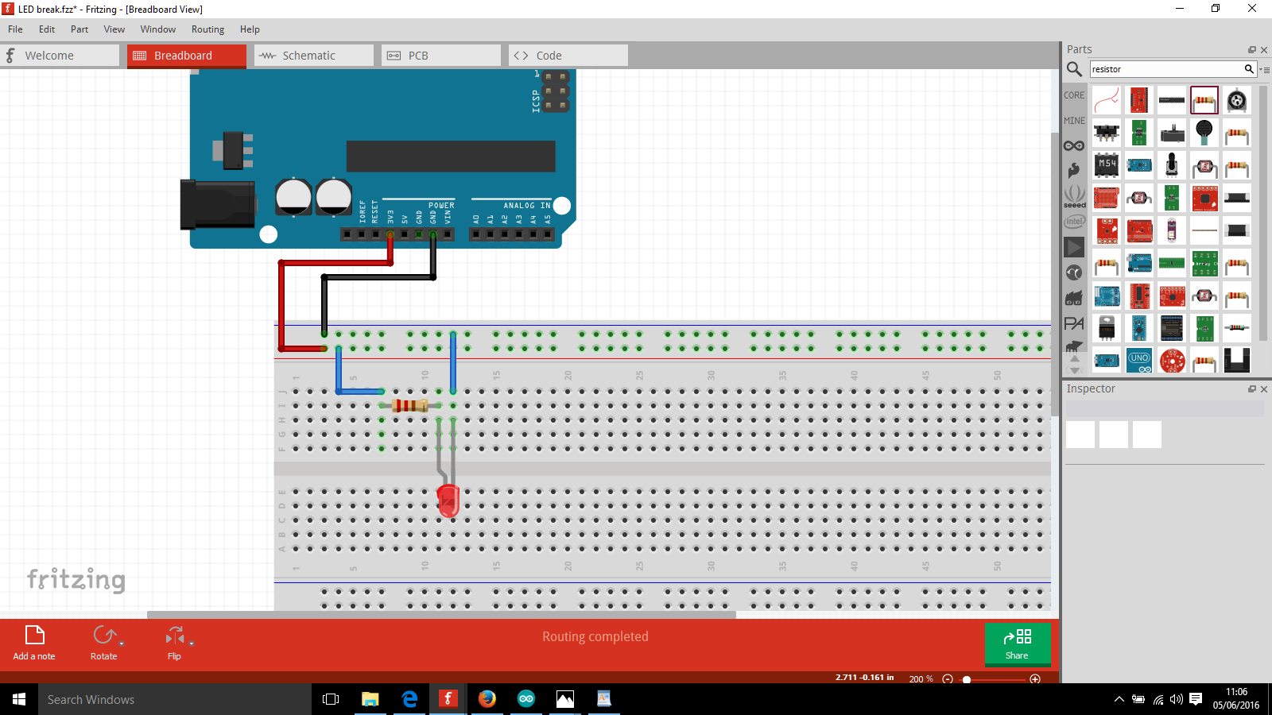

**Series/Parallel Circuits**

**Activity 3: Build a series circuit for 2 RED LEDS**

Equipment:

* Arduino UNO
* Breadboard
* Cables
* 1 x 200Ω Resistor
* 2 x RED LED

Build the circuit from the following diagram using the breadboard.

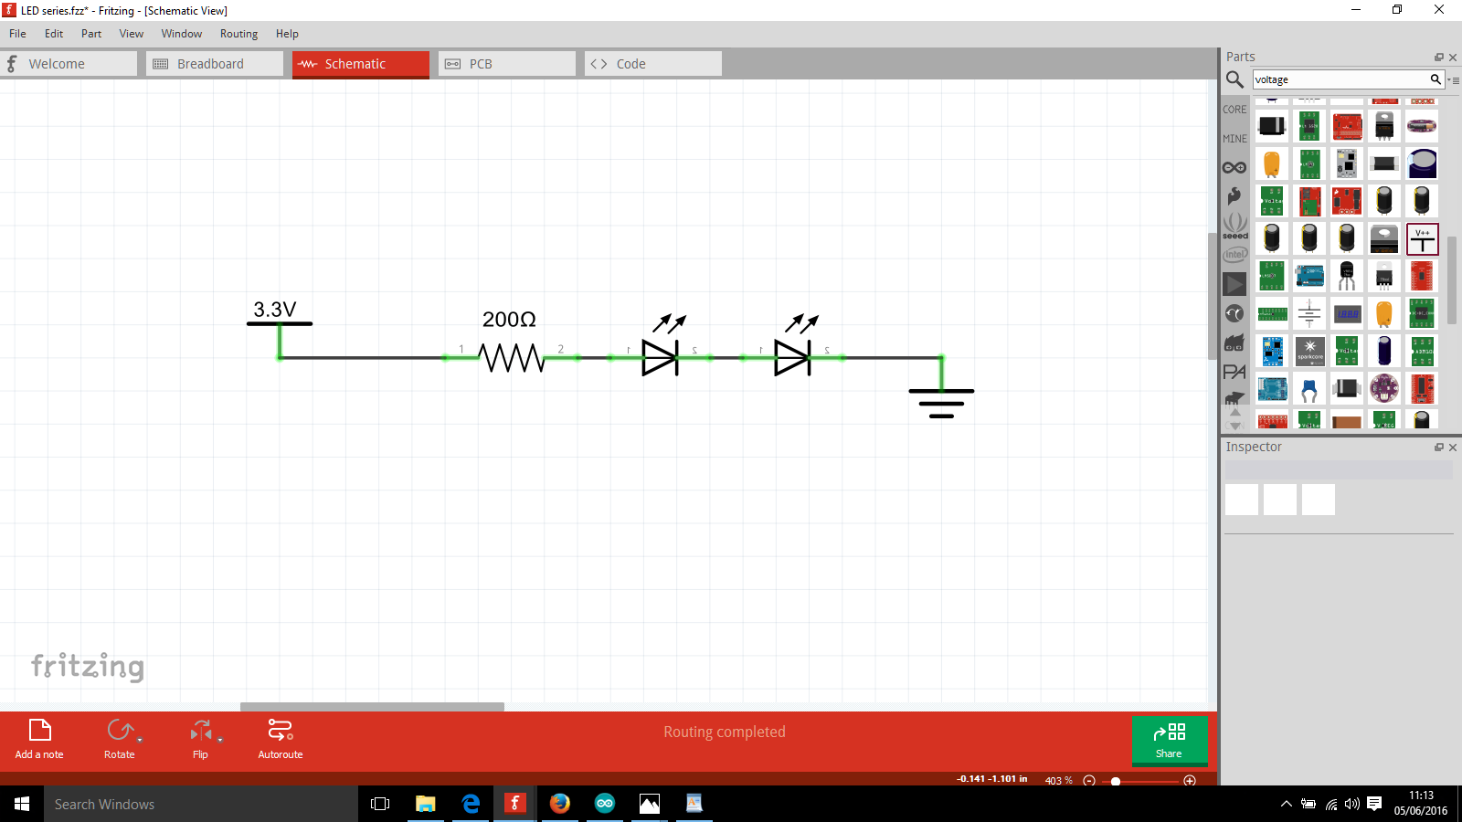

You should notice that the LED’s aren’t quite as bright as before.

This is because in a series configuration the amount of current travelling through the circuit is the same for every component. The Voltage across each component is different.

**Activity 4: Build a Parallel circuit with 2 RED LEDs**

Equipment:

* Arduino UNO
* Breadboard
* Cables
* 2x 200Ω Resistor
* 2x RED LED

Assemble the circuit as shown below in the diagram on a breadboard. Notice that each LED has its own resistor. It would be easiest to start by doing activity 2 again, and then adding onto it.

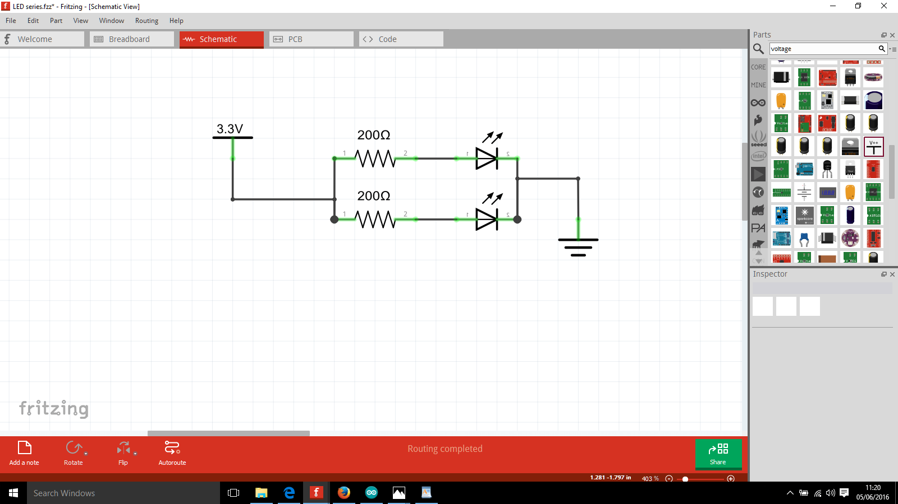

You should notice that the LED’s are equally as bright. The current across each component is different, and the voltage across each component area is the same.

**Basics: Arduino**

Arduino (sounds like arrr-dwee-no) is an open source microcontroller platform. It’s positive features are:

* Widely available
* Cheap (~£10 per board, £2 for cheap chinese clone)
* Easy to program
* **Lots of learning resources available**

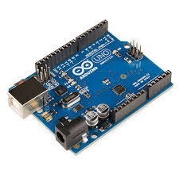

The program you use it with is called the Arduino Integrated Development Environment (IDE), to refer to it you could say “*arduino program”* or *“arduino IDE”*.

You write your code in the arduino IDE in file types called “*sketches”*. You write your code in the sketches and move them onto the arduino.

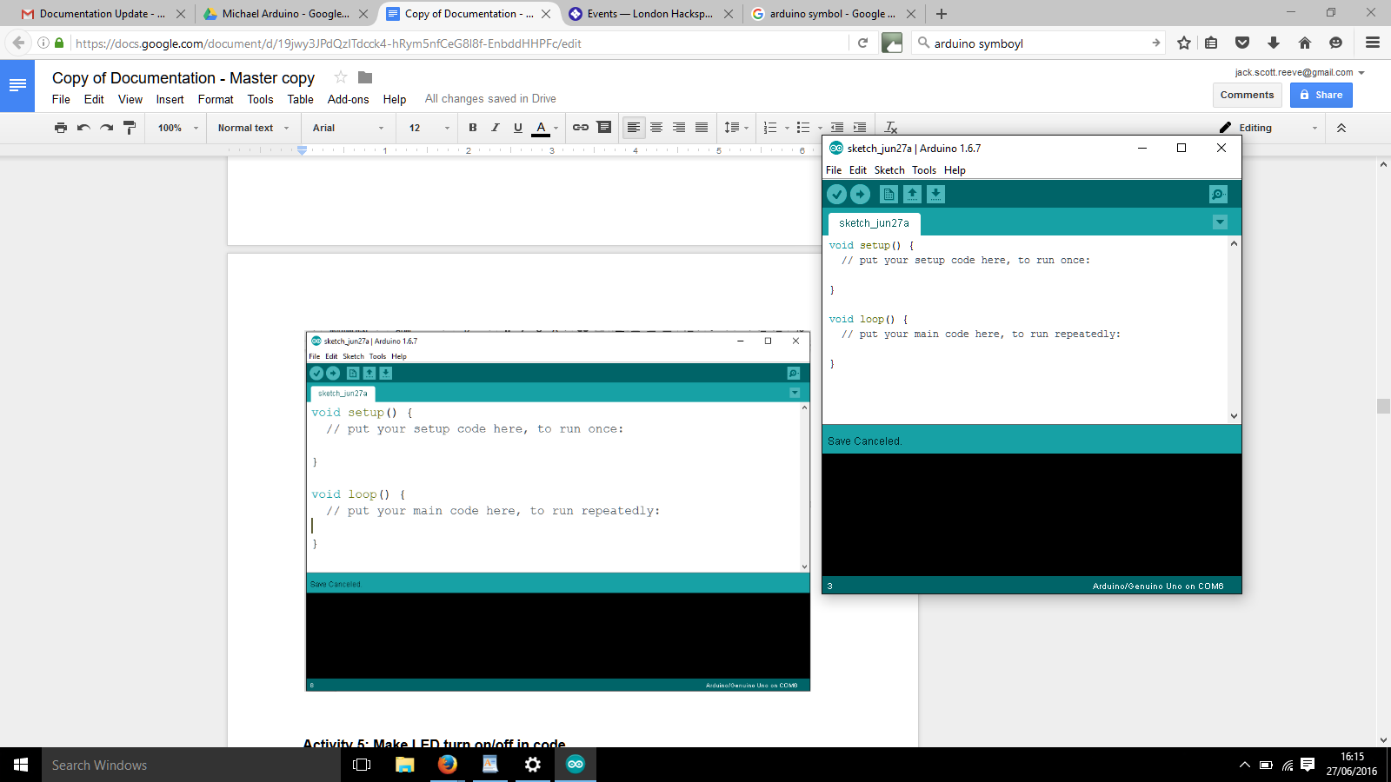

A default sketch looks like the above, and is by default saved with the name relating to the date.

There are two methods, titled **setup** and **loop**. They are both literally named - setup’s purpose is to setup what you are doing, and loop’s purpose is to loop and keep doing it forever.

The programming language you will be using is called ‘C’ (it's actually a slight variation of the standard C to make it easier). It is similar in many ways to Python, but subtly different in others. Note that in C, the indentation is only included to make it easy to read, it doesn’t have any programming effect like in Python.

**Configuring the Arduino IDE to work with the Arduino Uno**

The Arduino IDE will work with any Arduino, but you have to set it up right.

To set up with the correct Board:

* Locate the Arduino Menu at the top of the Arduino IDE
* Select Tools
* Select Board: “Arduino / Genuino Uno”
* Select Arduino / Genuino Uno

To set up with the correct Port:

* Plug the USB cable into the arduino and into your laptop
* Select Tools
* Select Port
* Select COM …. (this depends on which COM port appears)

To set up with the correct Programmer

* Locate the Arduino Menu at the top of the Arduino IDE
* Select Tools
* Select Programmer “AVRISP mkII”

**Writing code and getting it onto the Arduino UNO**

The steps we need to do here are:

1. Write the Code
2. Verify the Code
3. Upload the Code

When you upload the code, it is running on the Arduino Uno. There is no additional step to run the code.

In writing your code you can check that it makes sense by pressing the Verify button. Think of it as pressing a spell checker.

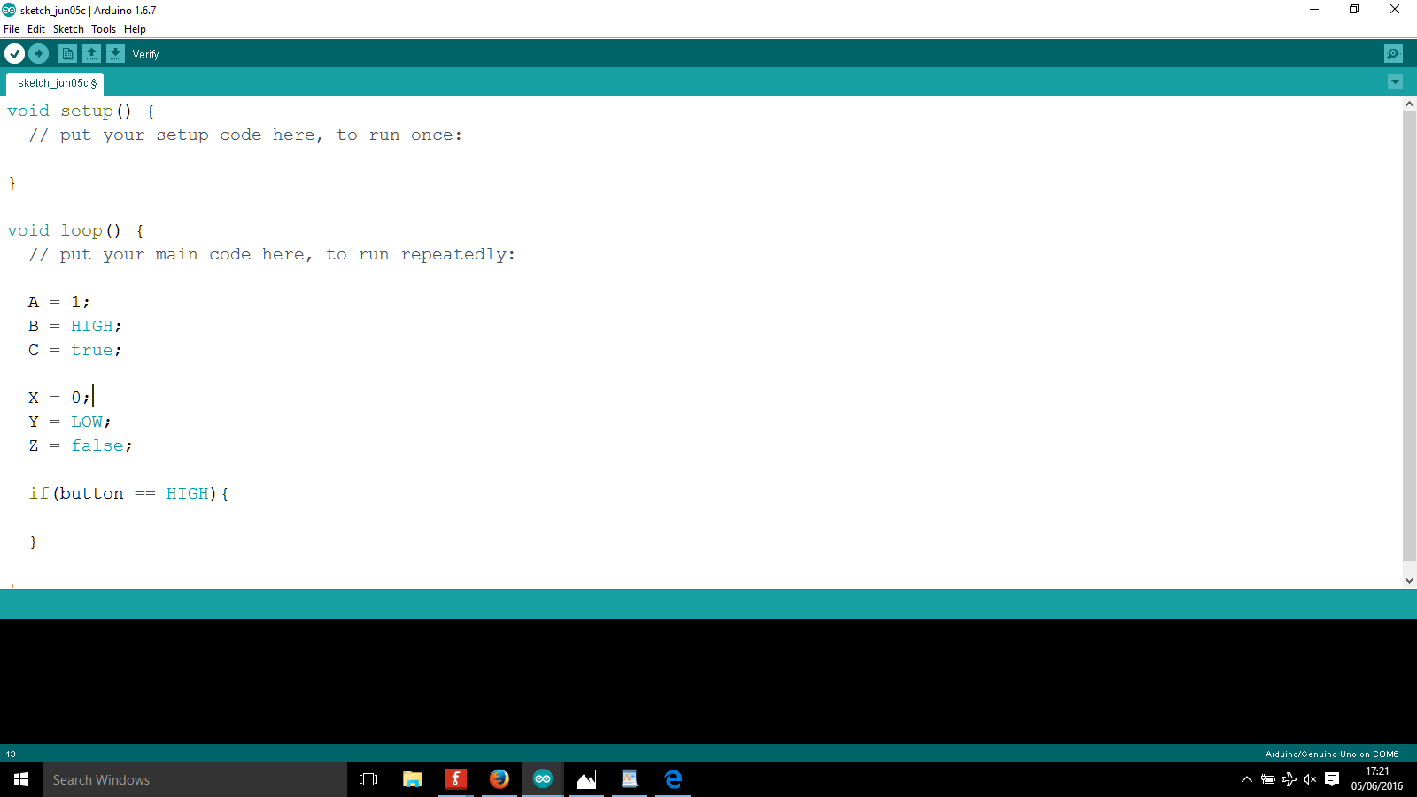

The first time pressing the Verify or Upload button on a sketch will prompt the arduino IDE to ask you to save the file. Give it a more memorable name than the default sketch_date it gives you (something more specific than vague like james_activity_5).

You will find that your code will rarely work first time! This is perfectly normal. When you are writing code, it doesn’t work 98% of the time and you just have to tweak it until it does.

The Error Console tells you what mistakes you have made through error messages. Honestly, the error messages can seem a bit cryptic at first but with experience you will understand what they mean and where exactly the problem is in your code.

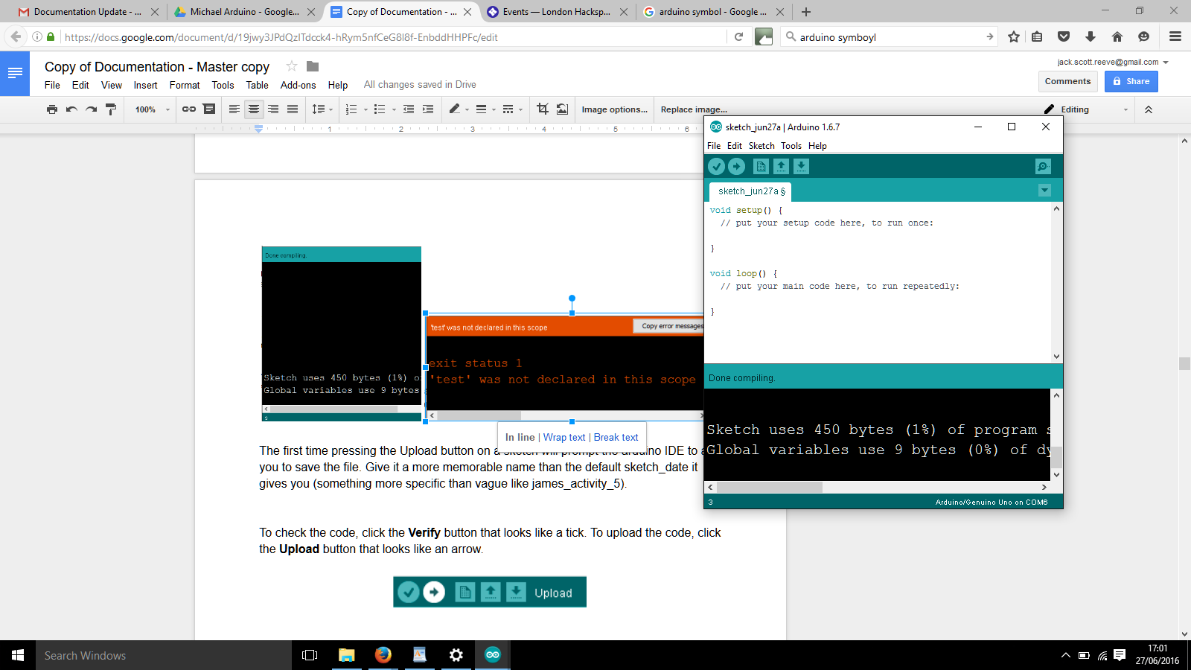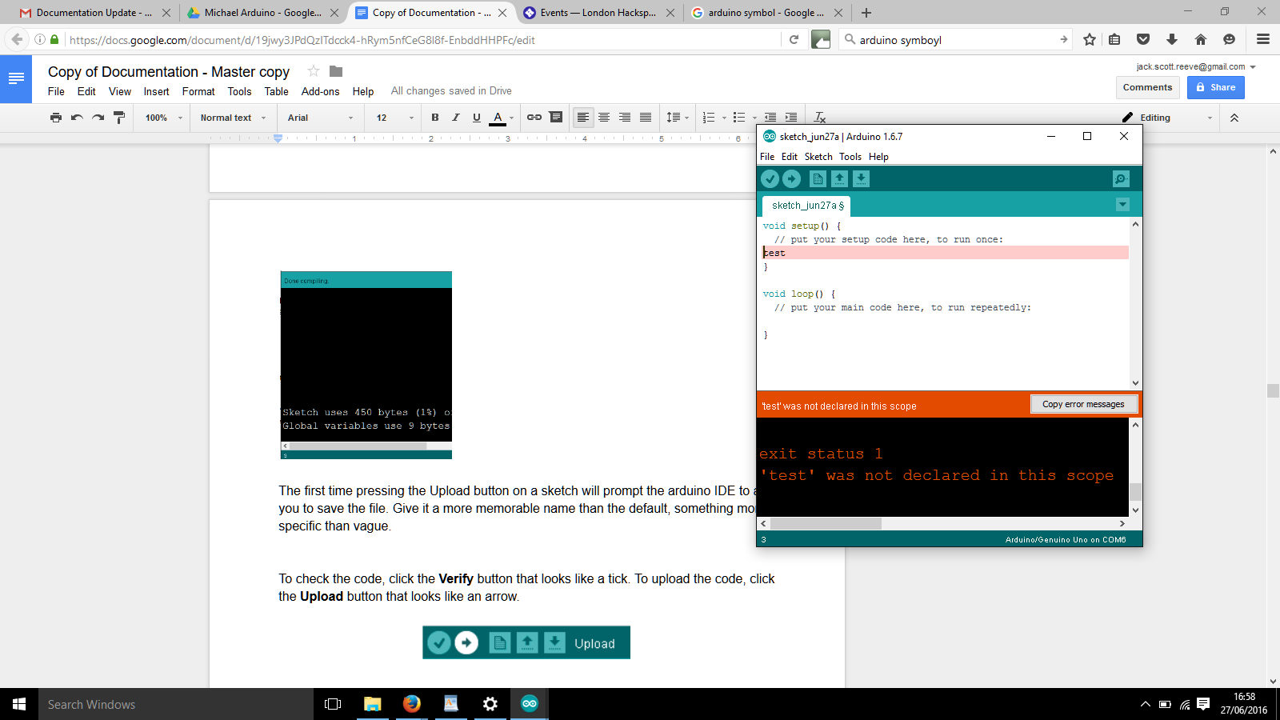

If the code you checked was OK, The Error Console with have a blue bar at the top with text stating “Done Compiling” and the text inside the Error Console will be white in colour. If it was not OK, it will have an orange bar at the top with text stating an error and the text inside will be orange in colour. We’ll look at an example error in detail below.

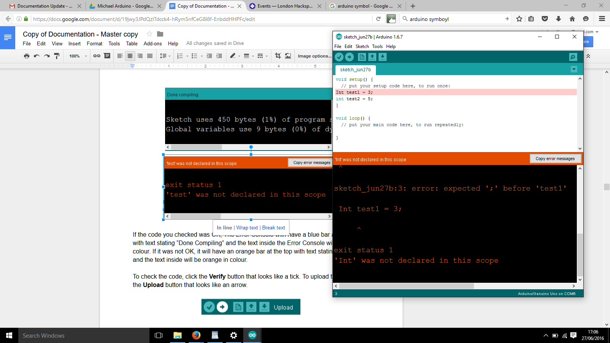

In this scenario I have written the code in the top, pressed verify and the output was the above screenshot. I read the message in the orange bar stating that “‘Int’ was not declared in this scope. To fix this, I need to change the uppercase I to a lowercase i, so Int becomes int.

To upload the code, click the **Upload** button that looks like an arrow.

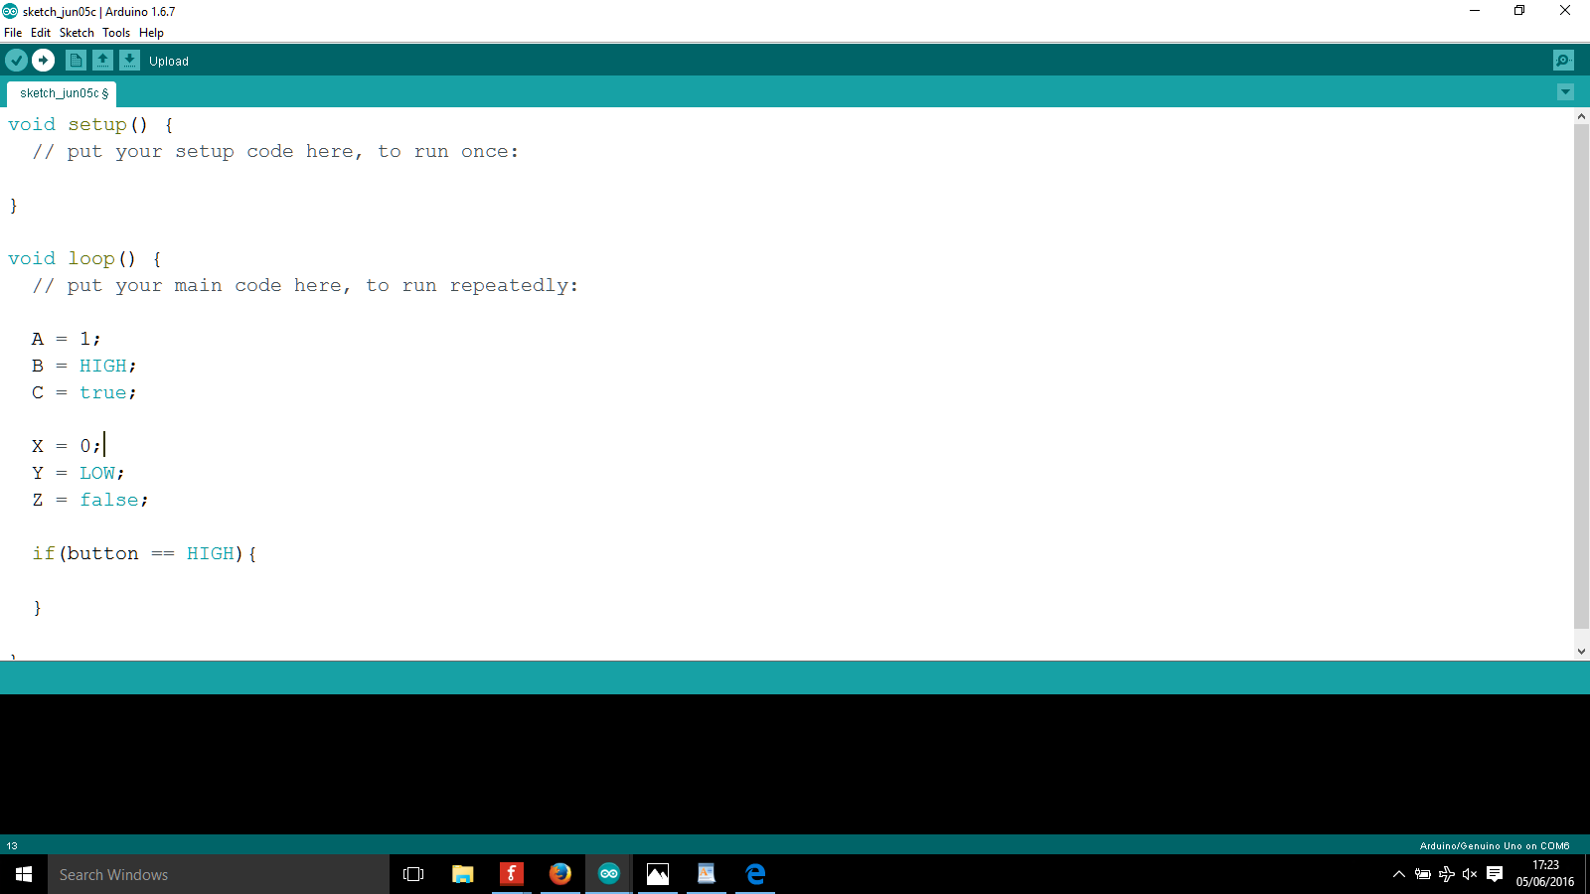

Uploading code can and will give error messages sometimes. The fixes are usually very simple, follow these steps:

1. Check that the USB cable is properly plugged into the Arduino UNO and your computer
2. Check that the COM port is configured correctly
3. Close the program, unplug the Arduino and try again

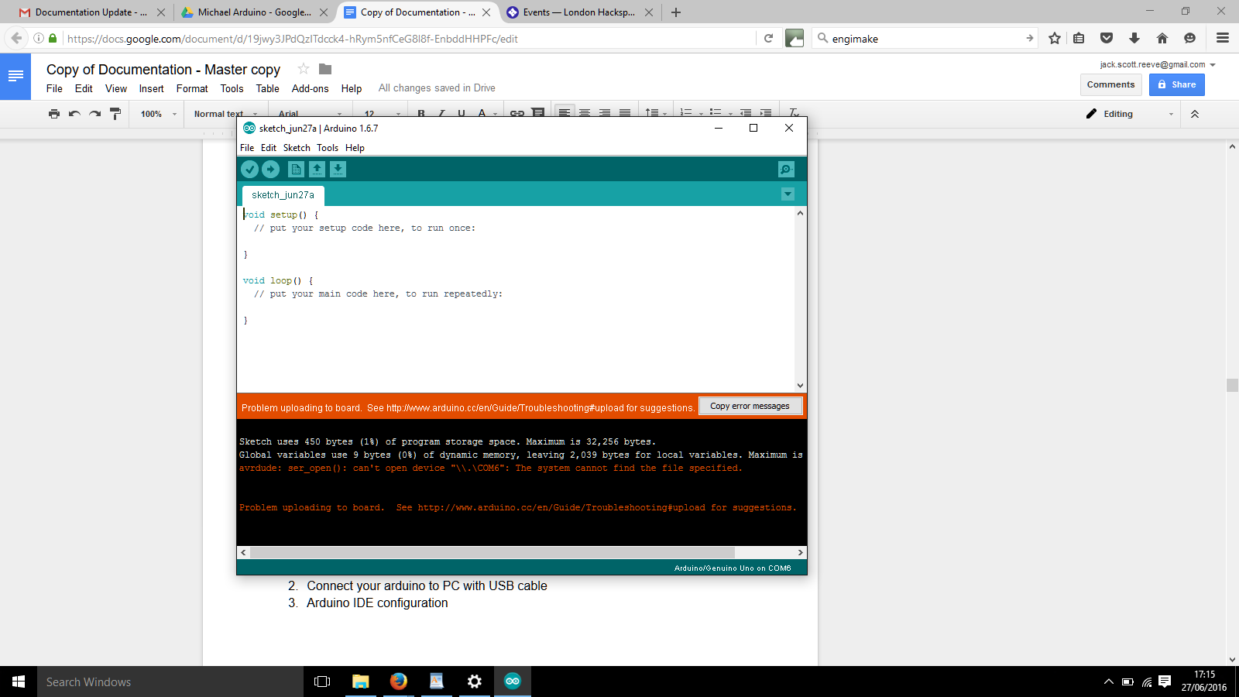

In the error message above, the error message …...COM6….tells us that there is a problem with the connection from the arduino to the computer. Try the routine stated above.

**Summary of how to program the Arduino Uno**

1. Connect your arduino to PC with USB cable
2. Write your code
3. Verify it
4. Arduino IDE configuration
   1. Board (Arduino Uno/Genuino Uno)
   2. Port (depends on what is connected)
   3. Programmer (AVRISP mkII)
5. Upload your code

|  |  |
| --- | --- |
| Tip X | *Keep getting errors in uploading the code? Check if your cable is plugged into the arduino and the computer. Check if the correct COM port is configured. Try a different COM port if it does not work.* |

**Activity 5: Make LED turn on/off in code**

Equipment:

* Arduino UNO
* Breadboard
* Cables
* 1x 200Ω Resistor
* 1x RED LED

Assemble the circuit on the breadboard as shown in the diagram below.

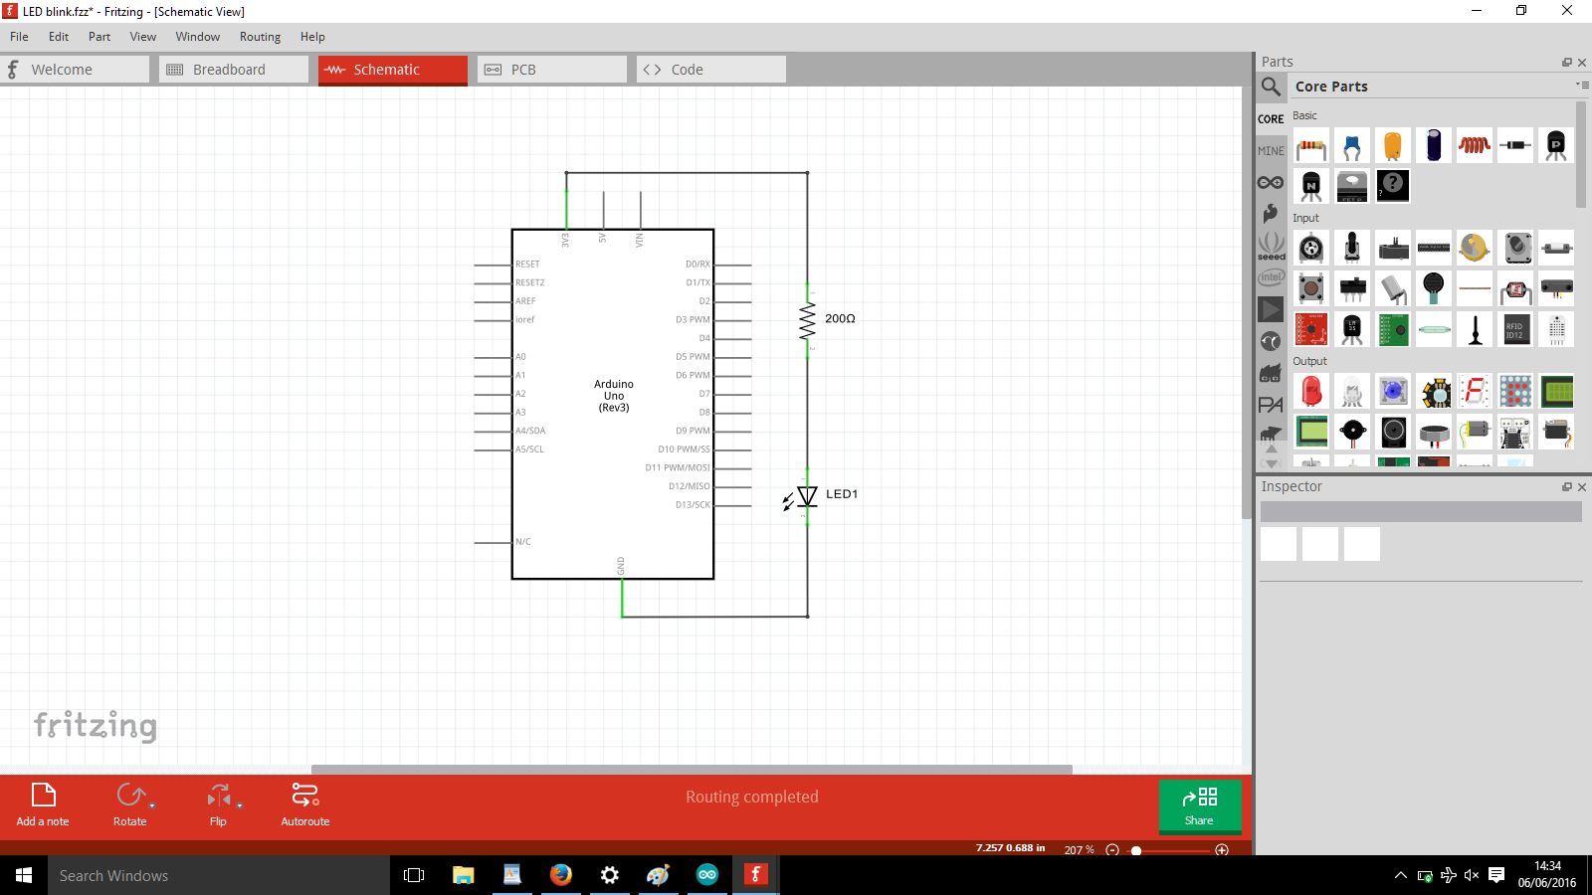

|  |  |
| --- | --- |
| **Tip 5** | *There are Input/Output pins of two types, Analog and Digital. A0 means Analog pin 0, D2 means Digital pin 2.* |

Start the Arduino program on your Computer. Input the code or load the sketch Mike_Blinksimple.

The programming language you will be using is called ‘C’. It is similar in many ways to Python, but subtly different in others. Note that the indentation is just to make it easy to read in C, it doesn’t have any programming effect.

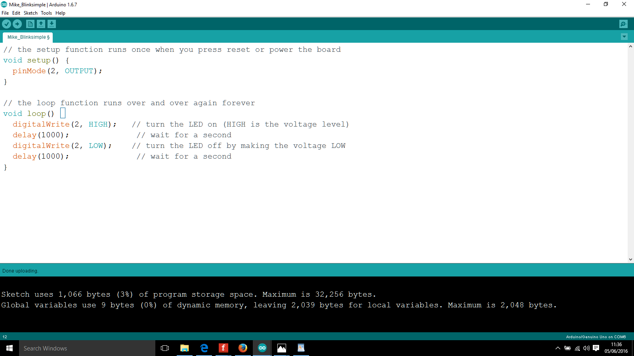

Explanation of code parts

**pinMode(2, OUTPUT);**

* Pin number 2 is configured as an OUTPUT

**digitalWrite(2,HIGH);**

* Write a digital value to pin number 2
* Write a HIGH value

**delay(1000);**

* Wait for 1000ms before doing the next line of code

To check the code, click the Verify button that looks like a tick. To upload the code, click the button that looks like an arrow.



For your reference, the high and low sequence above could be drawn as:

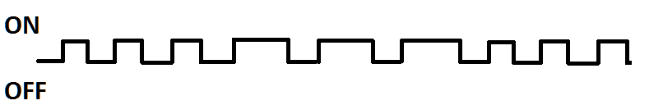

The result should be the LED turning ON for one second, then turning OFF for one second, then ON, then OFF…..etc.

**Activity 6: Make SOS signal**

An SOS signal is a cry for help. It’s an emergency code, simple to transmit and simple to understand. When the titanic was sinking, they were sending this code out.



The waveform would look like the following:



All on your own, implement a SOS signal using what you have learnt. You need to play with the delays. Its 3 short flashes, 3 long flashes and 3 short flashes.

**Digital Logic**

**Transistors**

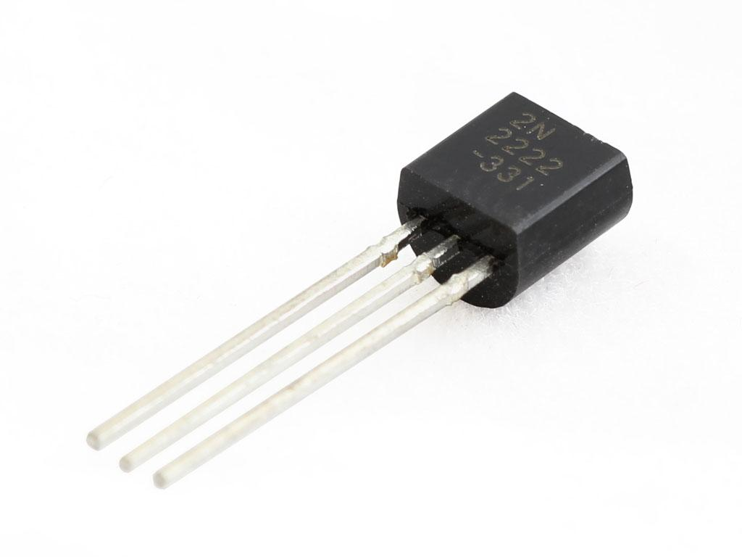

The transistor is a **very** special electronic component. Although it doesn’t look particularly interesting, it is probably the most important invention of the 20th century. It enabled the rapid development of computers from the primitive circuits before 1947 to the technology of 2016. A single transistor was bought for the equivalent of £35 in 1955 to make a hobbyist radio set with, today you will get 1,400,000,000 for £35.

**What are transistors used for?**

They can either be packaged fairly large in single basic circuit components, or packaged very densely (think 1.4 billion+) for complex components like memory chips or computer processors. Transistors basically underpin:

* Mobile Phones
* Washing machines
* Trains
* Televisions
* Computers
* Car control systems
* Spaceships
* ….Everything!

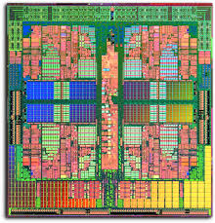 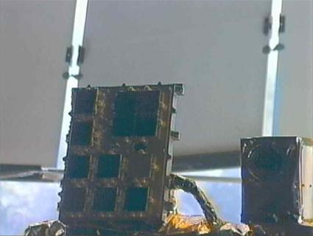

**How does a transistor work?**

* A transistor is like a switch inside a circuit
* It can control the voltage or current flow inside a circuit to make something further down the circuit ON or OFF
* You control the switch by sending a current/voltage
* It has three terminals, unlike resistors which have two terminals
  + Collector
  + Base
  + Emitter
* We are working with NPN transistors

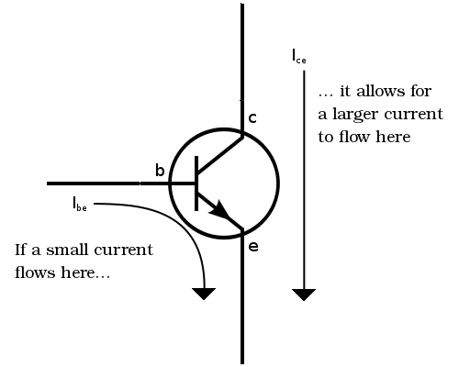

*In this diagram: C Collector, B Base, E Emitter*

A current IBE flowing from the base to the emitter “opens” the flow of current ICE from the collector to the emitter. The detailed chain of how you make this happen is:

* Apply a voltage of ~0.7V between the Base and Emitter
* Allows flow of current IBE from Base to Emitter
* Allows flow of current ICE from Collector to Emitter

***BASICALLY: Use the Base to control current flow ON or OFF from Collector to Emitter***

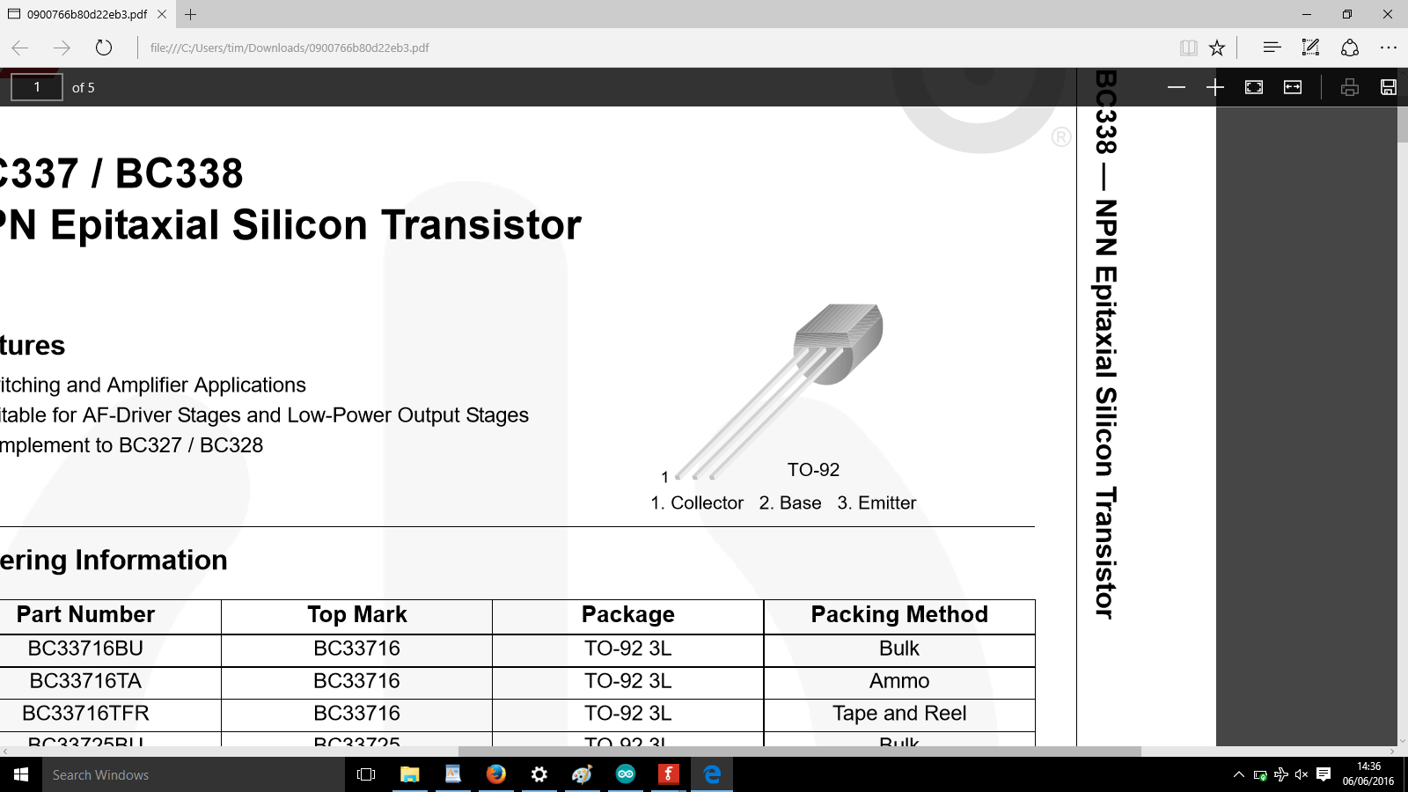

**How do you know which of three pins is the Collector, Base or Emitter?**

You check the datasheet for the component. You do this by:

* Find the part manufacturer code for the product (671-1116), usually on packet
* Search within the distributor (RS components in this case)
* Download the datasheet
* Read the datasheet and look for picture, diagram or labelling clues
* Make a note of it and double check against what you are doing

<http://docs-europe.electrocomponents.com/webdocs/0d22/0900766b80d22eb3.pdf>

**Very** important to get this connection right! Otherwise your transistor may get very hot and not work anymore!

**More complex details**

You don’t need to know any of this stuff at your level. But it may be good for a reference.

* A transistor is a semiconductor
* It contains n doped and p doped materials
* They come in several variants:
  + BJET, MOSFET
  + Subsets of these are NPN and PNP (to do with N and P doping)

**Truth Tables**

You just need to accept these truth tables as logical rules - they are the truth and are valid. Think how up is up or green is green - it just is.

* There are two inputs A, B
* The inputs can be high or low (1 or 0)
* There is one output Q
* The output can be high or low (1 or 0)

With two inputs in two states, you can have four combinations - 00, 01, 10, 11.

|  |  |
| --- | --- |
| **Tip 6** | *This 00, 01, 10, 11 is a* ***BINARY*** *sequence. If you wanted to write it in normal numbers that you are used to, it would be 0,1,2,3 .* |

You should memorise the AND, OR, NOT, NAND, NOR truth tables. If you remember the following as well, it makes it much easier to work with the truth tables.

* **AND**: only high in one case
* **OR:** high in three cases
* **NOT:** the opposite of the input
* **NAND:** the opposite output pattern AND
* **NOR:** the opposite output to OR

|  |  |  |  |
| --- | --- | --- | --- |
| **AND TRUTH TABLE** | | | |
| AND ANSI Labelled.svg | Inputs | | Output  **Q** |
| **A** | **B** |
| *0* | *0* | **0** |
| *0* | *1* | **0** |
| *1* | *0* | **0** |
| *1* | *1* | **1** |

|  |  |  |  |
| --- | --- | --- | --- |
| **OR TRUTH TABLE** | | | |
| OR ANSI Labelled.svg | Inputs | | Output  **Q** |
| **A** | **B** |
| *0* | *0* | **0** |
| *0* | *1* | **1** |
| *1* | *0* | **1** |
| *1* | *1* | **1** |

|  |  |  |  |
| --- | --- | --- | --- |
| **NOT TRUTH TABLE** | | | |
|  | Inputs | | Output $\underline{A}$ |
| **A** | |
| *0* | | **1** |
| *1* | | **0** |

|  |  |  |  |
| --- | --- | --- | --- |
| **NAND TRUTH TABLE** | | | |
| NAND ANSI Labelled.svg | Inputs | | Output  **Q** |
| **A** | **B** |
| *0* | *0* | **1** |
| *0* | *1* | **1** |
| *1* | *0* | **1** |
| *1* | *1* | **0** |

|  |  |  |  |
| --- | --- | --- | --- |
| **NOR TRUTH TABLE** | | | |
| NOR ANSI Labelled.svg | Inputs | | Output  **Q** |
| **A** | **B** |
| *0* | *0* | **1** |
| *0* | *1* | **0** |
| *1* | *0* | **0** |
| *1* | *1* | **0** |

**Activity 7: Build AND circuit**

Equipment:

* Arduino UNO
* Breadboard
* Cables
* 1 x RED LED
* 1 x 220Ω Resistor
* 2 x Push Button

Assemble the circuit as shown in the diagram. When connected properly. It should behave as seen in the AND truth table and the LED should light up only when both push buttons are pressed.

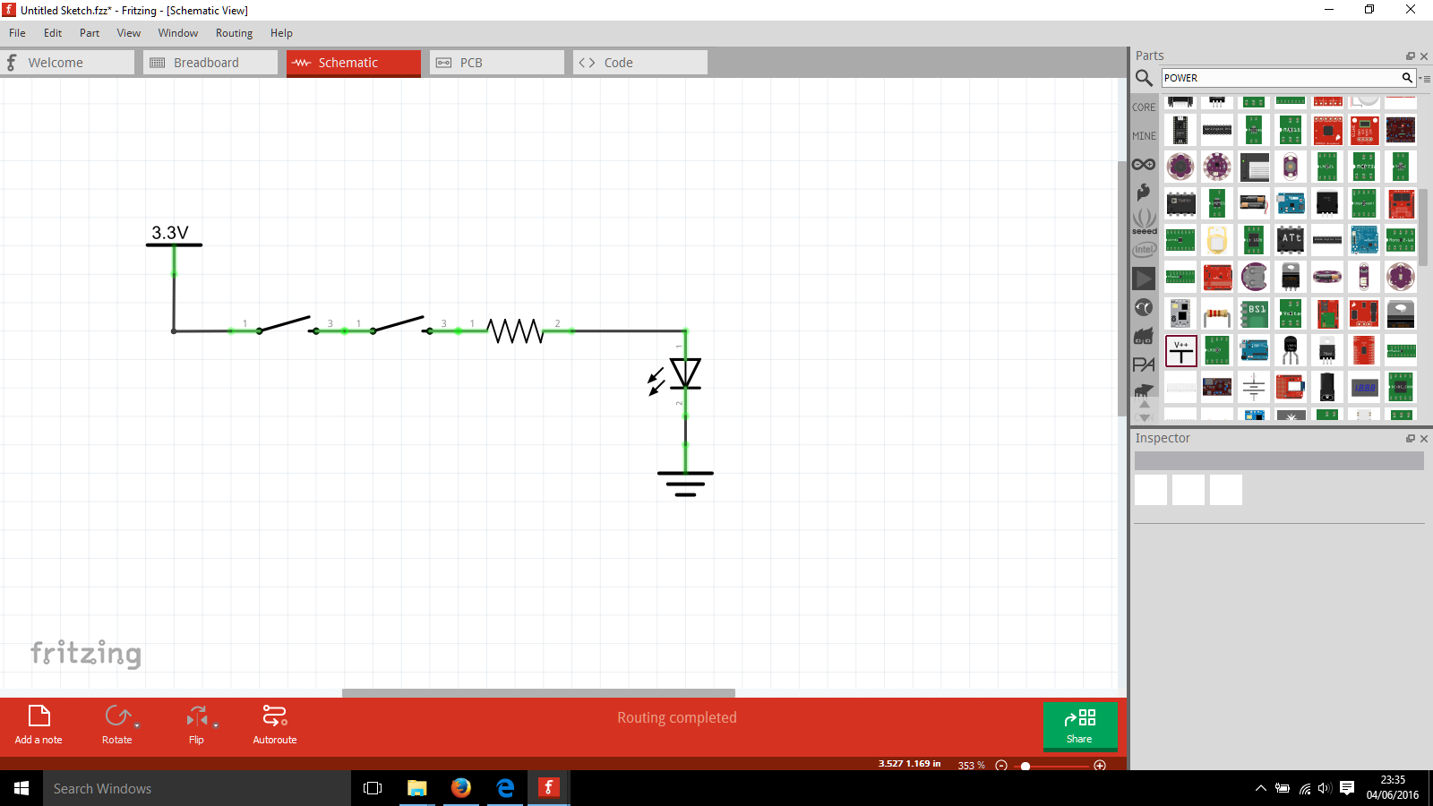

Notes about push buttons

The diagram of the push button is a simplification of the real push button component you have available. In the diagram it has 2 connections, the real one has 4 connections. It can be confusing and easy to make a mistake so what you should do is:

* Pay attention to which side the metal connections are sticking out from the push button
* Ignore one side of connections (ignore 2 of the 4 connections) - DO NOT place connections on both sides
* Mount the switches along the middle of the breadboard

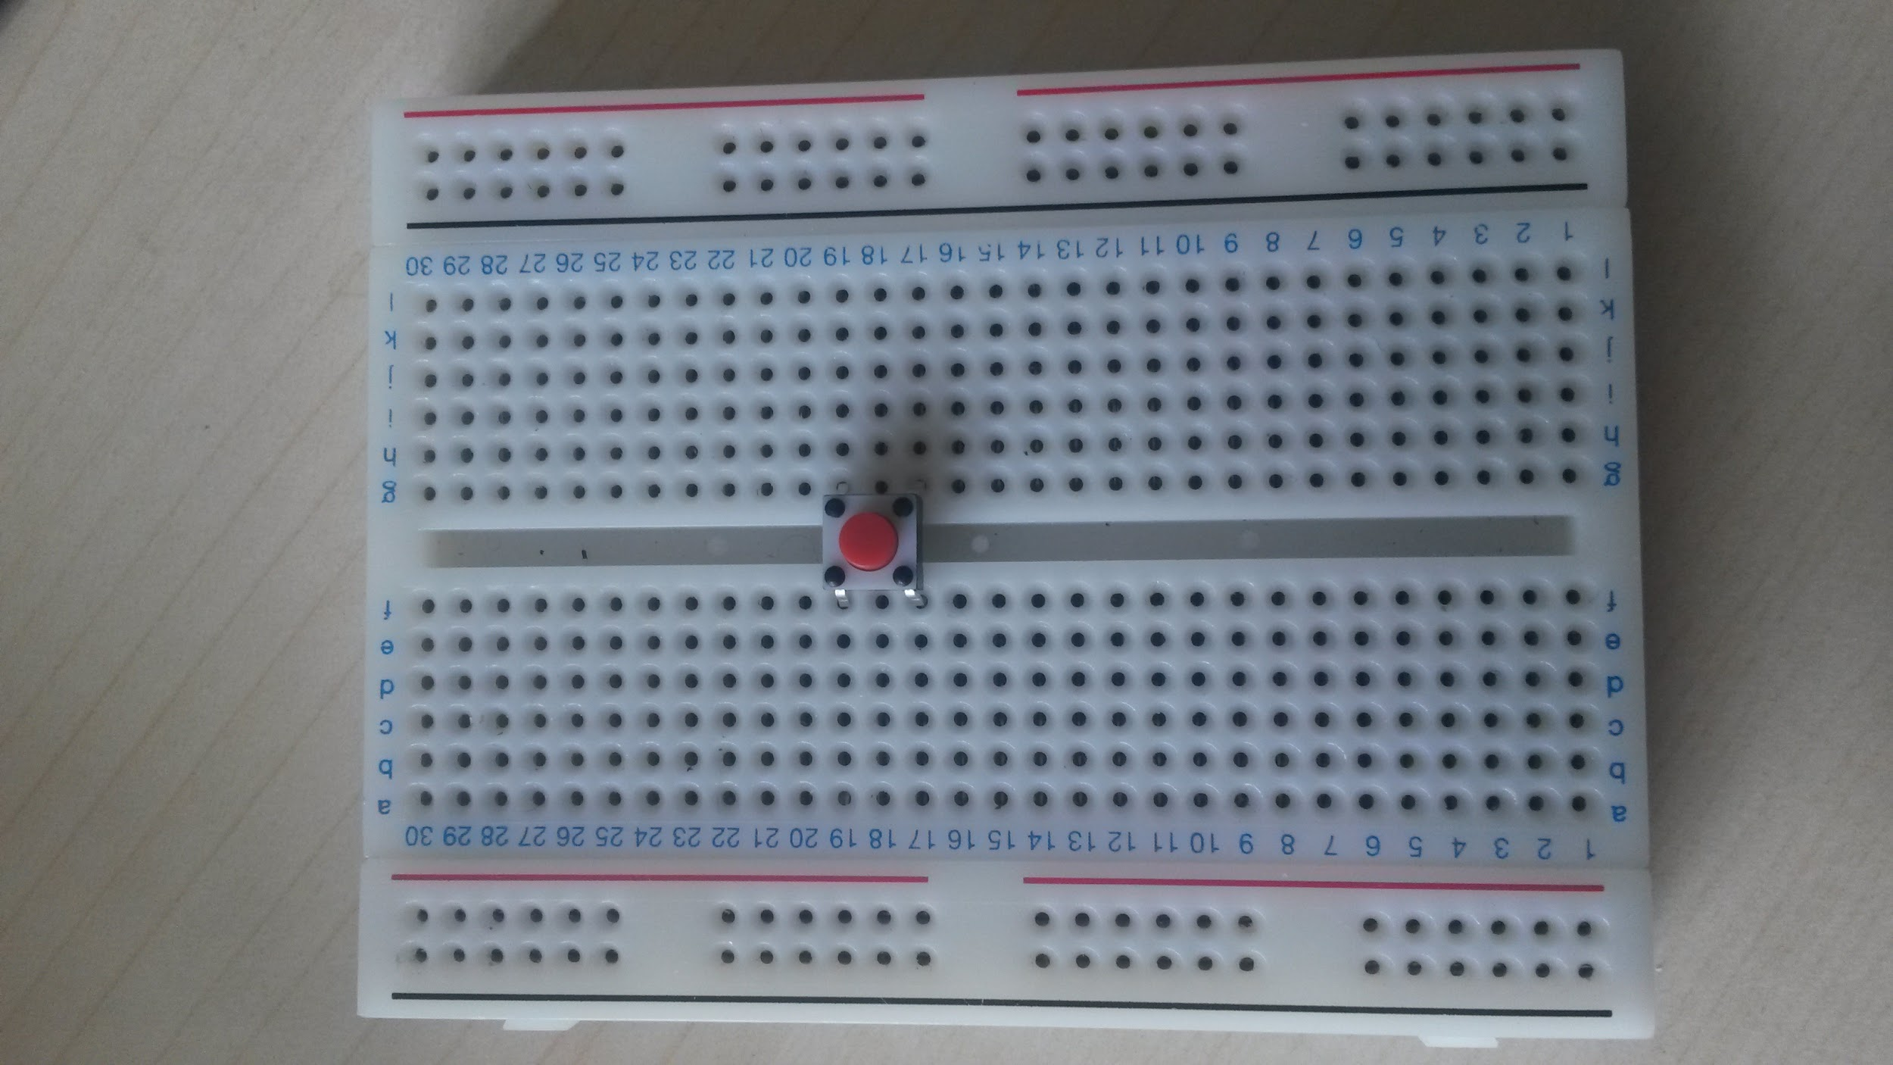 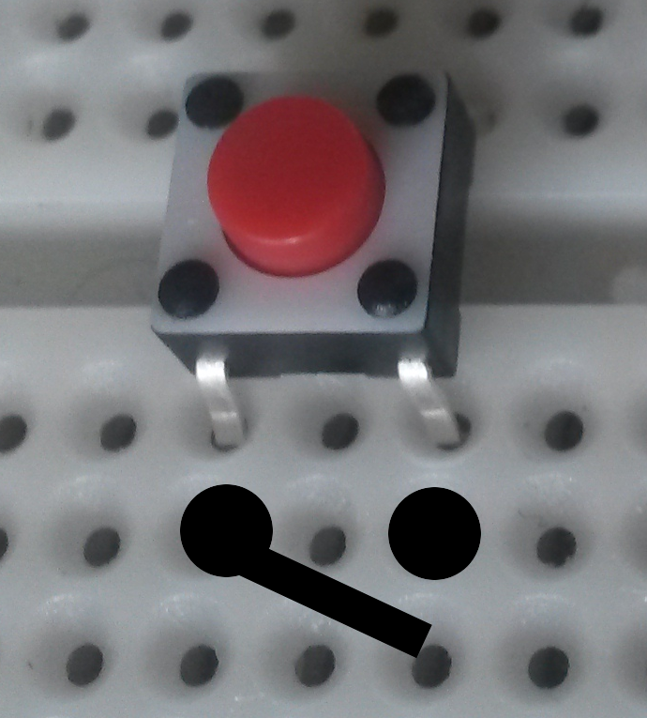

**Activity 8: Build OR circuit**

Equipment:

* Arduino UNO
* Breadboard
* Cables
* 2 x Push Button
* 1 x RED LED
* 1 x 220Ω Resistor

Assemble the circuit as shown in the diagram. When connected properly. It should behave as seen in the OR truth table and the LED should be lit when button 1 or 2 is pressed alone, or if button 1 & 2 are pressed together.

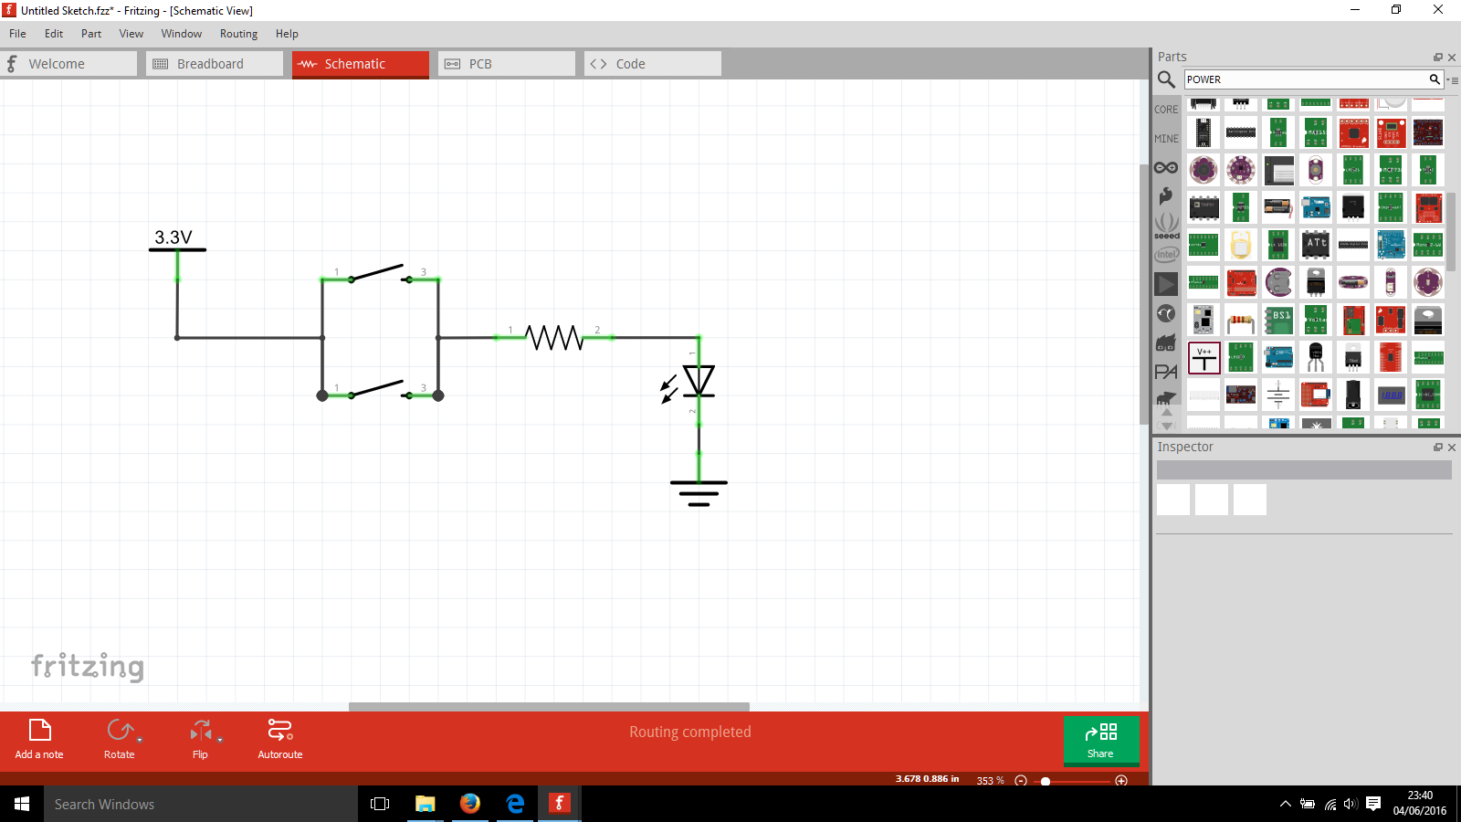

**Activity 9: Build NOT circuit**

* Arduino UNO
* Breadboard
* Cables
* 1 x Push Button
* 1 x RED LED
* 1 x Transistor
* 2 x 1kΩ Resistor

Assemble the circuit as shown in the diagram. When connected properly. It should behave as seen in the NOT truth table and the LED should be lit when the button is not pressed and unlit when the button is pressed.

|  |  |
| --- | --- |
| **Tip 7** | *Make it easy for yourself - start by making the half of the circuit with the LED in. Verify that the LED lights up, then add the other half with the switch and the transistor in.* |
| **Tip 8** | *Check which pins are Base, Collector, Emitter by referring to the transistor explanation page.* |

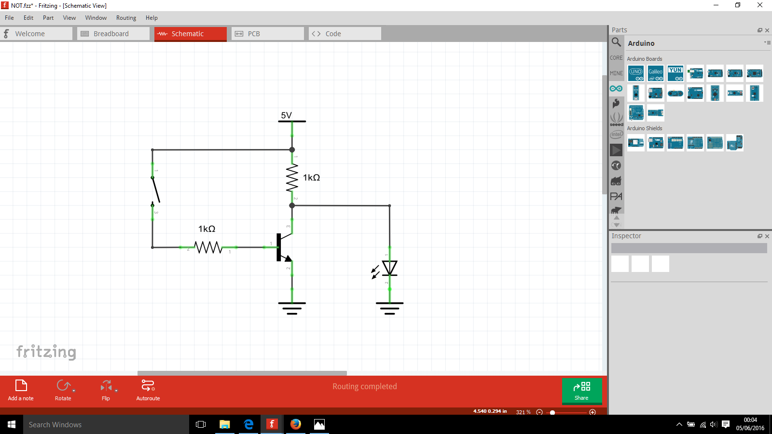

***Please note that the numbers you see on the circuit diagram above are not related to the Base, Emitter, Collector configuration from the transistor explanation / datasheet.***

Notes about transistors

Make it easy for yourself by putting it in the breadboard in the following orientation:

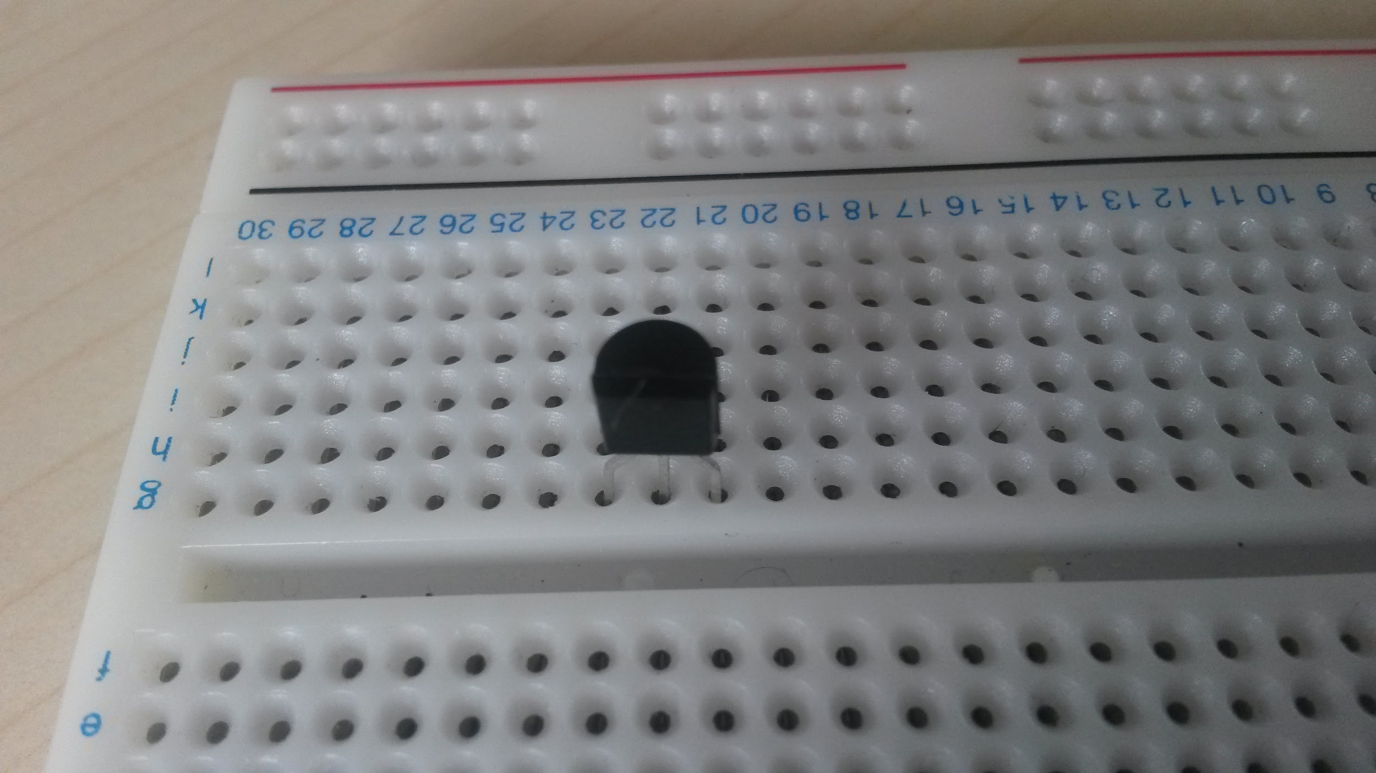 



**Activity 10: Build NAND circuit**

Equipment:

* Arduino UNO
* Breadboard
* Cables
* 1 x Push Button
* 1 x RED LED
* 2 x Transistor
* 3 x 1kΩ Resistor

Assemble the circuit on the breadboard as shown in the diagram below.

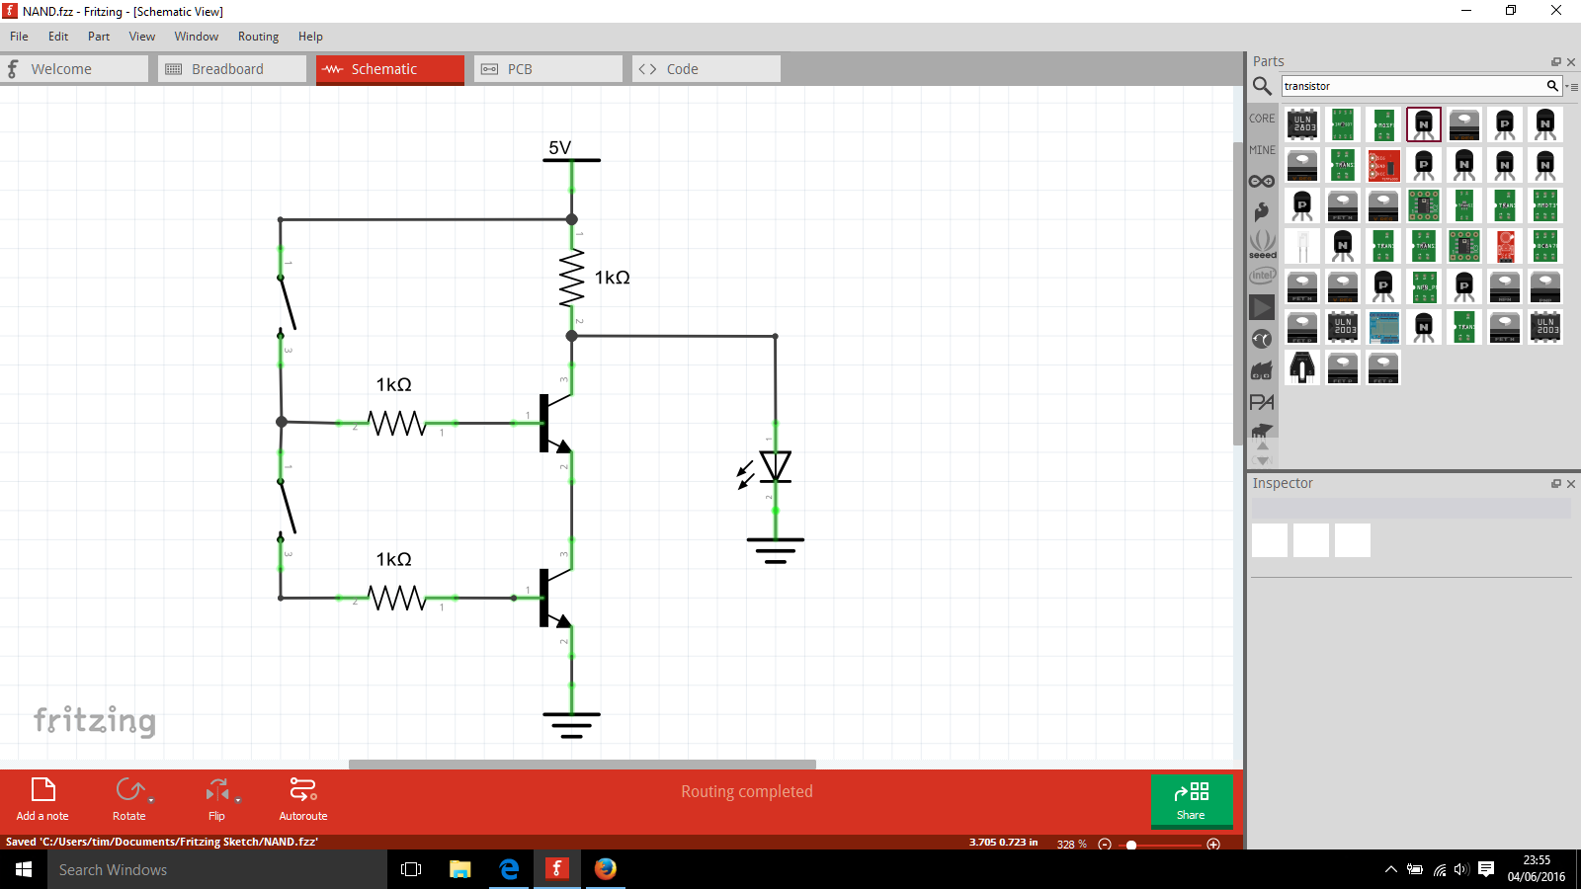

When connected properly. It should behave as seen in the NAND truth table and the LED should only be unlit when both buttons are pressed.

**Why does the LED turn off when I press the switch down?**

Because current always follows the path of least resistance (see image of lightning). When the switch is open, the transistor gate is closed and current cannot flow through the transistor to ground, so it flows through the path of least resistance which is through the LED to ground.

When the switch is pressed down, current flows to the base of the transistor. This current at the base opens the gate for the current to flow from the collector to emitter. Now there is a path for the current to follow through the transistor to ground. There is less resistance to go ground through the transistor compared to the LED, so the current does not go through the LED and the LED does not light up.

**Activity 11: Build NOR circuit**

Equipment:

* Arduino UNO
* Breadboard
* Cables
* 1 x Push Button
* 1 x RED LED
* 2 x Transistor
* 3 x 1kΩ Resistor

Assemble the circuit as shown in the diagram. When connected properly. It should behave as seen in the NOR truth table and the LED should only be lit when both buttons are unpressed.

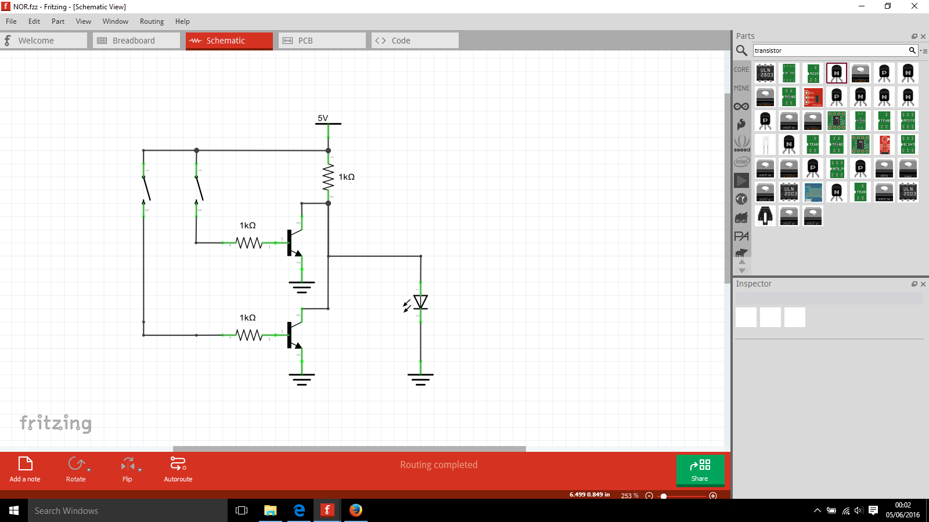

**Truth Explained**

|  |  |  |
| --- | --- | --- |
| **Type** | **ON** | **OFF** |
| BOOLEAN | *True* | *False* |
| CHARACTER | *HIGH* | *LOW* |
| BINARY | *1* | *0* |

These are all ways of expressing the same thing. In computer logic systems, at the most basic level, there is only two states that something can be in. Everything else more complicated is just built several layers on top of this.

In the following excerpt of arduino code, A = B = C and X = Y = Z

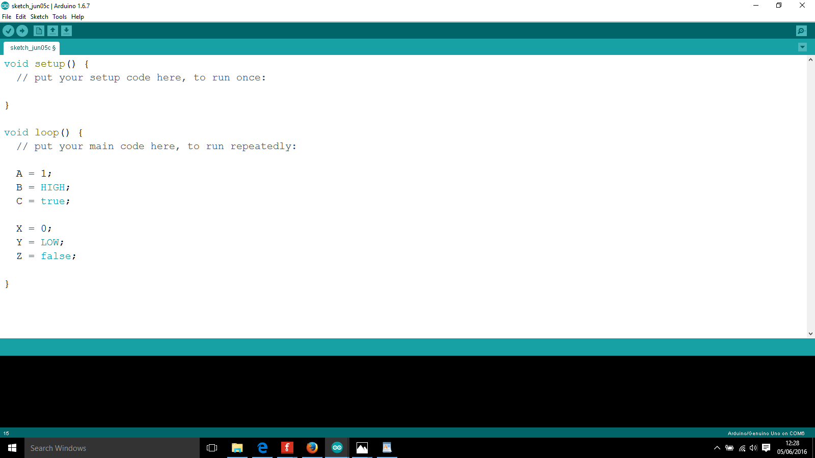

Digital pins are used with this kind of two state logic.

The typical convention is to set a **low** voltage level as GND, and a **high** voltage level as your reference (usually 5V or 3.3V).

You would use voltage levels in your logic for coding. For example, to check whether a button is pressed or unpressed:

if(button == HIGH){

//do something

}

**Basics: Coding**

This section is a reference for you on several coding techniques. You can look over it now, and come back to it when you need to for later exercises.

* For loop
* If / Else
* While loop
* Switch statement

**For Loop**

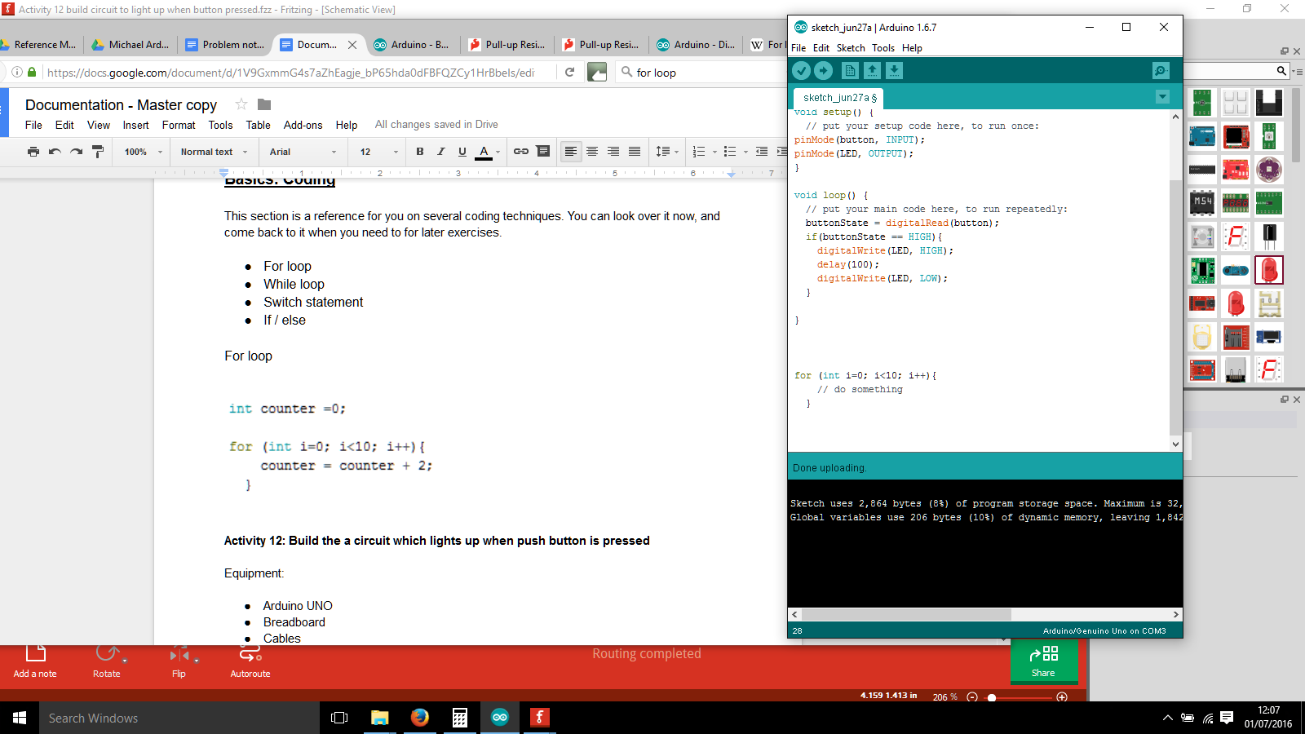

The **For** **Loop**, loops a certain number of time before it finishes. The above code shows the basic structure which would ‘do something’ ten times before finishing.

Breaking down what it is saying:

* Declare a temporary variable of type int named ‘i’, with value 0
* ‘i’ will stay less than the value 10
* Add 1 to i every time it gets to the end of the loop

The loop is set to run 10 times before it exits, and it knows it is at 10 because it is counting by checking the ‘i’ value. To help explain this, look at the example code below and the table:

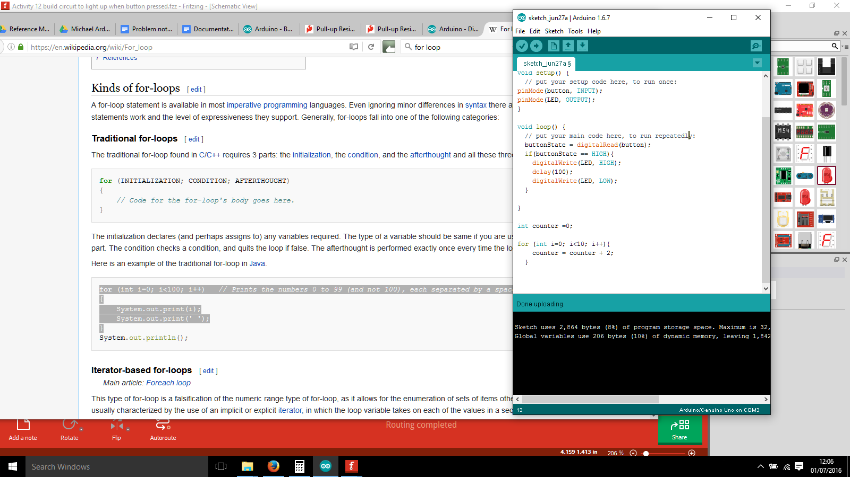

|  |  |  |
| --- | --- | --- |
| **Repetition Number** | **i value** | **counter value** |
| 1 | 0 | 2 |
| 2 | 1 | 4 |
| 3 | 2 | 6 |
| 4 | 3 | 8 |
| 5 | 4 | 10 |
| 6 | 5 | 12 |
| 7 | 6 | 14 |
| 8 | 7 | 16 |
| 9 | 8 | 18 |
| 10 | 9 | 20 |

**If/Else**

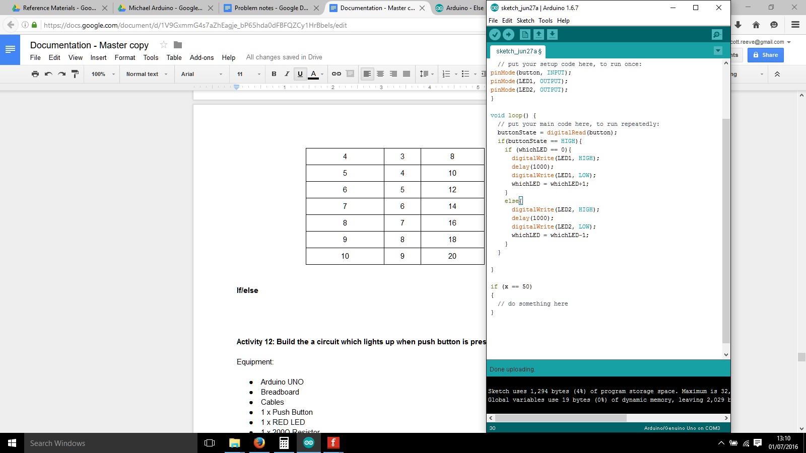

The **if** **statement** only executes if its conditions are met. In the case of the statement above, it would only execute if x had the value 50. The conditions are found in the curved brackets right after the word if, some explanations of the meaning are in the table below:

|  |  |  |
| --- | --- | --- |
| **Conditions** | **When will code execute** | **Example valid cases** |
| x == 50 | When x is equal to 50 | X = 50 only |
| x<50 | When x is less than 50 | X =-1,0,10,25,49... |
| x>50 | When x is greater than 50 | X = 51, 55, 10000... |

|  |  |
| --- | --- |
| **Tip 9** | *Double equals signs are used in the checking if statements, to assign a value you use a single equals sign* |

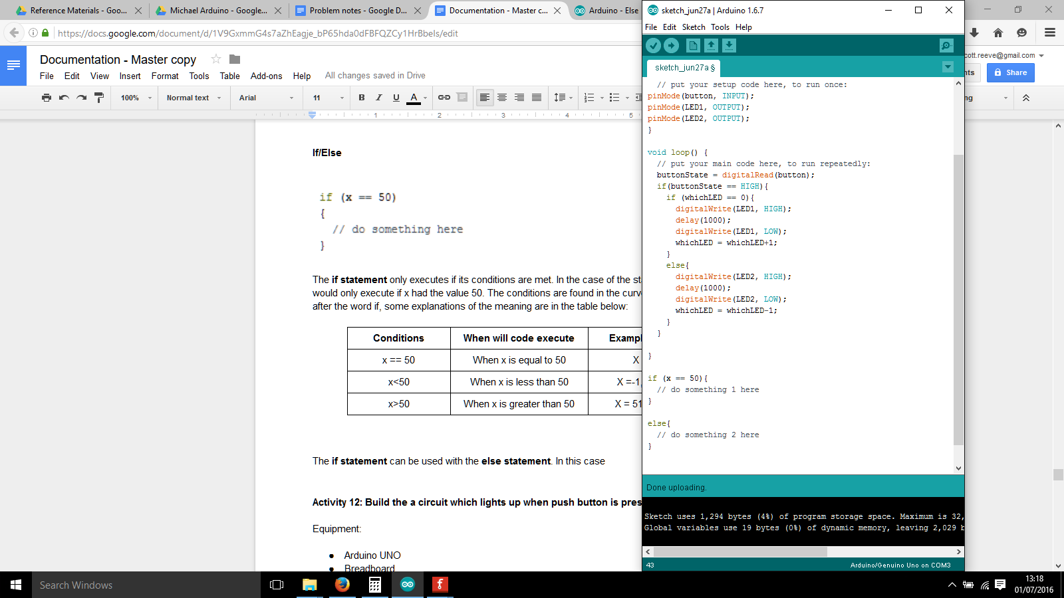

The **if statement** can be used with the **else statement**. If x = 50, then something 1 happens. If x = 35, then something 2 happens.

**Activity 12: Build the a circuit which lights up when push button is pressed**

Equipment:

* Arduino UNO
* Breadboard
* Cables
* 1 x Push Button
* 1 x RED LED
* 1 x 200Ω Resistor
* 1 x 1kΩ Resistor

Set the breadboard up with the following connections:

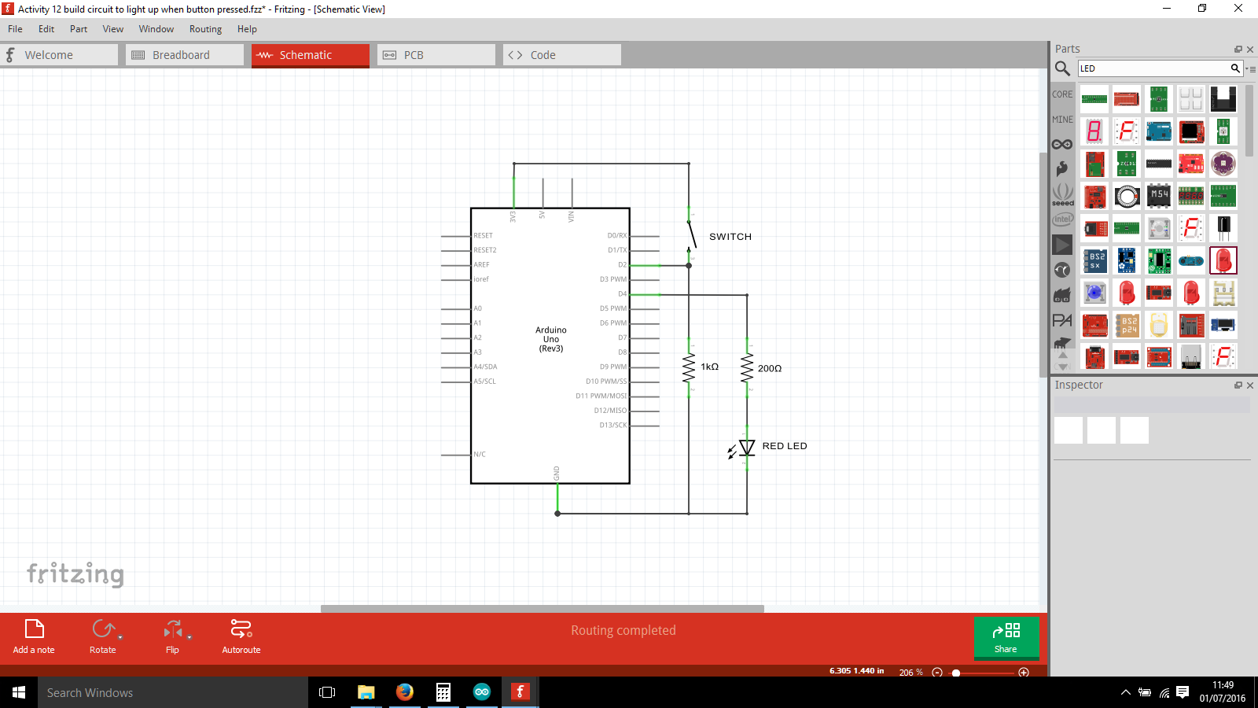

Write the following code in the arduino sketch:

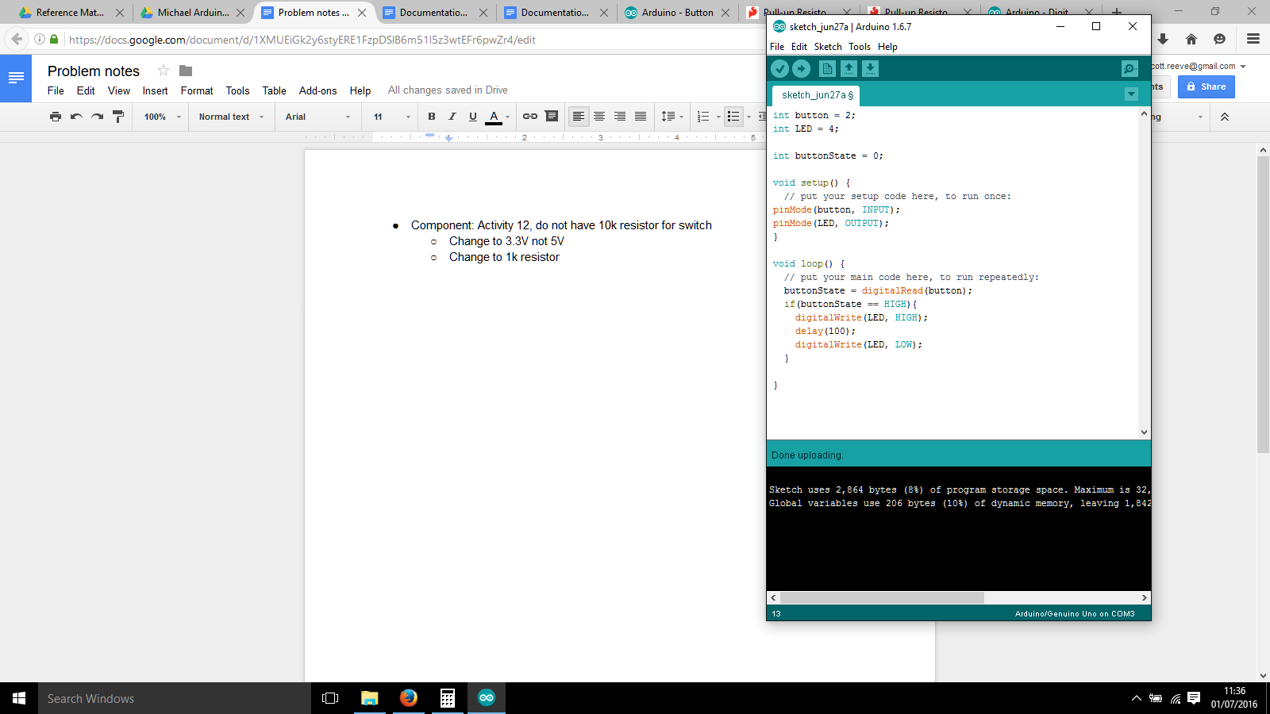

Explanation of code parts:

**buttonState = digitalRead(button);**

* Reads the digital value of ‘button’ (defined as pin 2)
* Saves the result of that into the variable ‘buttonState’

***Done correctly, this activity should result in the behaviour of the LED turning on for 1/10 second when the button is pressed.***

**Activity 13: Make LEDs light alternately on button push in code**

Equipment:

* Arduino UNO
* Breadboard
* Cables
* 1 x Push Button
* 2 x RED LED
* 2 x 200Ω Resistor
* 1 x 1kΩ Resistor

Set the breadboard up with the following connections:

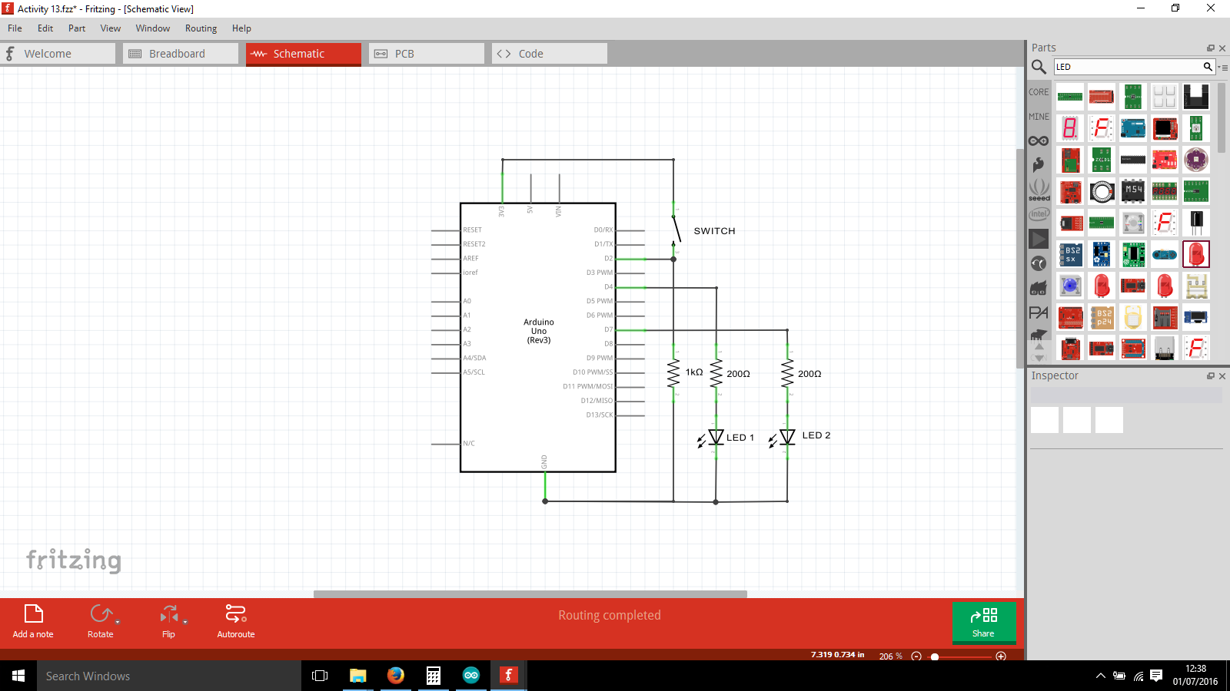

Write the following code in the arduino sketch:

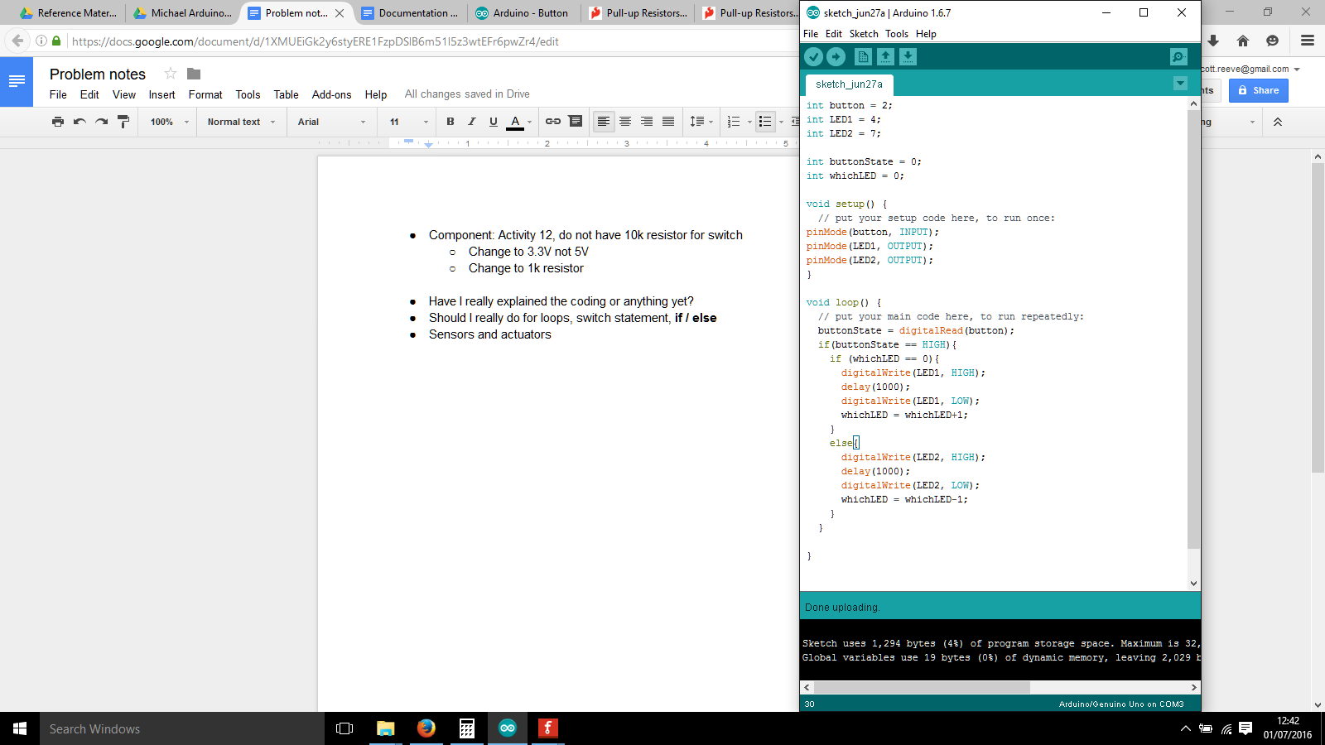

To get the behaviour we are looking for when pushing the button, only push it down for a little while (less than one second) otherwise it will flash alternately between the two. Try pushing the button down and holding it down, it will flash alternately between LED 1 and LED 2.

Explanation of code parts:

**whichLED = whichLED-1;**

* Take away 1 from the old whichLED
* Move this value into the new whichLED

Using whichLED = whichLED-1; and whichLED = whichLED+1; in the if/else statement ensures that the whichLED value will only change between 0 and 1.

***Done correctly, this activity should result in the behaviour of one LED 1 turning on only from a button push, next time the button is pushed LED 2 should turn on only, and next time LED 1 etc.***

**Light Dependant Resistors**

Resistance does not have to be a fixed value - it can vary in the circuit. One component that can vary it is the Light Dependant Resistor (LDR). It’s resistance decreases with increasing light sensitivity - or you could say that its resistance decreases as light increases on its surface.

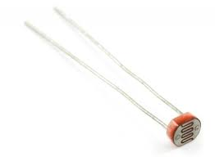

**Activity 14: Build a LED LDR circuit**

Equipment:

* Arduino UNO
* Breadboard
* Cables
* 1 x LDR
* 1 x RED LED

Assemble the circuit on the breadboard as shown in the circuit diagram below:

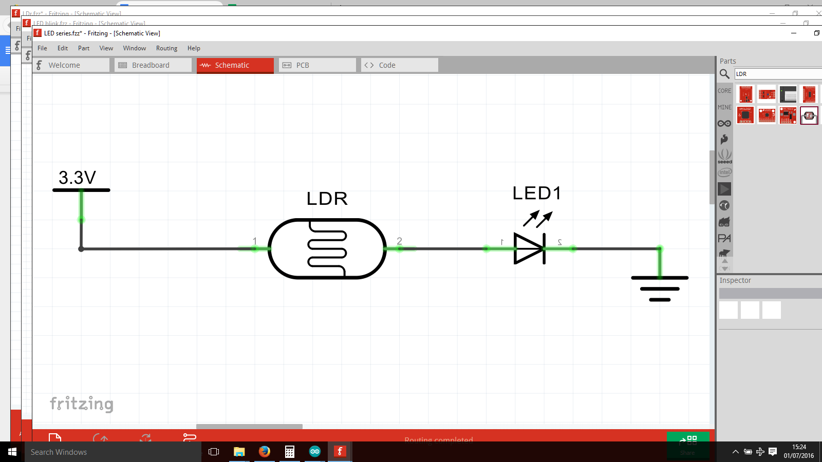

***You should find that if you put your finger over the LDR, the LED will get dimmer.***

**Digital Vs Analog**

There are two kinds of basic signals used to transmit information: Digital and Analog. They both encode information by varying amplitude over time to various degrees.

(Note that in UK English, it should be spelt as *Analogue.*However whenever you do coding, it will be in US English, *Analog*. Always write it as Analog, but in case you are doing an English exam, remember to spell it differently!).

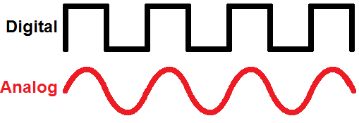

**Digital signals** are discrete - they have sharp angles, changing nearly instantaneously from

**Analog signals** are continuous - they have smooth angles, changing smoothly between values.

The Analog signal has more information inside it because there is more differences possible, there are many many levels at which they can be. For instance, in the example above the Digital Signal can only be 0 or 1, whereas the Analog signal can vary a lot in between 0 and 1

.

**ANALOG signal** **DIGITAL signal**

Sound waves are easy to relate to analog / digital signals. Old fashioned gramophone equipment produces sound by a needle scratching a disk - this is an analog signal. Mp3 players produce sound using digital electronics to make digital signals with voltage waveforms.

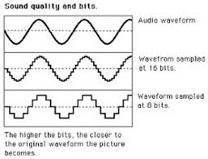

The number of samples per second is what makes a digital sound signal good or bad quality. The sample amount is measured in **bits**. The more bits you sample with, the more detail is in the digital signal. If you sample with 1 bit, you end up with the digital signal waveform at the start of the section, and when you increase the bits you change the signal.

**PWM explained**

For your purposes, you only really need to know that the PWM range you will be using ranges from 0 to 255, where 0 is fully OFF and 255 is fully ON

**Pulse-Width-Modulation (PWM)** is a more complicated method to communicate digital information. The normal way to communicate information is with 1 and 0, varying the sequence. PWM has another variable included, which is time. The PWM signal repeats a set pattern over and over again.

**Duty Cycle** is a way of expressing a ratio of how often the Pulse is HIGH compared to LOW. The maths would be ON/OFF.

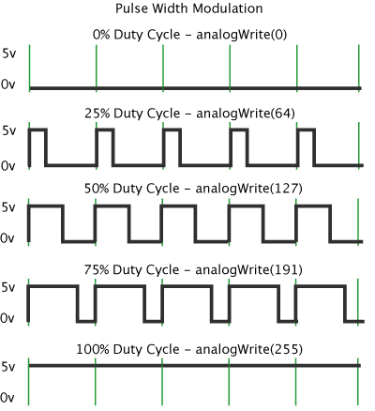

**Arduino pins: Analog and Digital**

*ANALOG IN: A0,A1,A2,A3,A4,A5*

Found on the bottom left side of the Arduino UNO, these pins are used to input Analog signals into the Arduino UNO. If you have an analog component such as an LDR which you would like to read the value of, you would connect it to one of these pins.

To read in analog signals you would use the function *analogRead*, as shown below:

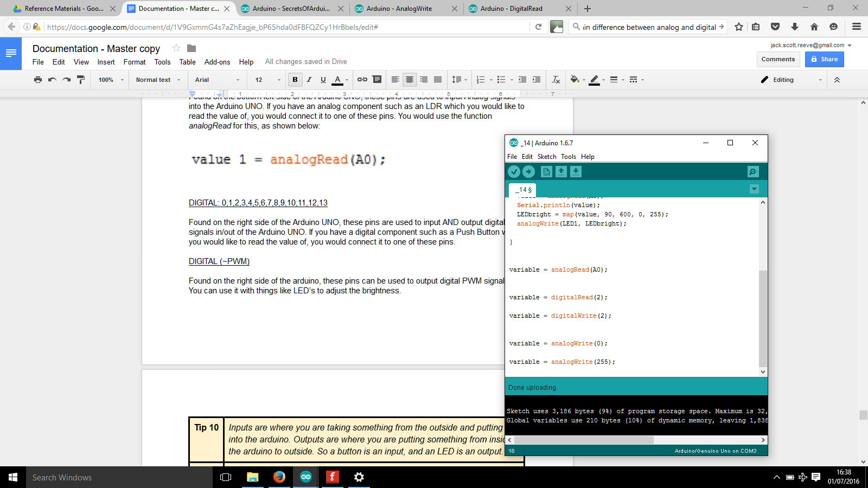

DIGITAL: 0,1,2,3,4,5,6,7,8,9,10,11,12,13

Found on the right side of the Arduino UNO, these pins are used to input AND output digital signals in/out of the Arduino UNO. If you have a digital component such as a Push Button which you would like to read the value of, you would connect it to one of these pins.

To input digital signals, such as a push button you would use the function *digitalRead.*



To output digital signals, such as turning an LED on or off, you would use the function *digitalWrite*.



DIGITAL (~PWM)

Found on the right side of the arduino, these pins can be used to output digital PWM signals. You can use it with things like LED’s to adjust the brightness between ON, dimmed and OFF. The valid range is typically 0 to 255.

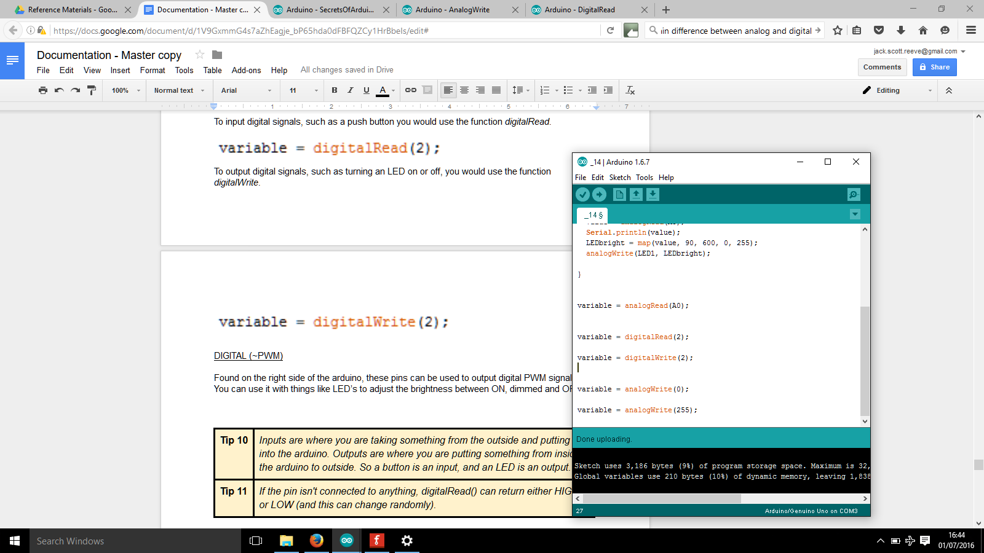

|  |  |
| --- | --- |
| **Tip 10** | *Inputs are where you are taking something from the outside and putting it into the arduino. Outputs are where you are putting something from inside the arduino to outside. So a button is an input, and an LED is an output.* |
| **Tip 11** | *If the pin isn't connected to anything, digitalRead() can return either HIGH or LOW (and this can change randomly).* |

**Activity 15: Build and program a LDR circuit**

Equipment:

* Arduino UNO
* Breadboard
* Cables
* 1 x 1kΩ Resistor
* 1 x LDR

Assemble the circuit on the breadboard as shown in the circuit diagram below:

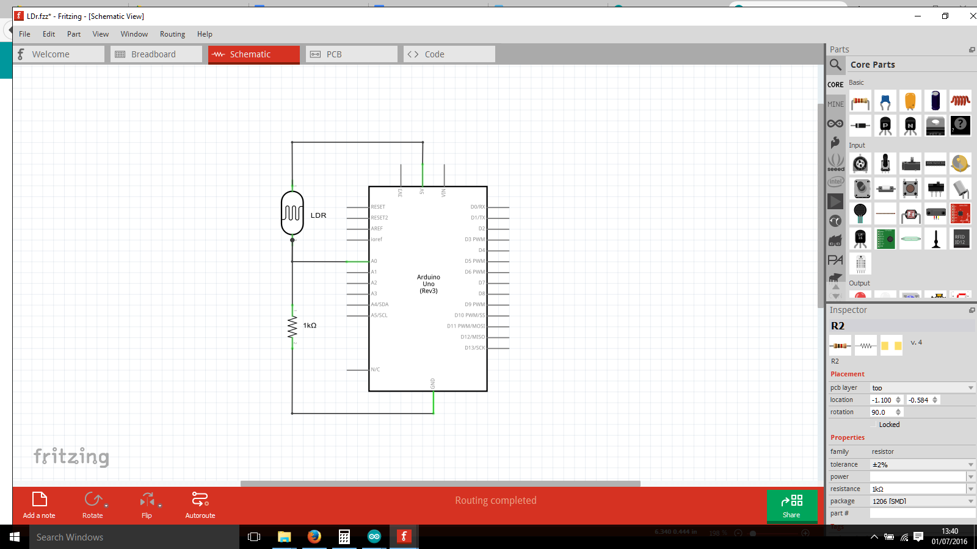

Write the code below into the arduino sketch:

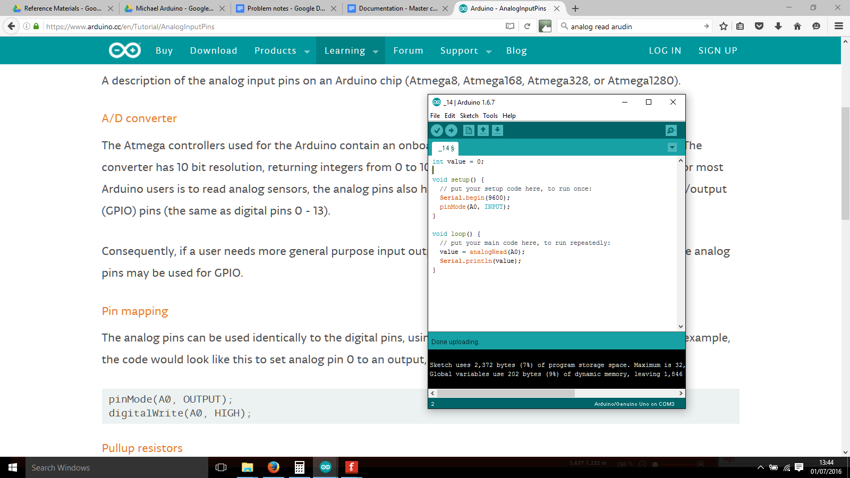

Explanation of code parts:

**Serial.begin(9600);**

* Opens a serial connection from the arduino to the PC
* Sets the ‘baud rate’ as 9600 Bytes per second

**Serial.println(value);**

* Prints value on the Serial Monitor
* Starts a new line after the value has been printed

Upload the code and open the Serial Monitor by pressing the magnifying glass icon.

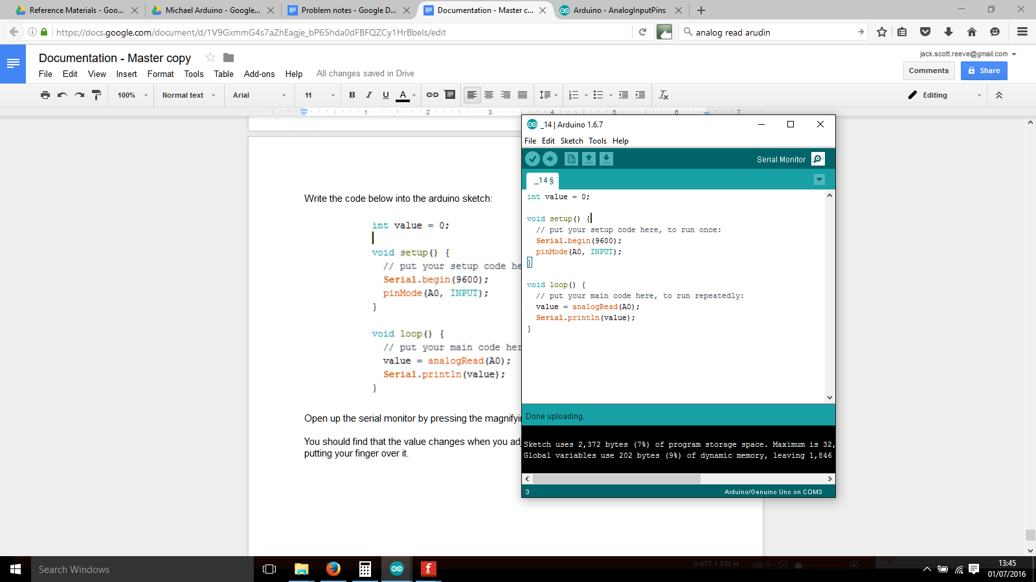

The newest value is at the bottom row of the Serial Monitor. You should find that the value changes when you adjust how much light the sensor receives by putting your finger over it.

***Take a note of the Value reported in the Serial Monitor for the next exercise:***

* completely cover the LDR
* completely uncover the LDR

Sample values here were 110 and 550. Alter the value so it is less than what you read, so 90 and 600 would be appropriate.

**Activity 16: Control the brightness of an LED with the LDR**

Equipment:

* Arduino UNO
* Breadboard
* Cables
* 1 x RED LED
* 1 x 1kΩ Resistor
* 1 x 200Ω Resistor`

Assemble the circuit on the breadboard as shown in the circuit diagram below:

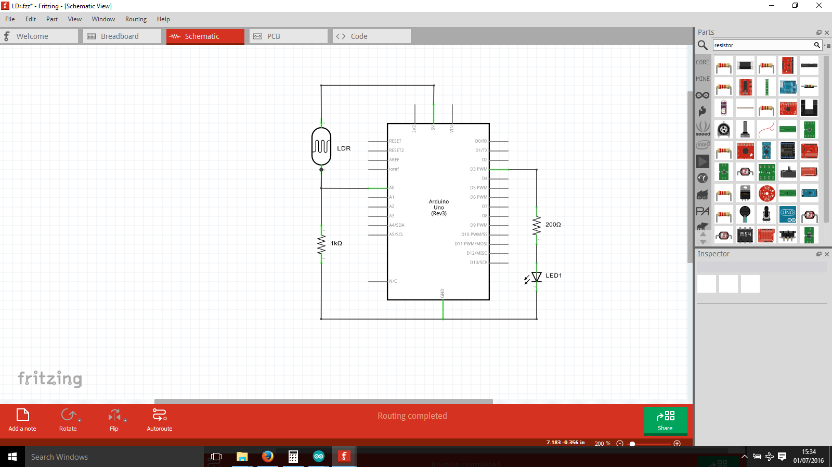

Write the code below into the arduino sketch:

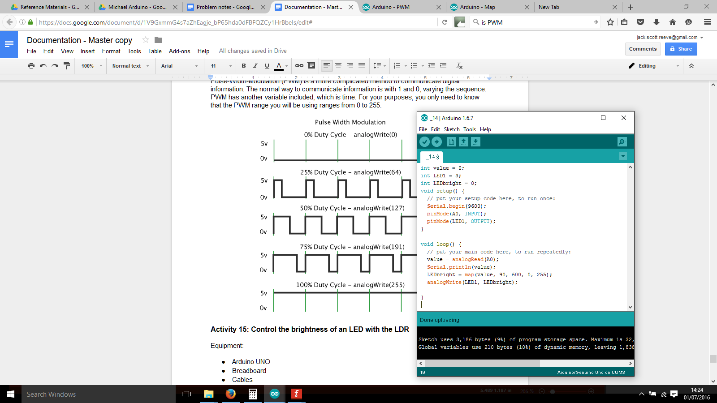

Write your noted down values from the previous exercise into the map function. For me it was 90 and 600, but for you it will likely be different.

***What you should see is the darkest when you cover the LDR, and brightest when you uncover the LDR.***

**Map function explained**

## **map(value, fromLow, fromHigh, toLow, toHigh)**

The map function is used to convert a range of values to another range of values. For example I could change the variable input values range 1-10 to 2-20. That would yield the following map function:

**map(input, 1, 10, 2, 20)**

In this example, a input value of 1 would be changed to 2. An input value of 3 would be changed to 6. An input value of anything outside the boundaries of 1 and 20 would not be changed.

|  |  |
| --- | --- |
| **Tip 10** | Map function values - its important to get the fromLow and fromHigh values to include the full range of values possible that you have read in the Serial Monitor. If you have set the range to 550, and the Serial Monitor shows 600, then the value will not be altered by the map function and remain as 600! |

**Component: Potentiometer**

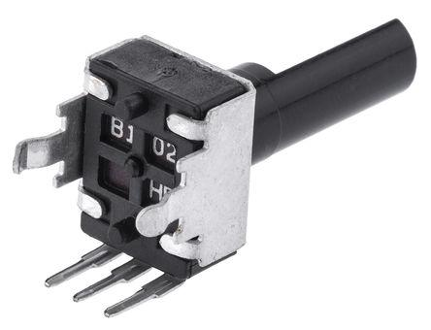

A potentiometer (*sounds like po-ten-chee-om-e-ter*), sometimes called a pot, is a variable resistor. It’s resistance value is altered depending on which position the dial is in. It is an analog component. It has three pins, Voltage, Signal and Ground

Some applications of potentiometer include:

* Audio control
* Television
* Motion control

Perhaps the most obvious application is in the guitar amp.



Its circuit symbol is the following:

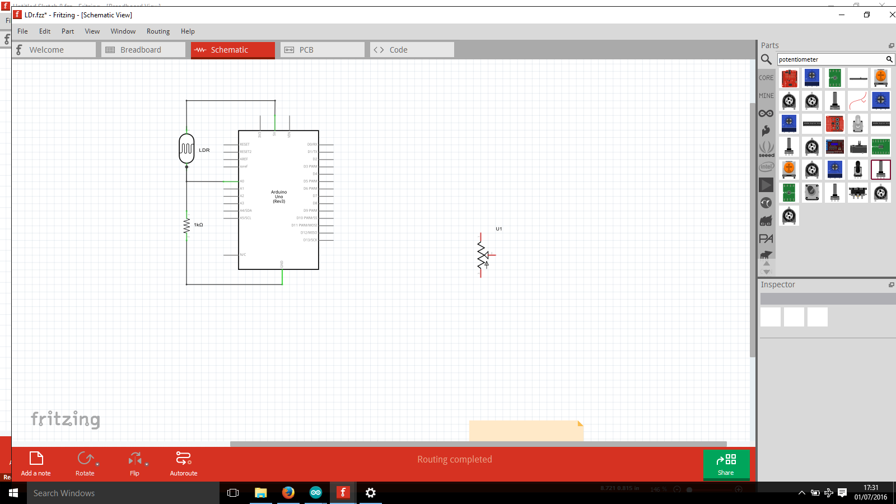

You may wonder which way round to connect the POT - which side should you connect the 5V and GND signals? The answer is it doesn’t matter - it’s like a resistor. What DOES matter is connecting the middle pin as the analog input.

**Activity: 17 Dim LED with potentiometer**

Equipment:

* Arduino UNO
* Breadboard
* Cables
* 1 x RED LED
* 1 x POT
* 1 x 200Ω Resistor

Prior to assembling the circuit on the breadboard as shown in the circuit diagram below, paying attention to putting the POT in the breadboard advice:

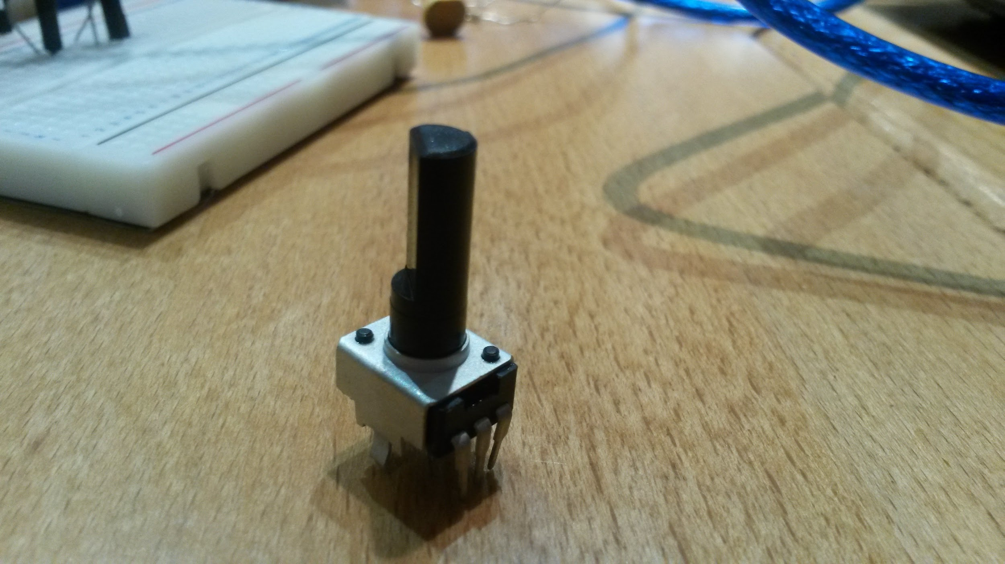 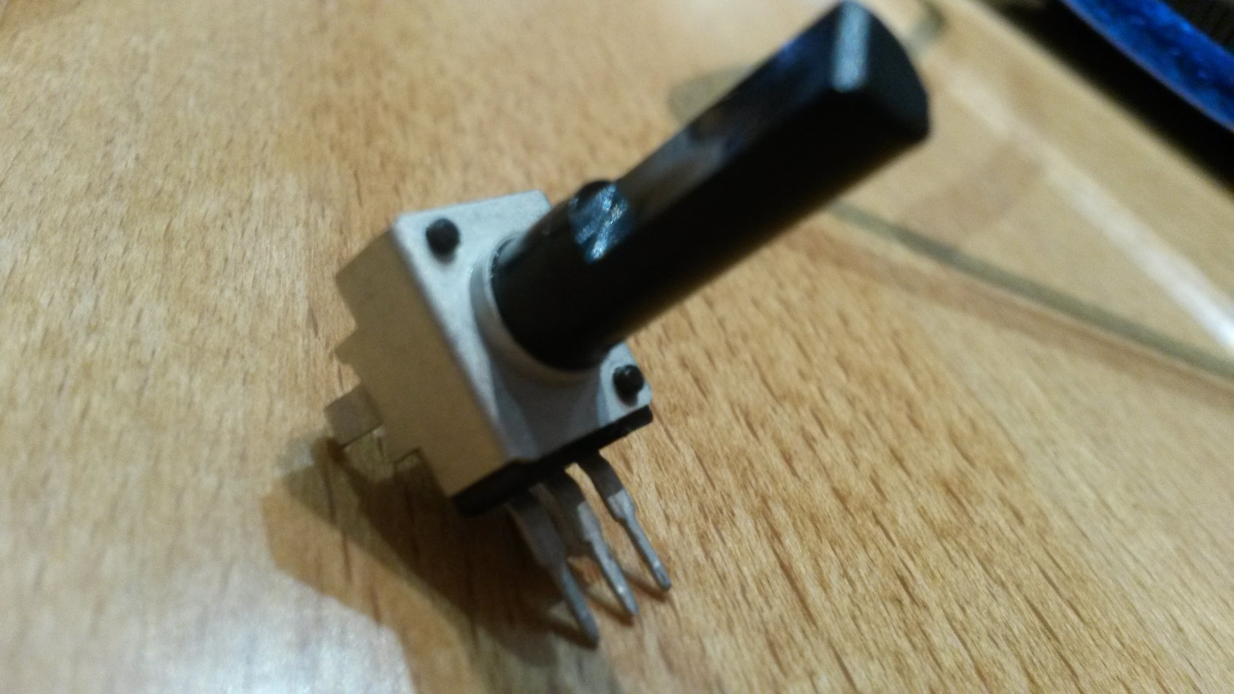

Take the POT and bend the 3 pins by 90 degrees as shown. Place it into the breadboard like the the following picture. ***Make sure the pins are stuck in all the way.***

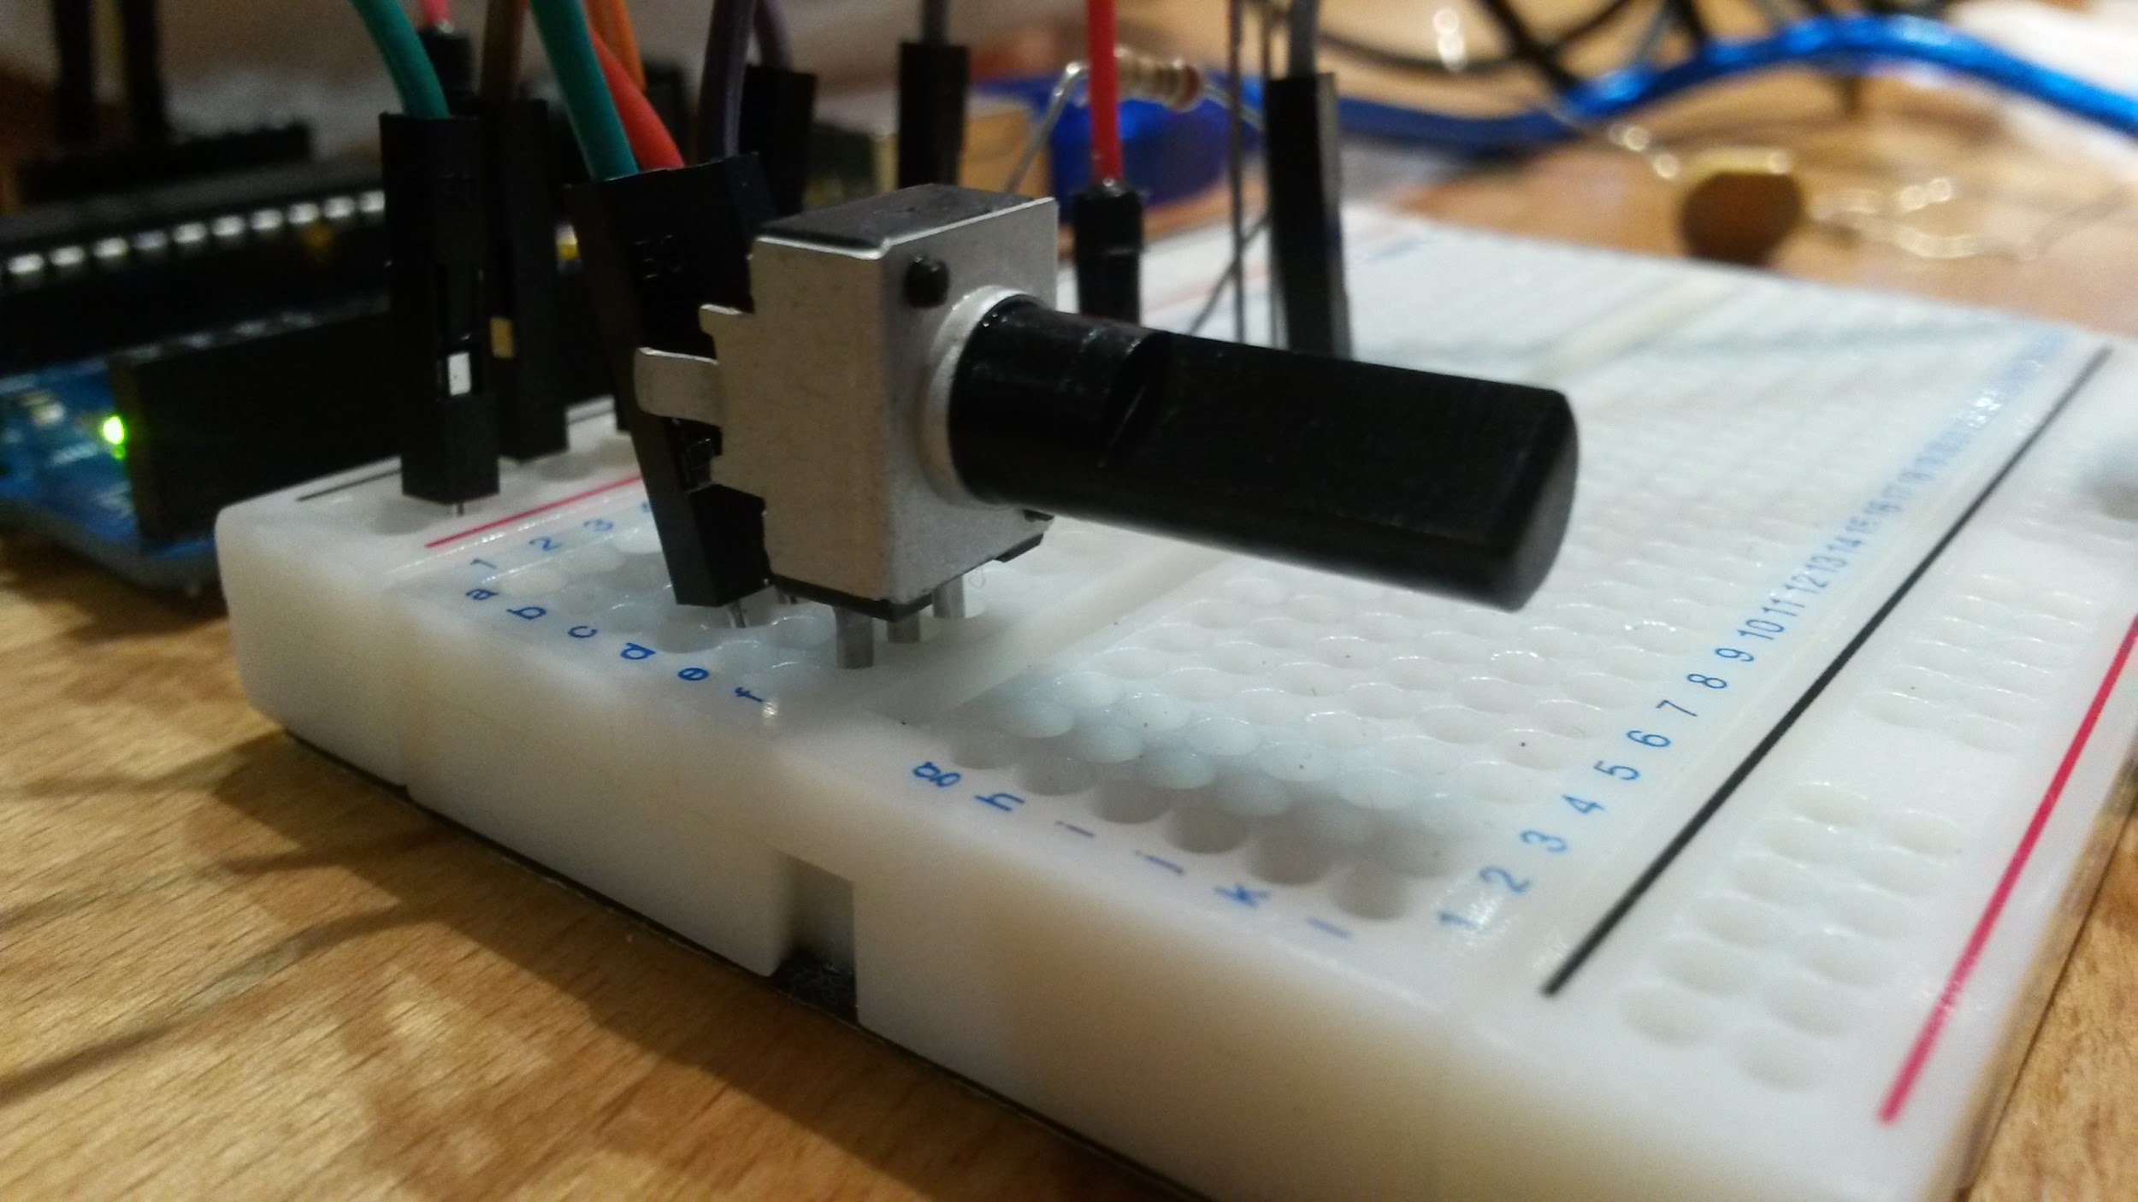

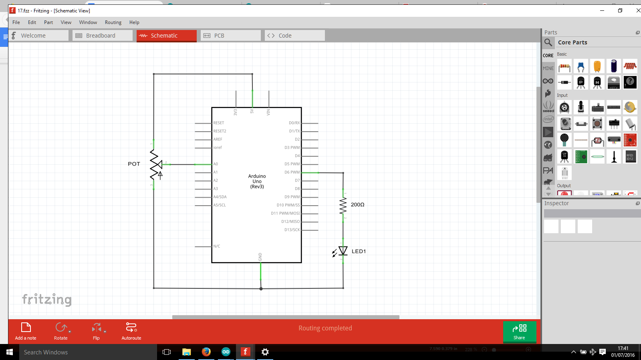

Write the following code into the arduino sketch:

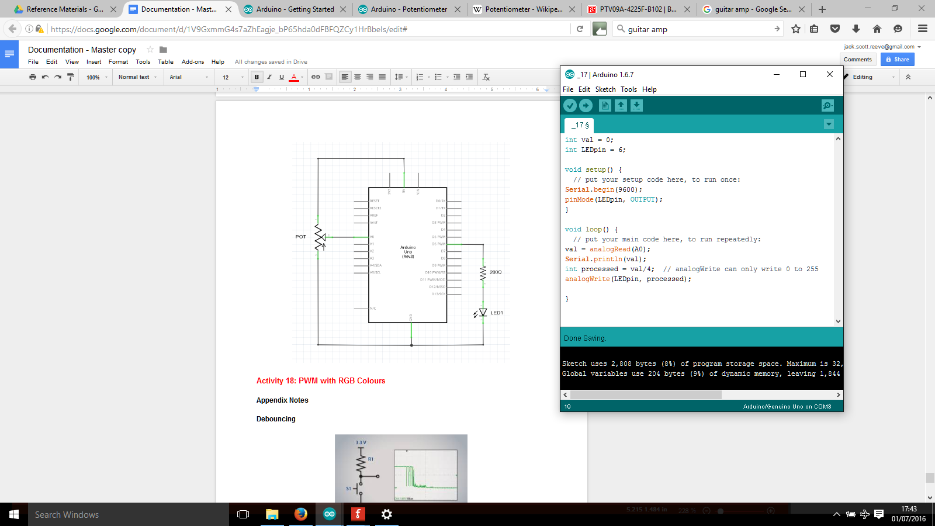

Explanation of code parts

**Int processed = val /4;**

This is performed because analogWrite can only write values in the range 0 to 255. analogRead provided val with values that can range from 0 to 1023. We could have used the map function but dividing val by 4 is a quick and easy solution to get it into the correct range.

You should find that when you turn the potentiometer, the LED brightens / dims proportionally. All the way in one direction is completely ON, and all the way in the other is completely OFF.

**Activity 18: PWM with RGB Colours**

Equipment:

* Arduino UNO
* Breadboard
* Cables
* 1 x RGB LED
* 1 x 220Ω Resistor (**RED RED BROWN** GOLD)

***BE CAREFUL NOT TO LOOK DIRECTLY AT THE LED WHEN THE VALUES ARE HIGH! It’s OK when the default low values are used, but it’ very bright when at high values !***

Before you assemble the circuit, take note of the correct procedure to put the RGB LED on the board:

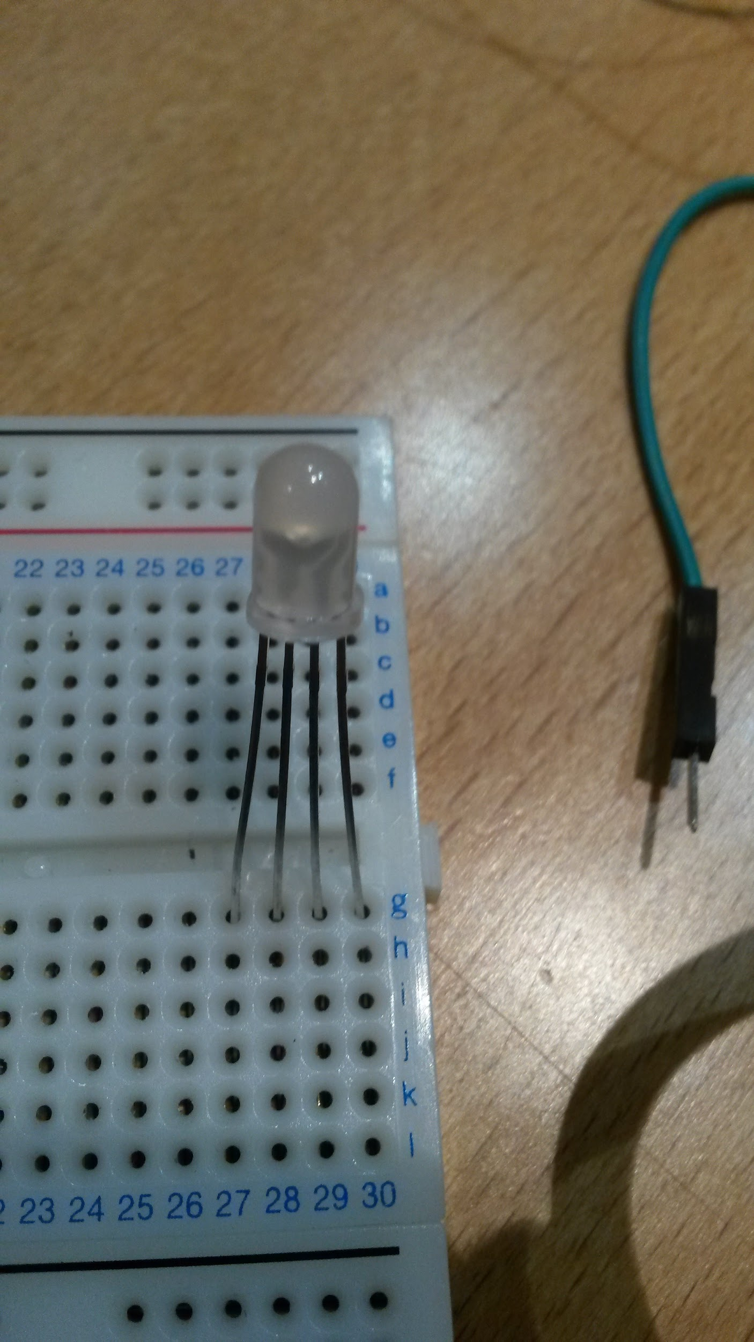

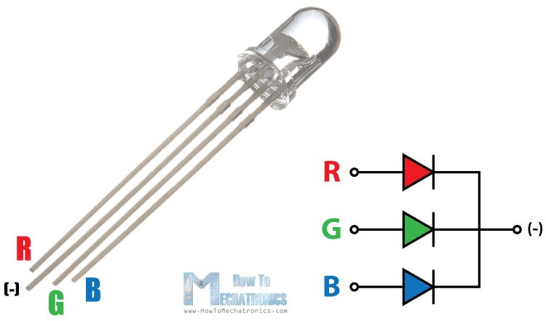

* Make sure you put it in the breadboard like shown, otherwise you could **short the LED and destroy it**
* The longest leg is the GND (ground or -) pin
* Which is the R,G and B pin? It depends on the LED. Just connect them up to the pins stated below and experiment with the values to see which one is which

Assemble the circuit on the breadboard as shown in the circuit diagram below:

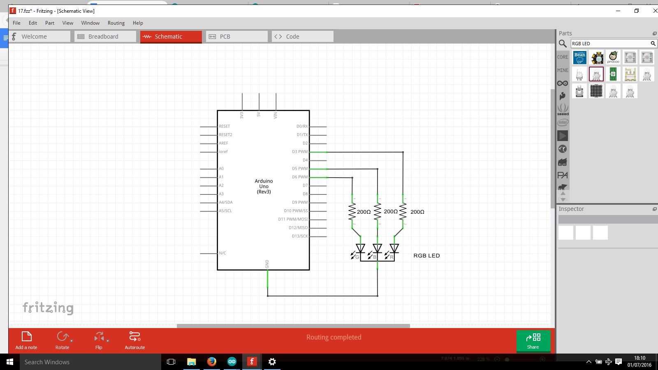

Write the following code into the arduino sketch:

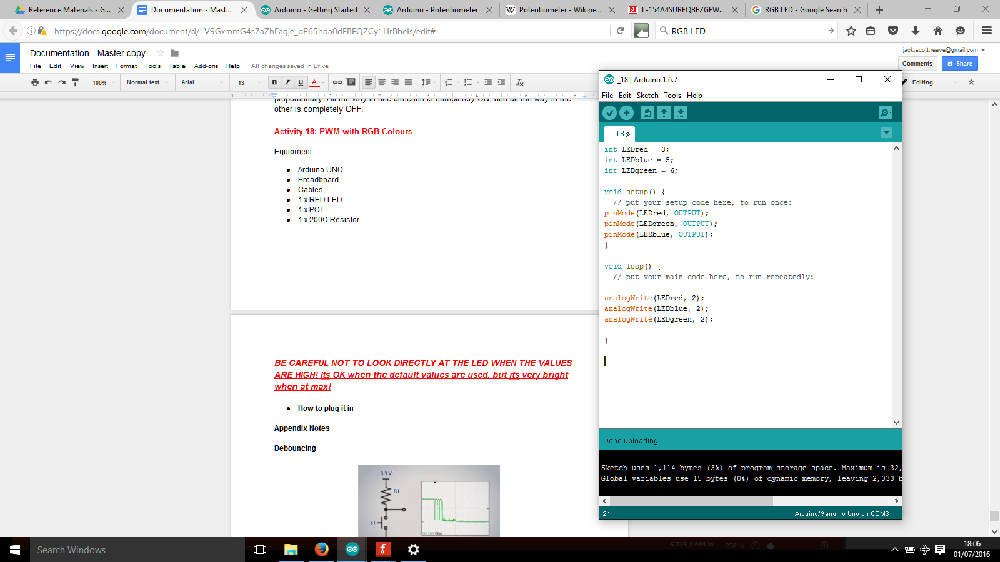

You should find that the LED turns on, very dimly. If you look closely at the LED, you should be able to see the distinct LED’s lighting up.

* You can adjust the LED colour based on the number parameter in the analogWrite function
* It is a PWM signal
* Range from 0 to 255 is valid
* 0 is completely OFF, 122 is half ON, 255 is fully ON

You can experiment with mixing ratios of R, G and B to make different colours. Try making yellow, Purple or light blue.

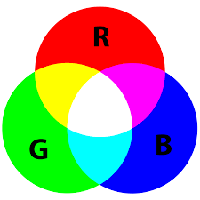

Note that it won’t be exactly proportional because different voltages/PWM values give different brightnesses to each LED (i*f you really wanted to know the exact reason, it’s to do with atomic energy transition levels, quantum physics*).

**Further steps with PWM**

You can take what you have learned with PWM and apply it to other things. For example, you could use it with a buzzer, and 10% duty cycle (value 24) would be low pitch, and 100% duty cycle (value 255) would be high pitch.

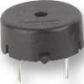

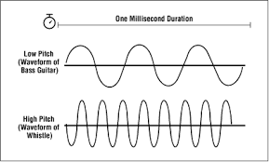

**Using the Liquid Crystal Display (LCD)**

The LCD displays text and characters. You can use it to display stored text inside the Arduino, values read from sensors and much more!

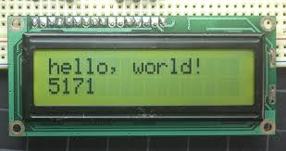

**Activity 19: CONNECT LCD to Arduino**

Equipment:

* Arduino UNO
* Breadboard
* Cables
* 1 x POT
* 1 x 220Ω Resistor (**RED RED** **BROWN** GOLD)
* 1 x LCD

Assemble the POT from your kit as shown below:

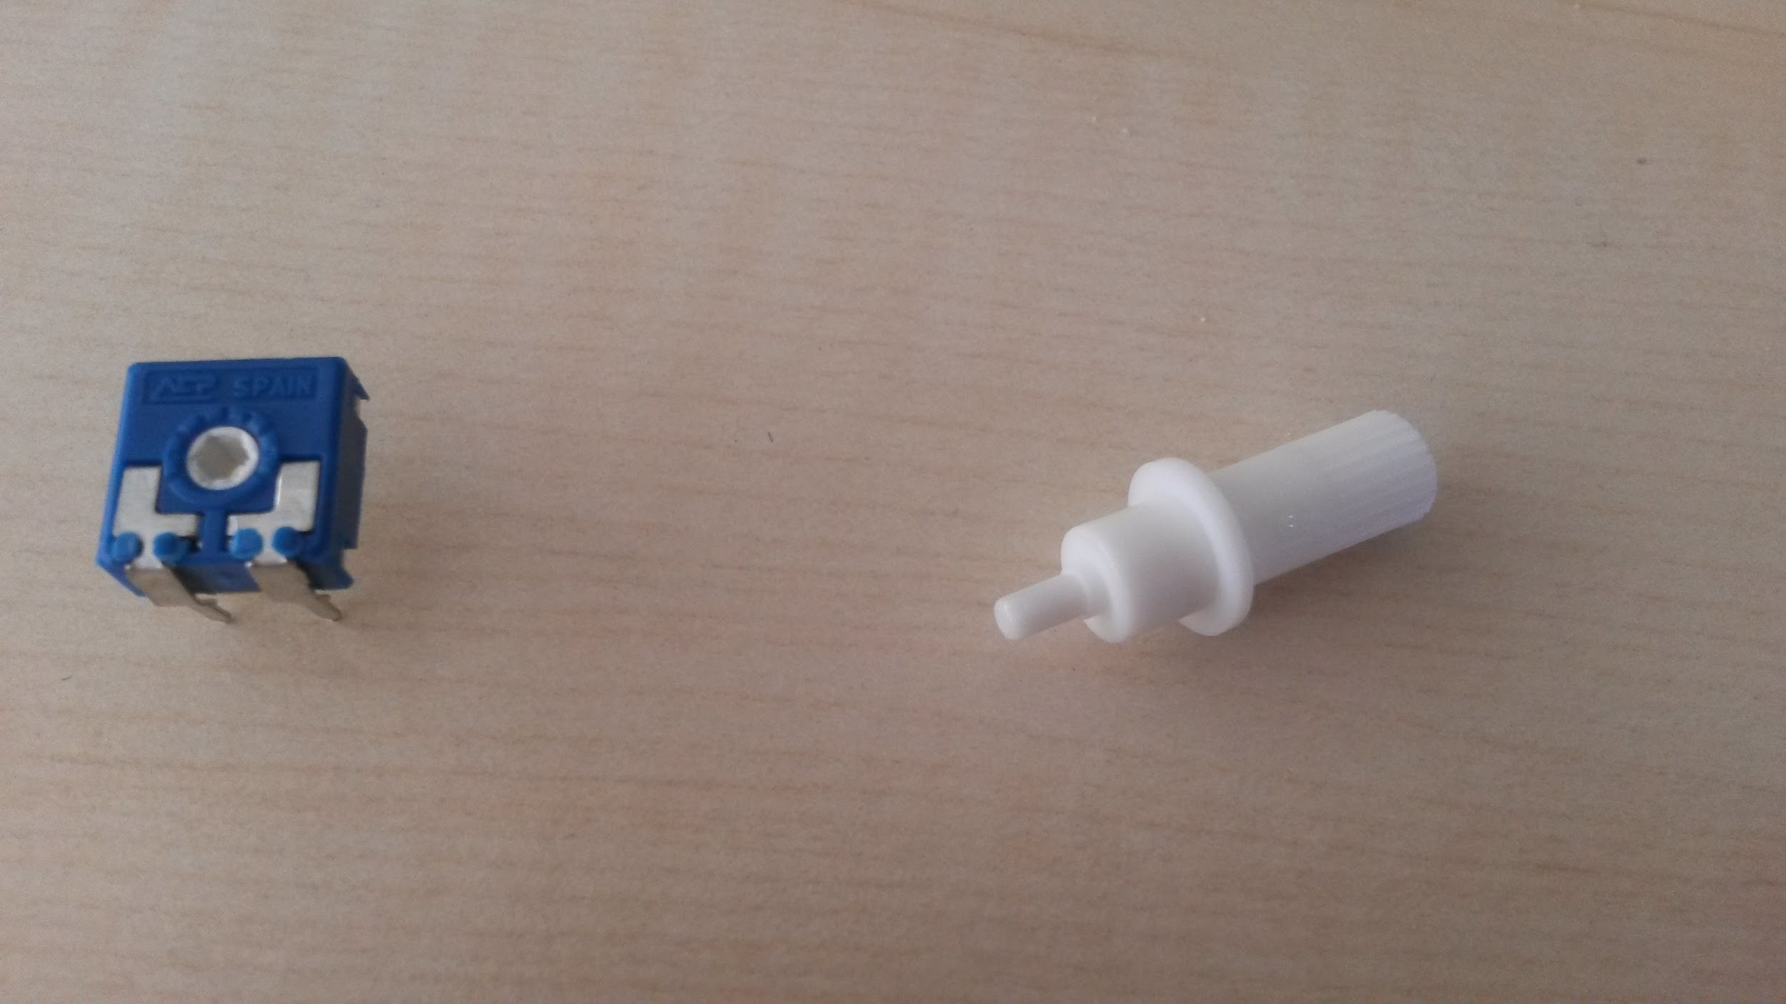

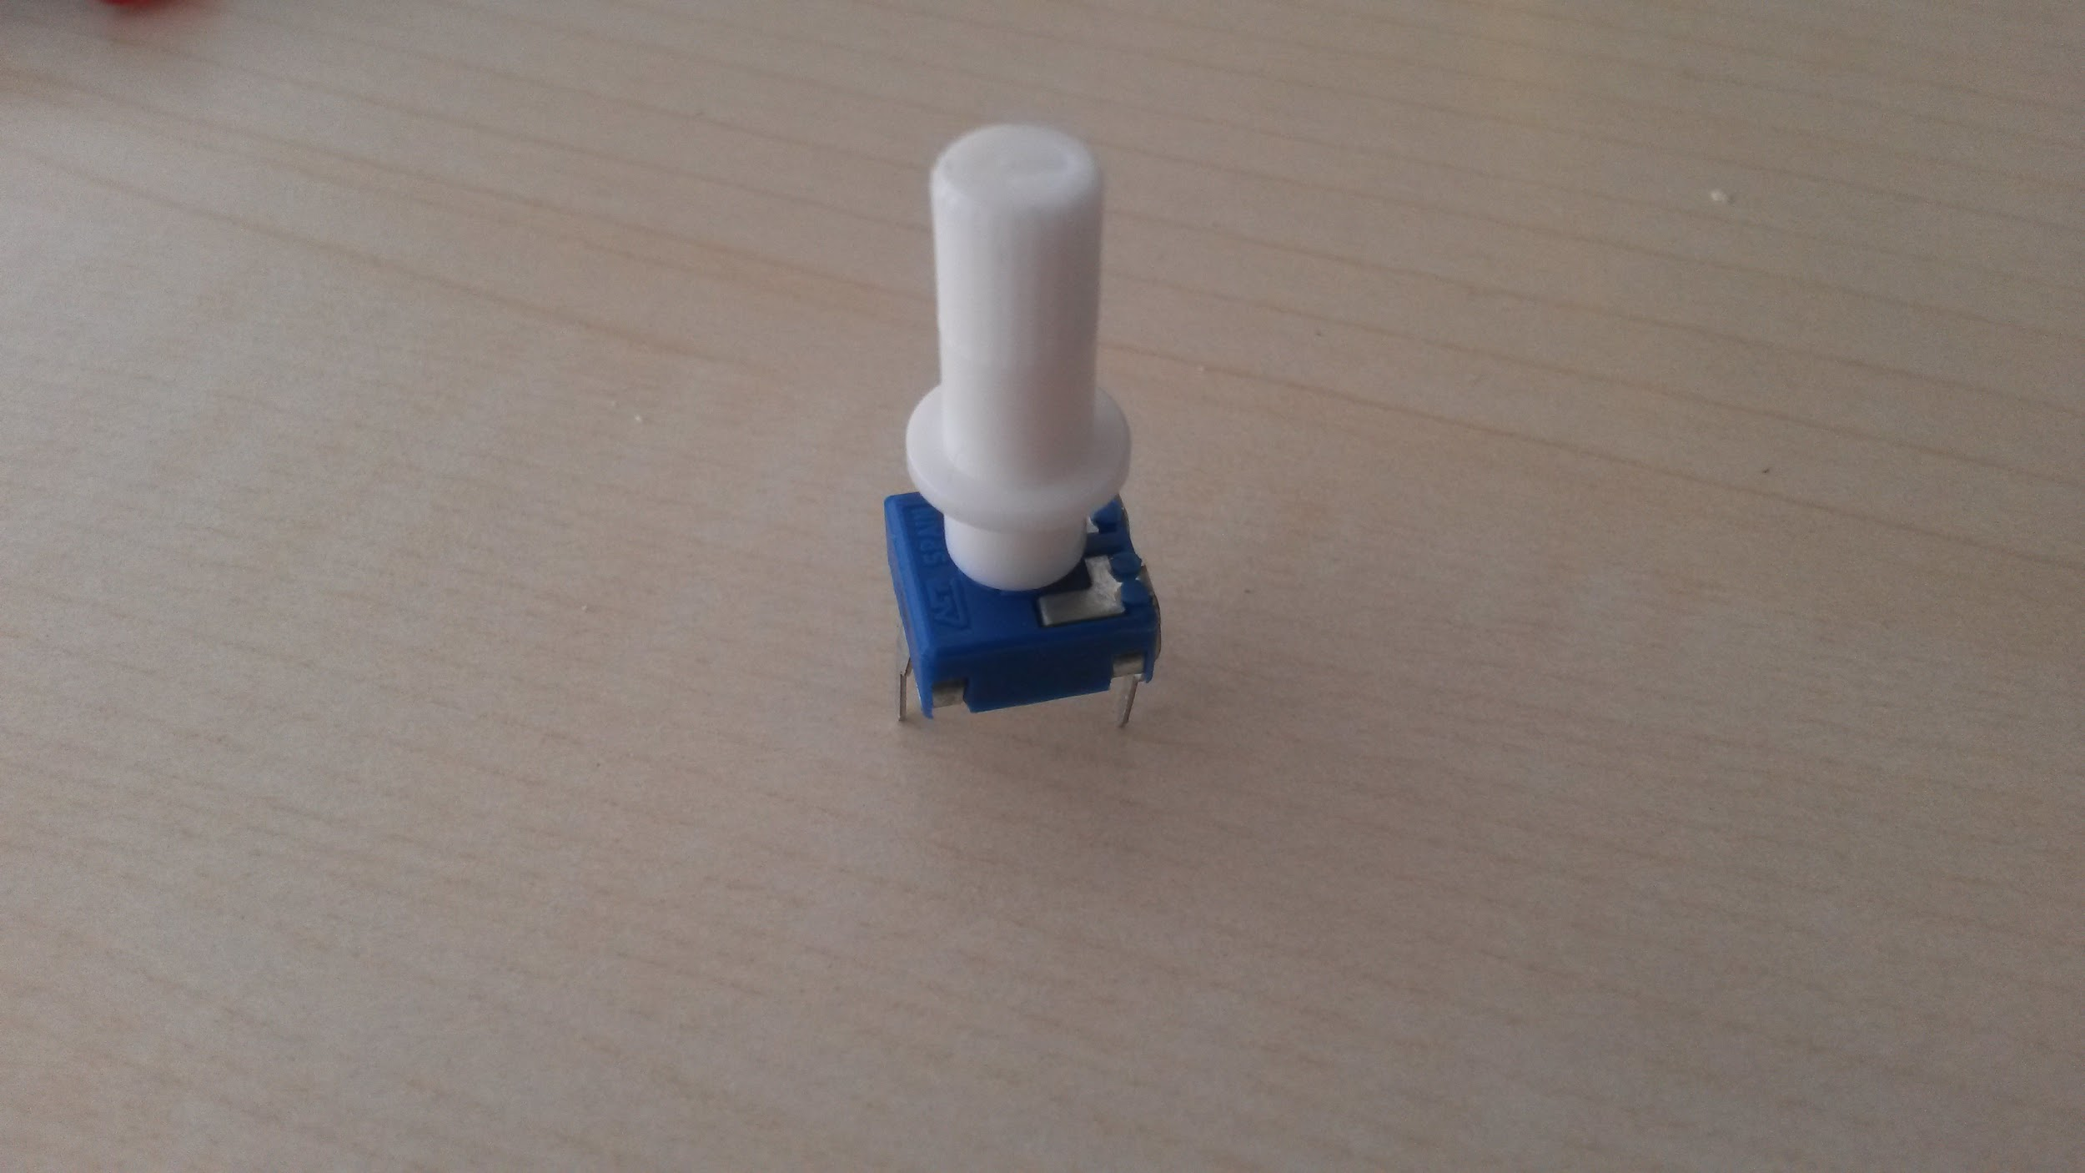

Assemble the breadboard as shown in the diagram below. Some notes to read first:

* The **BLUE** rail on the diagram corresponds to the **BLACK** rail on the breadboard you have
* It is suggested to mount the 16 pins of the LCD in the bottom right corner of the breadboard (this will make it easier to use with later activities)

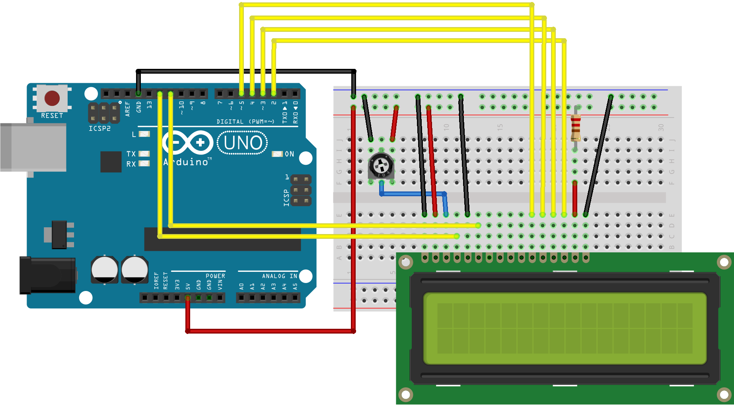

Take the plastic wrapper off the LCD and turn the potentiometer dial.

You should find that the LCD is lit up when you turn the dial (may have to look closely and turn it far).

|  |  |
| --- | --- |
| **Tip 11** | If the LCD display is very dark, it is not your fault - it is just manufacturer variance unfortunately. |

**Activity 20: hello, world! on LCD**

Equipment:

* Arduino UNO
* Breadboard
* Cables
* 1 x POT
* 1 x 220Ω Resistor (**RED RED** **BROWN** GOLD)
* 1 x LCD

Use the same breadboard setup as in Activity 19.

Write the following code into the arduino sketch:

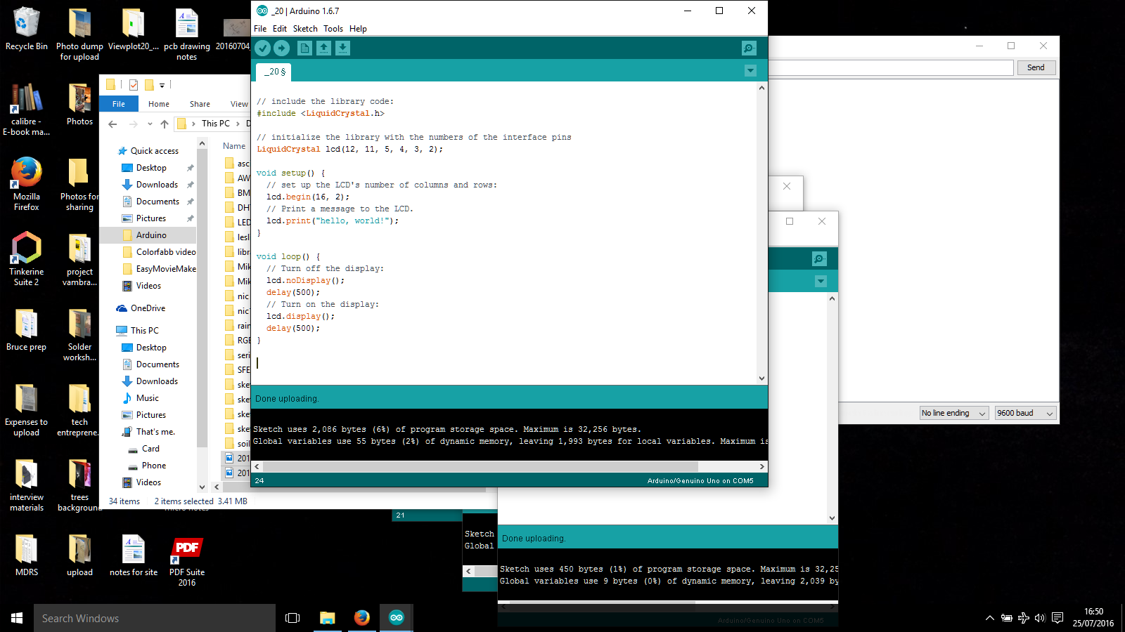

Explanation of code parts

**#include <LiquidCrystal.h>**

* This statement references a specific pre-known library
* Think of a library as a “magic box” of extra code needed to make some things work
* You generally do not have to bother with/understand/edit libraries

**LiquidCrystal lcd(12,11,5,4,3,2);**

* This declares an object of type LiquidCrystal with name lcd
* The numbers are assigning the pins to match up with how you have connected the board
* You don’t need to change any of these numbers. Write them in exactly as they are found (you would only need to change them if you had a different manufacturer of LCD)

**lcd.begin(16,2);**

* Defines an LCD of 16 columns and 2 rows
* You don’t need to change any of these numbers (you would change them if you had a bigger LCD for example)

You should find that the LCD displays “hello, world!” flashing on and off.

**Activity 21: Scrolling text**

Equipment:

* Arduino UNO
* Breadboard
* Cables
* 1 x POT
* 1 x 220Ω Resistor (**RED RED** **BROWN** GOLD)
* 1 x LCD

Use the same breadboard setup as in Activity 19.

Write the following code into the arduino sketch:

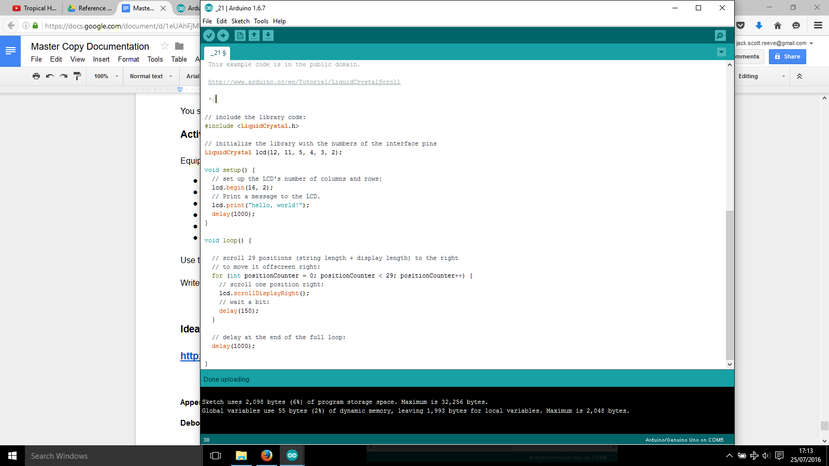

Explanation of code parts

**lcd.scrollDisplayRight();**

* This function displays the LCD moving one block right at a time
* The text scrolling right movement is defined by the for statement to move in increments of 1
* The text scrolling right movement is defined by the for statement to move 29 times before exiting
* The text will scroll until the number limit is reached, stop, and then continue from there (experiment with replacing 29 with 5 to show this)

You should find that the text “hello, world!” moves rightwards on the display.

**Speaking Computer language**

Q How do computers understand words when you write them?

A They don’t - computers understand numbers only.

When you write something like “DOG” into a computer, it does not understand the characters D,O and G directly. It converts them to numbers using a common reference called ASCII (sounds like as-key).

An extract from the ASCII table is shown below.

* You don’t need to memorise anything as it just a reference table
* You are interested in the values in *Dec* (decimal) and *Chr* (character) columns
* We are only interested in this excerpt range of inclusive 32 to 126, as anything outside these are interpreted are specific commands (e.g. decimal 8 is backspace)

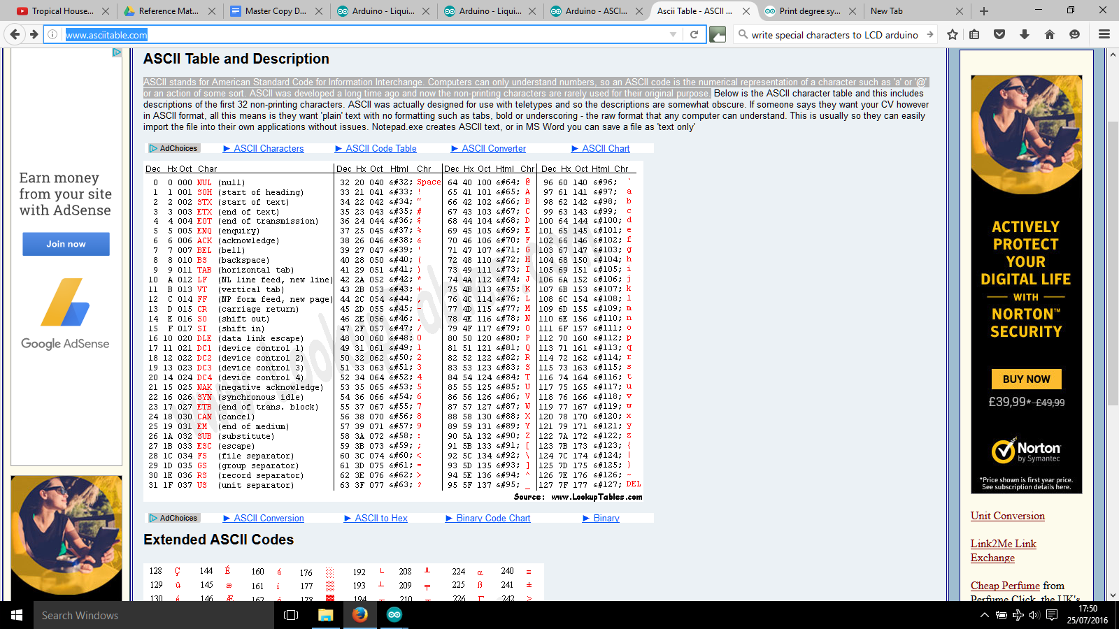

<http://www.asciitable.com/>

**Activity 22: Writing characters in number format**

In this activity we are going to write DOG in number format to the LCD.

Equipment:

* Arduino UNO
* Breadboard
* Cables
* 1 x POT
* 1 x 220Ω Resistor (**RED RED** **BROWN** GOLD)
* 1 x LCD

Use the same breadboard setup as in Activity 19.

Write the following code into the arduino sketch:

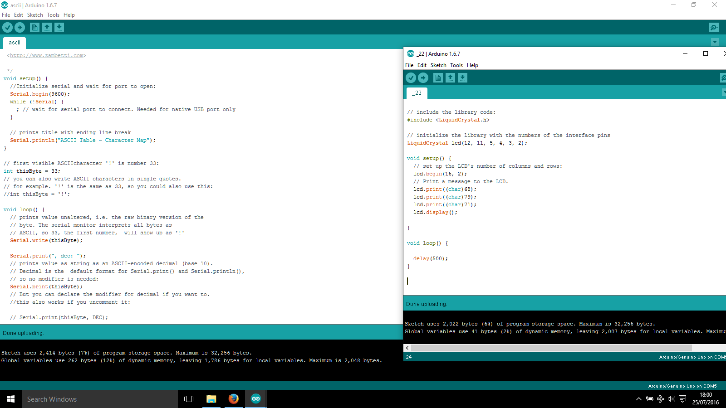

Explanation of code parts

**(char)68**

* References the character with decimal value 68 ( **D** )

You should see DOG on the LCD.

**Activity 23: Serial Read to control brightness of LED from computer**

In this activity we are going to control the brightness of the LED by typing in values into the Serial Monitor(First used in Activity 15). We will use PWM values from 0 to 255 (where 0 is fully OFF and 255 is fully ON)

Equipment:

* Arduino UNO
* Breadboard
* Cables
* 1 x POT
* 2 x 220Ω Resistor (**RED RED** **BROWN** GOLD)
* 1 x LCD
* 1 x GREEN LED

Leave the breadboard setup the same as in Activity 19. In addition connect pin 9 to ANOTHER 220Ω Resistor to GREEN LED to GND. Ensure that you use breadboard columns that are not connected to the LCD.

Write the following code into the arduino sketch:

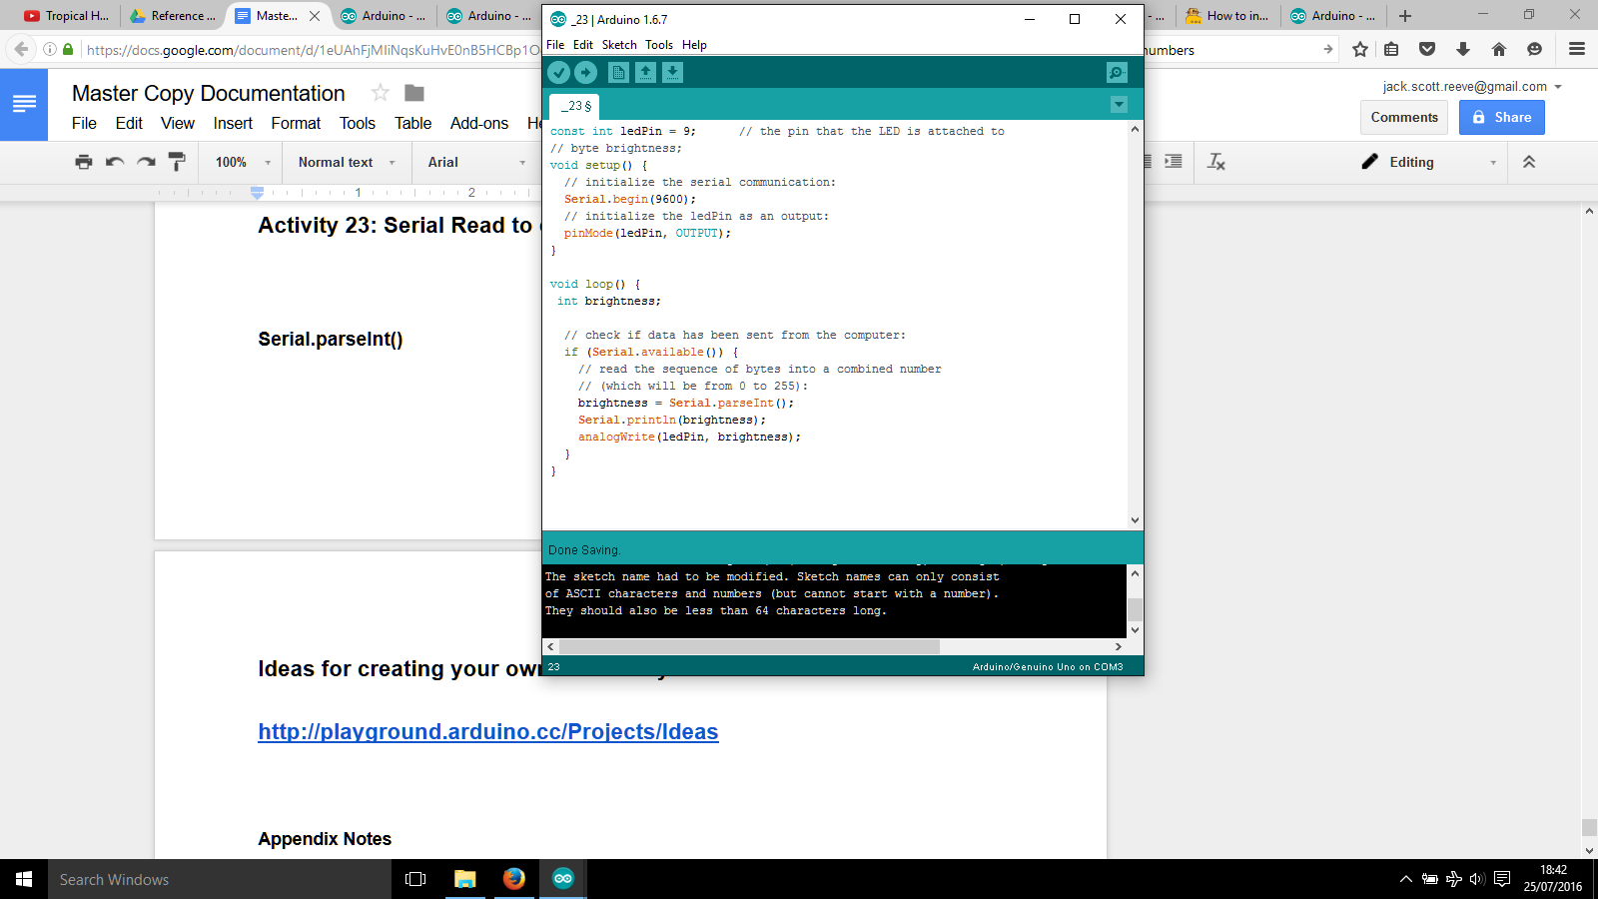

Explanation of code parts

**Serial.parseInt()**

* Reads in the values as integers (numbers)
* Parsing -reads in the values in one go (25 is read as “25” not “2” “5”)

Open the Serial Monitor and type in a number between 0 and 255 and press enter.

You should find that the LED changes brightness across the PWM scale you have used before where 0 is fully OFF and 255 is fully ON.

**Activity 24: Displaying analog value on LCD**

In this activity we will read an analog value from the LDR and display it on the LCD.

Equipment:

* Arduino UNO
* Breadboard
* Cables
* 1 x POT
* 2 x 220Ω Resistor (**RED RED** **BROWN** GOLD)
* 1 x LCD
* 1 x LDR

First assemble the breadboard as in Activity 19. Second add an LDR to the breadboard with the same arrangement as the diagram from *Activity 15: Build and program and LDR circuit.*

Write the following code into the arduino sketch:

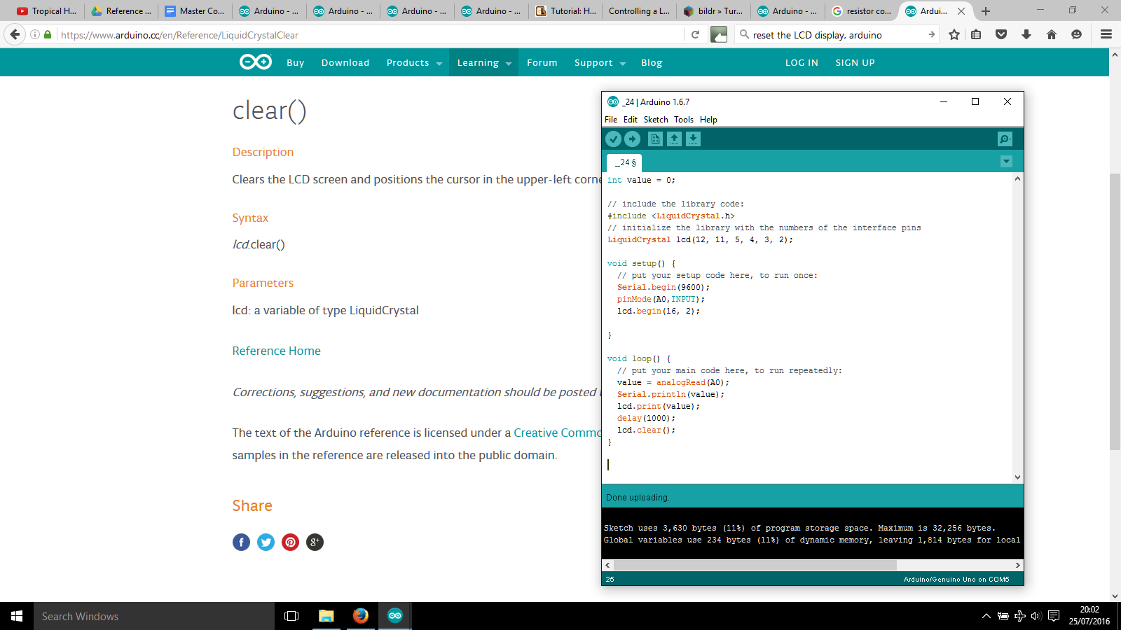

Explanation of code parts

**lcd.clear();**

* Clears the display (you could say it resets it) so that the next time a value is written, it appears in the same place

You should find that values in the range between 0-1023 appear on the LCD , flashing every 1 second. In testing here, the numbers seen were 500 in daylight and 50 when the LDR is covered.

**Activity 25: Display messages on Serial Monitors from buttons**

In this activity we will setup an LCD with two buttons. The application is for a computer game where the Question is “Continue” and the choices are “YES/NO”

Equipment:

* Arduino UNO
* Breadboard
* Cables
* 1 x POT
* 2 x 1KΩ Resistor (**BROWN BLACK RED** GOLD)
* 1 x 220Ω Resistor (**RED RED** **BROWN** GOLD)
* 1 x LCD
* 2 x Push Button

First assemble the breadboard as in Activity 19 (LCD). Second add two buttons to the breadboard, using Activity 12 as a reference. Connect the buttons to 3V3 (this is 3.3V) and digital pins 7, 8 of the breadboard. Be careful with your breadboard space as there is a lot on there now! You might want to extend it with another breadboard.

Write the following code into the arduino sketch:

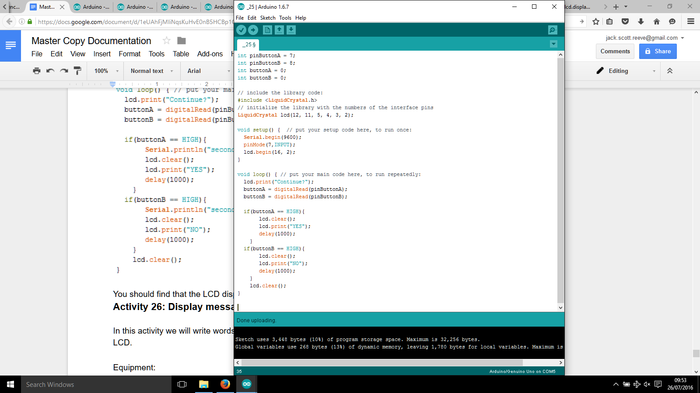

You should find that the LCD displays “Continue?” as default and “YES” and “NO” when each button is pressed.

**Activity 26: Display messages on Serial Monitors from keyboard**

In this activity we will write words onto the Serial Monitor and have them appear on the LCD.

Equipment:

* Arduino UNO
* Breadboard
* Cables
* 1 x POT
* 1 x 220Ω Resistor (**RED RED** **BROWN** GOLD)
* 1 x LCD

First assemble the breadboard as in shown in the diagram from Activity 19.

Write the following code into the arduino sketch:

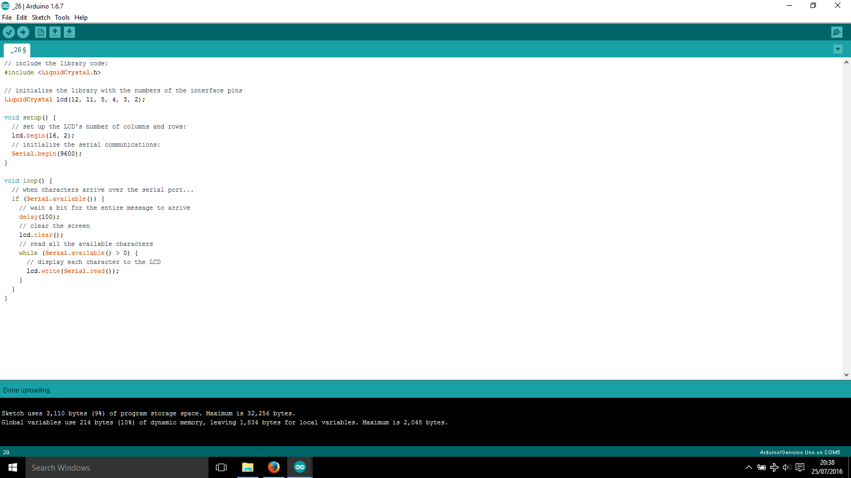

Explanation of code parts

**if/while serial available...**

* This prevents problems with the display by waiting until the Serial buffer is empty

Upload the arduino sketch and open the Serial Monitor. Type in some words and press enter on the keyboard.

You should find that the text you wrote in the Serial Monitor has appeared on the LCD!

**Sensors and Actuators**

* Sensors convert signals to electrical impulses
* The decision making process is handled by the microcontroller
* The reaction is performed by the actuators

**Person > sensors  
 < actuators system**

A **sensor** takes information from the environment (i.e light, movement, heat) and converts it into electrical signals that the computer can understand.

An **actuator** takes an electrical signal and converts it into anything else (i.e. sound, light movement); for example an LED takes electricity and turns it into light, a motor takes electrical energy and converts it into kinetic energy et al.

**Actuators: Motors**

Motors are defined as::

*“a machine, especially one powered by electricity or internal combustion, that supplies motive power for a vehicle or for another device with moving parts.”*

Internal combustion motors are to do with combustion which is burning fuel and has mechanical moving parts. Electric motors are to do with electricity and magnetism where the fuel is current and does not have mechanical moving parts. Below is shown some examples of Motors inside cars.

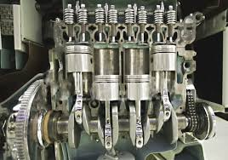 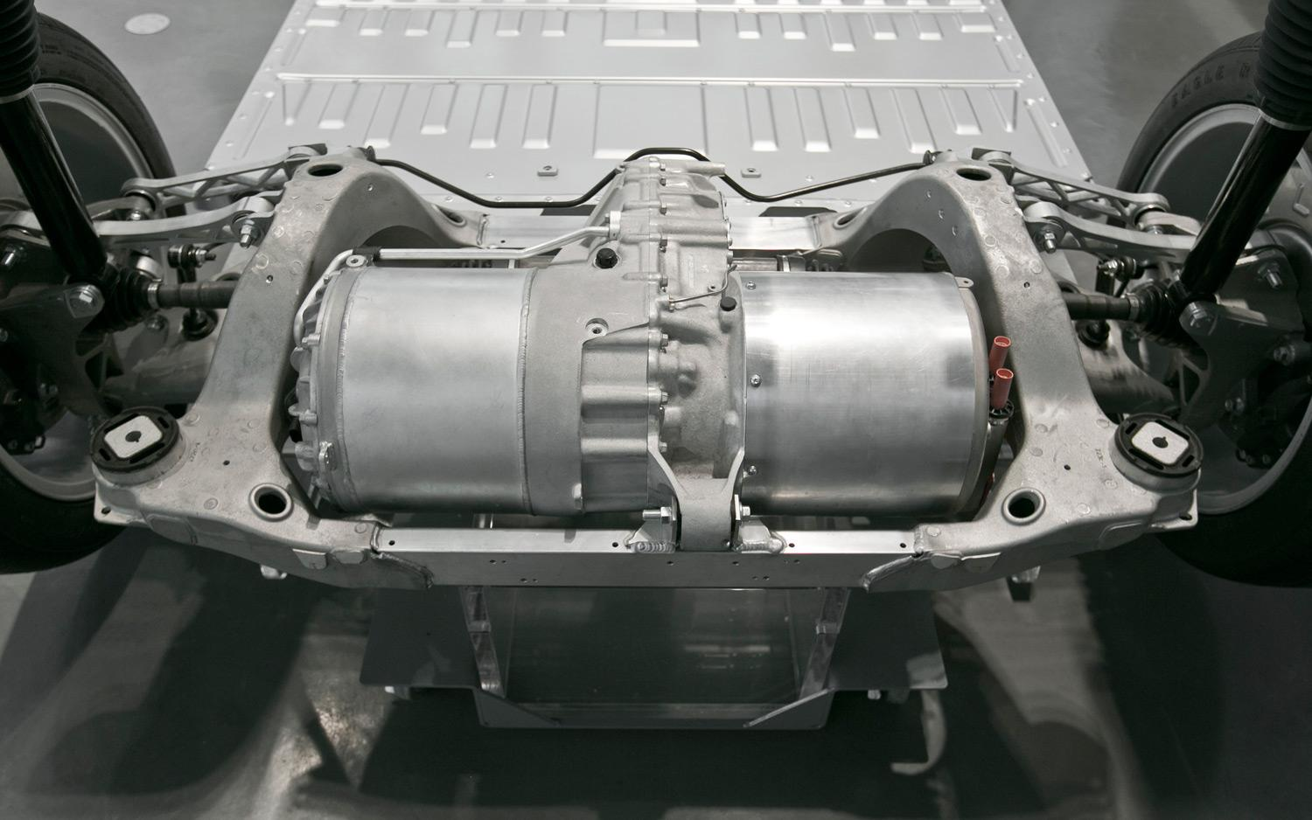

**Internal combustion Motor engine** **Electric Motor**

 

**Ford Car**  **Tesla Car**

For the purposes of arduino, we are interested in electro-magnetic motors. There are many different types, the simple ones you need to know about are: Continuous rotation motors, Servo motors, Stepper motors, DC motors.

|  |  |  |  |  |
| --- | --- | --- | --- | --- |
| **Motor Type** | **Images** | **Application** | **Advantages** | **Limitations** |
| Servo |  | Robotics(simple), Mechatronics | Low Cost, large variety, simple to control | Limited range of rotation (typically 180°)  Moderate precision (typically accurate to ± 1°) |
| Continuous Rotation Servo |  | Robot Drive Trains (e.g. wheels) | low cost, compact, simple to control | Not designed for heavy loads  Can be difficult to find the middle neutral point |
| DC |  | Pumps, fans, blowers | Very low cost, very simple | Can’t do complex |
| Stepper | Image result for stepper motor | 3D Printers, Robotics, Any precise robotics | Precise repeatable positions, precise speed control, | Low efficiency ( uses a lot of power) |

Which Motor should I use?

* If you were going to make an OK robot arm, you would use Servo Motors
* If you wanted to make a precisely performing super accurate robot arm, you would use Stepper Motors
* If you wanted to make a robot with wheels that drives around, you would use Continuous Rotation Servo Motors
* Typically Servo Motors are the most commonly used of all these types

Quick explanation of Servo Motors

**Q How do you measure how good a servo motor is?**Three parameter are of interest: Torque, Speed and Weight. The best servo motor would have:

* Torque (T) HIGHEST
* SPEED (s seconds) LOWEST
* WEIGHT (g grams) LOWEST

**Q Where can I find this information?**Check its datasheet / basic webpage where it is being sold. Read the code off the servo motor and just google it if you are lazy. Make sure you are looking at the right one! (SM-S2309S)

Detailed explanation of Servo Motors

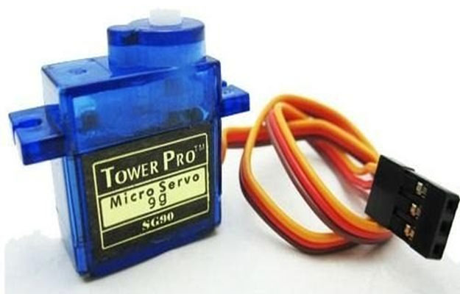

**Standard Servo Motor**

Servo Motors have three cables, Power, Signal, Ground. You make the servo move to a set position from an 180 degree range by sending a value down the Signal Cable.

The signal must be a PWM signal, and its units are typically given in microseconds (μs). Typically 1500μs corresponds to 90 degrees, with 1000μs corresponding to 0 degrees and 2000μs corresponding to 180 degrees.

If a servo is given a higher voltage, it will perform better. Specifically its torque will increase, and it its speed will increase. If you look at the data on the website for SM-S2309S, you will find that Torque is given in voltages of 4.8V and 6V. The servo motor will work outside of this motor range, but at a lower level (e.g. 3.0V) it will have much reduced performance and too high a voltage (e.g. 7.2V) could damage / destroy the motor.

**Activity 27: Basic Controlling a Servo Motor Position**

In this activity we will set the servo motor to a specific position with a microsecond value.

Equipment:

* Arduino UNO
* Breadboard
* Cables
* 1 x Servo Motor
* 1 x Servo Horn

First attach any of the servo horn to the servo motor (it comes in the packets with the motors). Normally you would screw it in, just place it on the top for now.

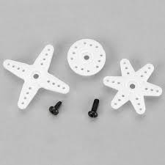

**Various Servo Horn**

Assemble the breadboard as in shown in the diagram below.

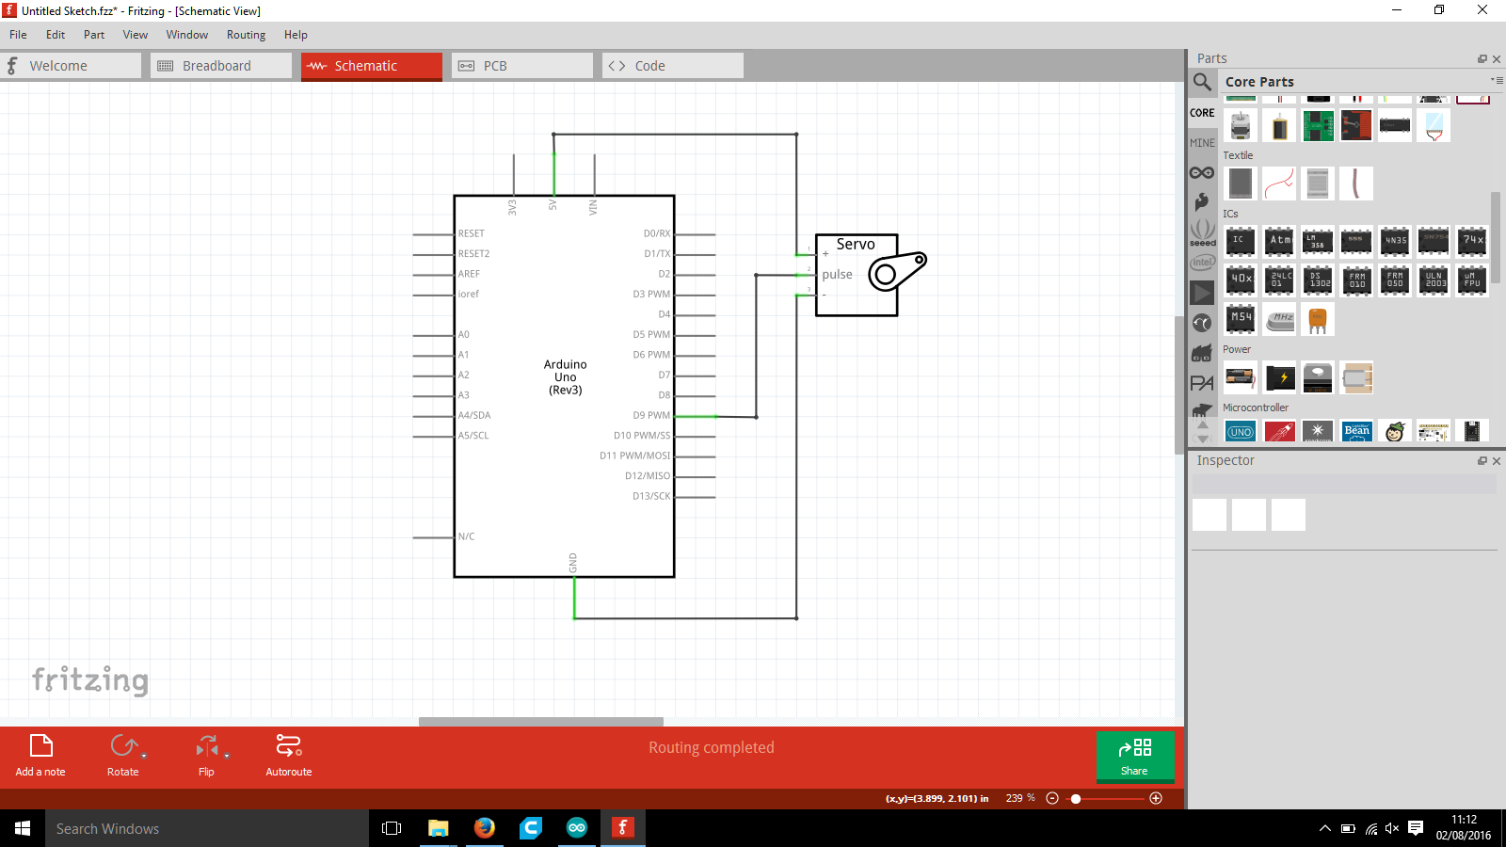

|  |  |
| --- | --- |
| **Tip 12** | Don’t know what Pulse is? It’s the signal. Sometimes manufacturers write a lot of different things for pulse/signal, but here’s how you can easily work out what you need to connect. Find Ground and 5V first, then look at the remaining connections. |

Write the following code into the arduino sketch:

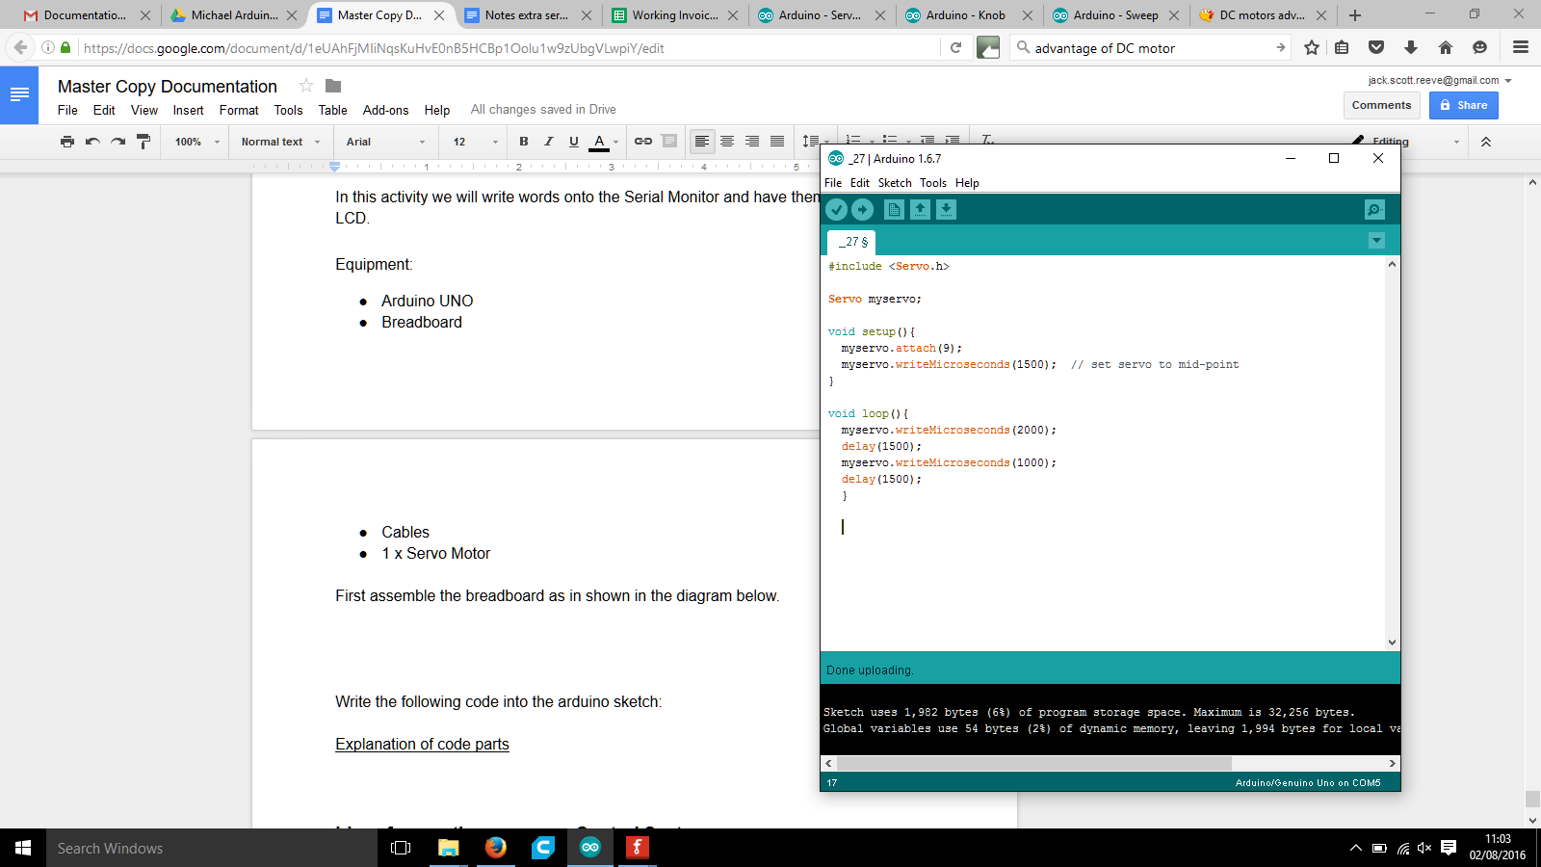

Explanation of code parts

**Servo myservo;**

* This declares a Servo object and names it myservo

**myservo.attach(9);**

* You configure pin 9 of the arduino as a servo

**myservo.writeMicroseconds (1500);**

* Sends a PWM signal of 1500 to myservo
* Sets a roughly mid-point position to the servo

|  |  |
| --- | --- |
| **Tip 13** | A microsecond is one millionth of one second (a millisecond is one thousandth of a second). You don’t need to worry about it, all you need to know is that roughly 1000 = 0 degrees, roughly 2000 = 180 degrees |

You should find that the servo changes position over 180 degrees.

**Activity 28: Range control a servo motor position**

In this activity we will connect the servo to the arduino and tell the servo to move over 180 degrees by changing the microsecond value (1000-2000).

Equipment:

* Arduino UNO
* Breadboard
* Cables
* 1 x Servo Motor
* 1 x Servo Horn

Set up the breadboard as in the diagram of Activity 27.

Write the following code into the arduino sketch:

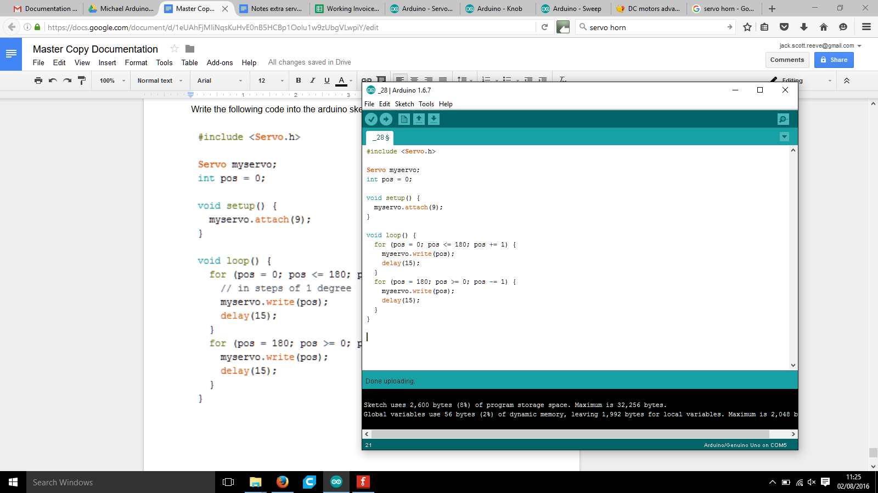

Explanation of code parts

**For (pos=0; pos>= 180; pos += 1){**

* Sets the position variable starting at 0, increasing to 180 in increments of 1

**myservo.write(pos);**

* Moves the servo to the position set by pos

**delay(15);**

* Delays for 15ms in between each movement
* Some delay is necessary because the code executes faster than the servo can move

|  |  |
| --- | --- |
| **Tip 14** | You can set position using the microsecond function or the write function. The write function (0-180) is a bit simpler and more obvious, whereas the microseconds function (1000-2000) is a bit more complex and less obvious. |

You should find that the servo horn moves forwards and backwards through its full range(180 degrees)

**Activity 29: Potentiometer control of Servo Motor**

In this activity you will move the position of the servo motor by a proportional position of the potentiometer.

Equipment:

* Arduino UNO
* Breadboard
* Cables
* 1 x Servo Motor
* 1 x Servo Horn
* 1 x POT

Assemble the breadboard as shown in the diagram below:

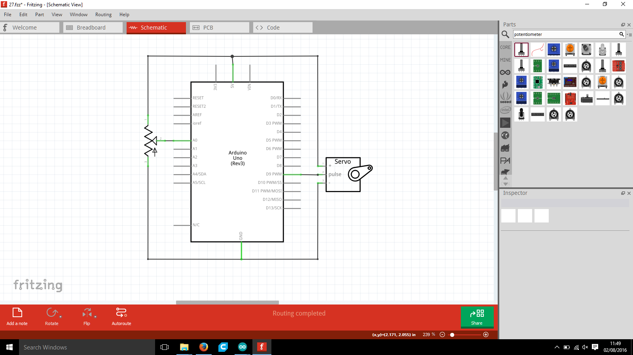

Write the following code into the arduino sketch:

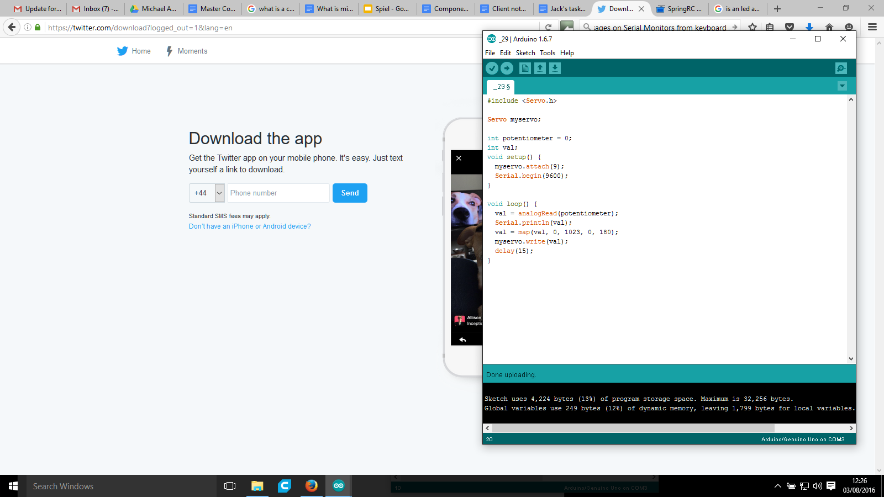

You should find that the servo moves position proportionally (try moving all the way clockwise and anticlockwise).

**Activity 30: Basic powering the DC Motor**

In this activity you will be powering the DC motor at different speeds.

Equipment

* 1 x Arduino UNO
* 1 x breadboard
* Cables
* 1 x DC Motor

Assemble the breadboard as shown in the diagram below:

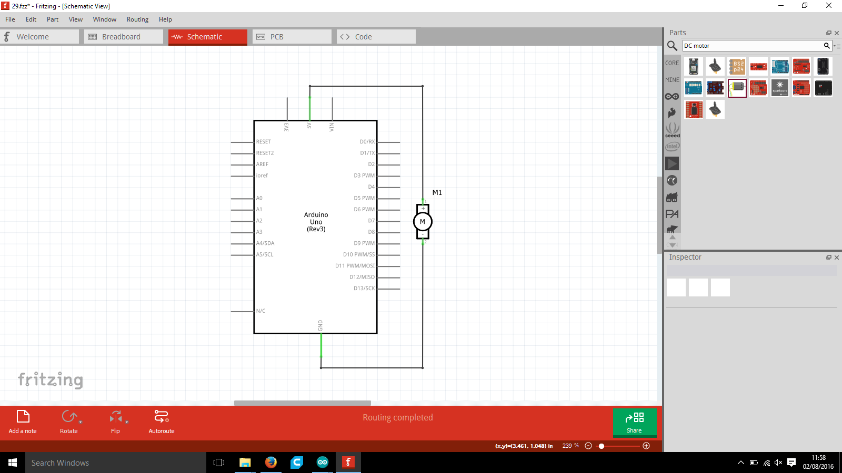

You should find that the motor spins. Try changing the 5V to 3.3V, the speed should decrease.

**Activity 31: Controlling the DC Motor with simple code**

In this activity you will turn the DC motor ON with a simple digitalWrite function.

Equipment

* 1 x Arduino UNO
* 1 x breadboard
* Cables
* 1 x DC Motor

Assemble the circuit on the breadboard as shown in the diagram below.

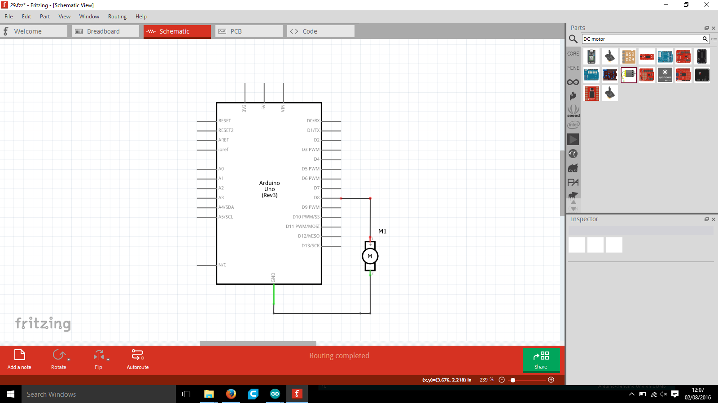

Write the following code in the arduino sketch:

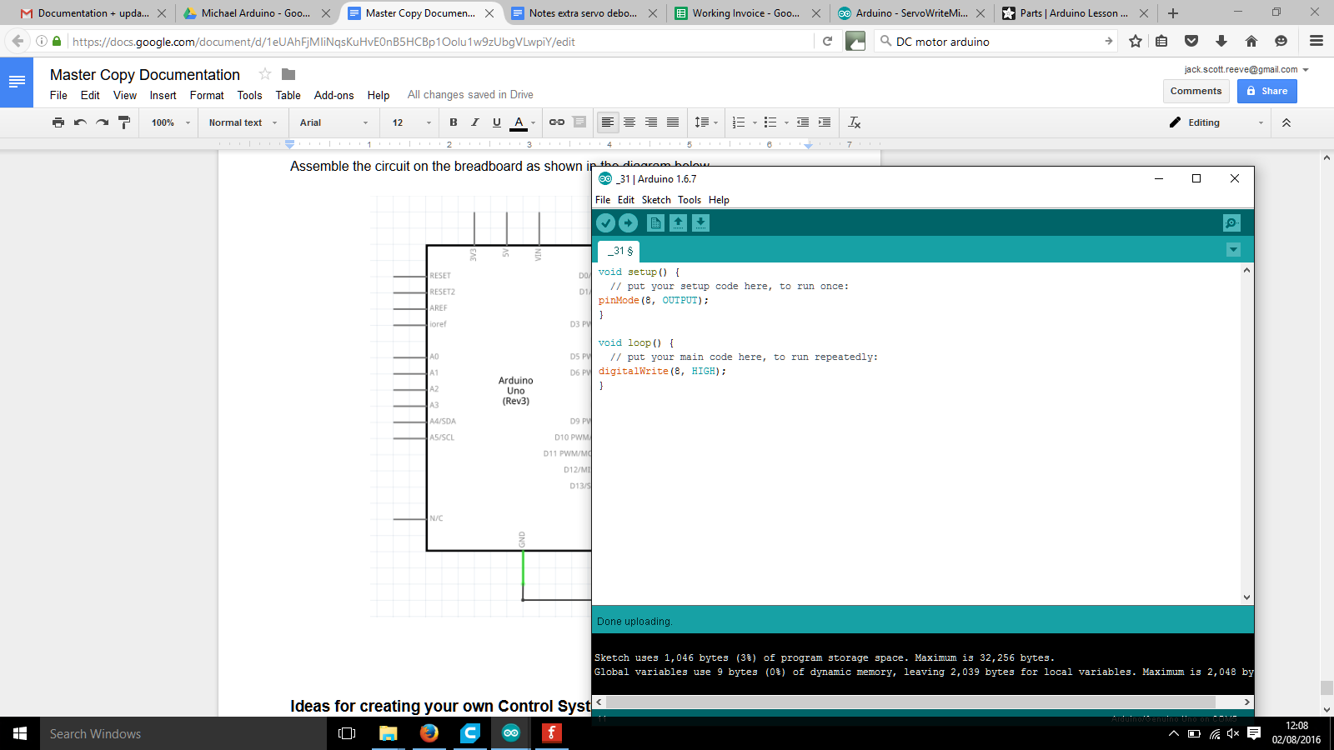

You should find that the DC Motor…..does nothing. It will not work. Try turning the gear gently and quickly moving your hand away. You should find that it starts to rotate, albeit MUCH slower than before.

**WHAT is going on?**

**Q Why does the motor only move slowly?**

*Because it requires a fair amount of current. Recall how we said that changing the voltage of the DC Motor varies the speed? Well it also has to have the current to back it up. The maximum amount of current that can be drawn from an I/O (Input/Output) pin (any of the numbered digital pins) is 40mA, and this motor needs a lot more than this to get to its high speeds. (FYI you can draw a LOT more current direct from the 5V and 3V3 pins).*

**Q How can you make the motor move faster?**

*Increase the voltage whilst also increasing the current.*

*Basically you need to control the motor speed using the digital pin, but power it directly from 5V. The next activity will explain how to do this using a transistor.*

**Q Why does the motor only start moving after you get it going yourself?**

*It’s because of the “****stall-torque****”. The motor requires more torque to get moving that it actually requires to move at a low speed. An analogy to help explain it:*

*Think of pushing a full shopping trolley from standstill. You have to really push it to get it moving, and once it is moving you can push it more gently to keep it moving.*

**Activity 32: Control a DC motor with a transistor**

In this activity you will turn the DC motor on to great speeds.

Equipment

* Arduino UNO
* Breadboard
* Cables
* 1 x DC Motor
* 1 x 220Ω Resistor (**RED RED** **BROWN** GOLD)
* 1 x BC547B Transistor (written on flat side, from arduino starter kit box)
* 1 x IN4007 Diode

Note that we are using the transistor from the Arduino starter kit. Recall the section on transistors, just after *Activity 6.*



The diode looks like the following image. Notice the dash of gray on one side

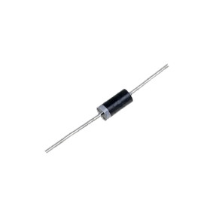

This dash tells you the direction the arrow points as in the circuit diagram below. Diodes are called “rectifiers”, they allow current to only flow in one direction. We use it coupled with a DC motor because normally when the motor stops to spin, it would generate a voltage spike (back emf) which could damage components. The diode blocks this and prevents the damage. (You don’t need to worry about how it works, just know that you **MUST point the dash towards the 5V connection!**.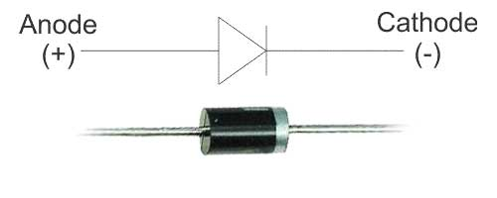

Assemble the circuit on the breadboard as shown in the diagram below.

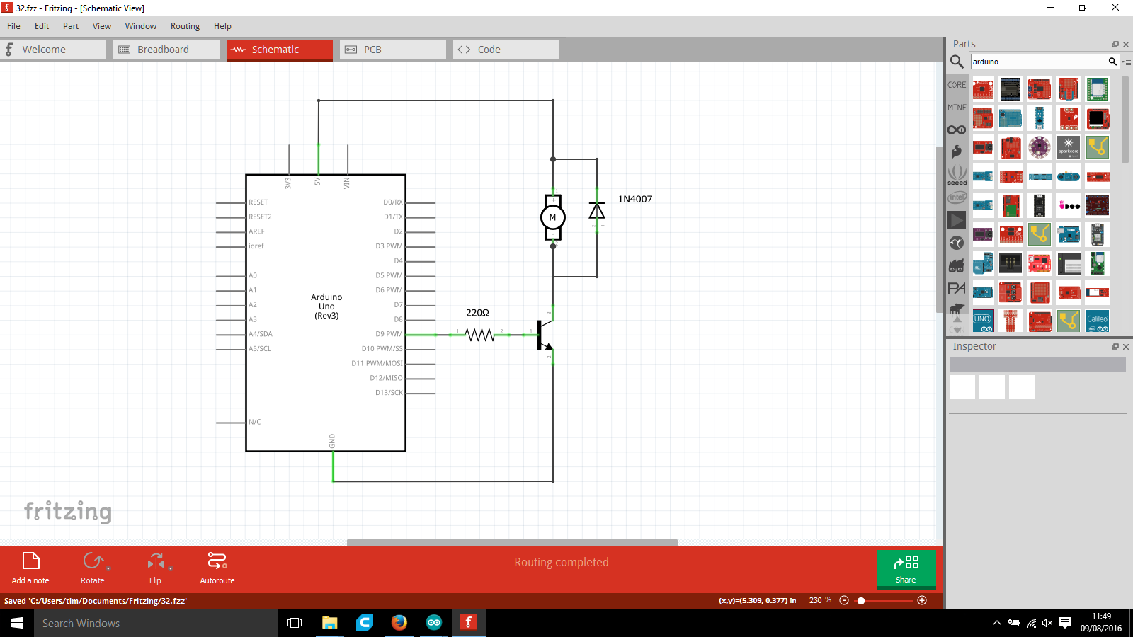

Write the following code in the arduino sketch:

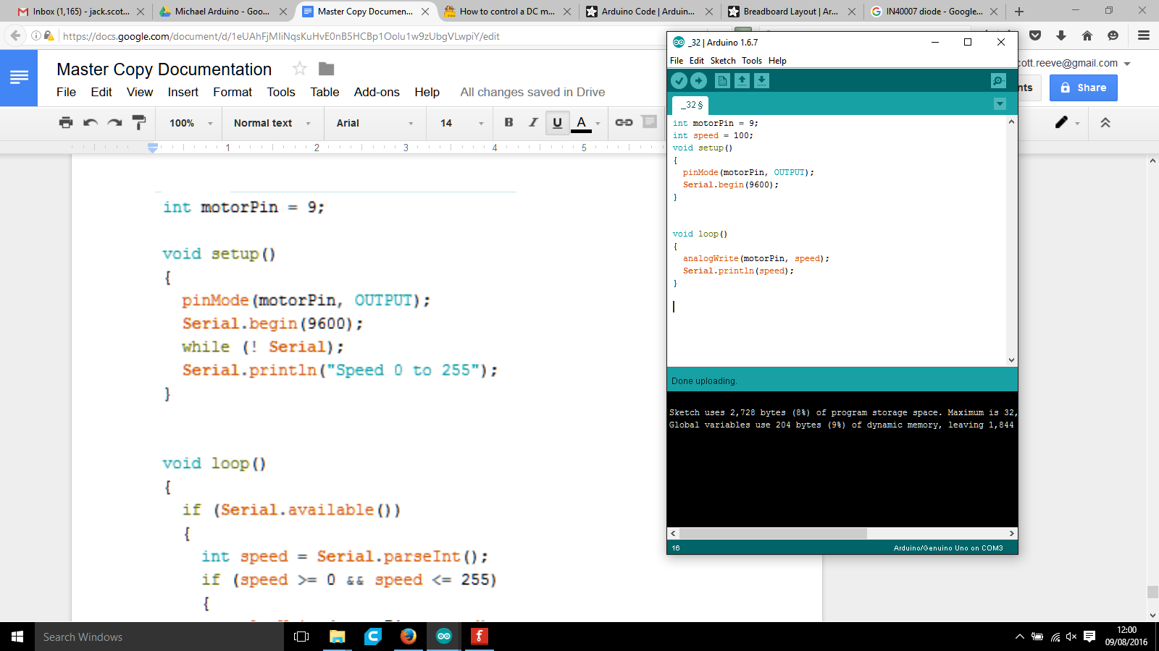

Explanation of code parts

**Int speed =100;**

* This sets the speed of the motor. It must be between 0-255

You should find that the motor

**Recap of all sensors/actuators you have used**

**Sensors**

* Push Button Switch
* Light Dependant Resistor (LDR)
* Potentiometer (POT)

**Actuators**

* Light Emitting Diode (LED)
* RGB LED
* Liquid Crystal Diode (LCD)
* Servo Motor
* DC Motor

Extra to do

Powering a DC motor

LED Strips

IR sensor

Aim to do this in 2 hours

**Ideas for creating your own Control Systems**

* Need to create a range of project difficulty
* 15 students
* All individual projects
* Doesn’t include brainstorm
* Something they can complete in 2 months
* Start beginning of october, finish by mid december
* 1 x 2 hour session per week
* 1 x 2 hour block per week
* 7 weeks plus half term

Sensor / actuator minimum

Our job is to make sure

* It’s A level standard
* That they can come up with it
* Encourage a brainstorming session
* A set of default ones to fall back on
* A certain level of complexity in the processing of code
* Complex use of many components

Minimum

* 7 x 2 hour contact = 14 hours contact
* 7 x 2 hour independent study = 14 hours

[**http://playground.arduino.cc/Projects/Ideas**](http://playground.arduino.cc/Projects/Ideas)